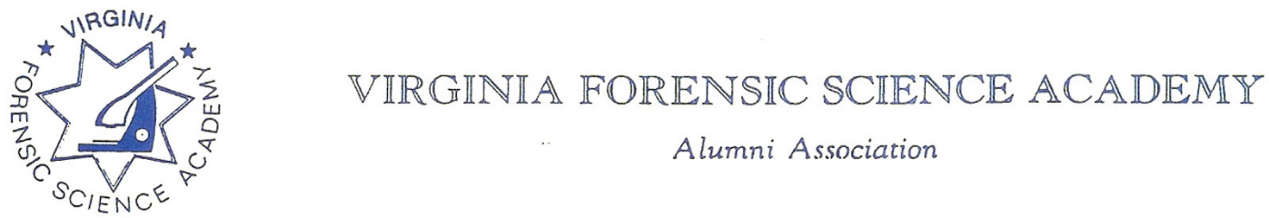

To: VFSAAA

Date: June 27th, 2025

From: Mark Garman, Secretary

Re: VFSAAA Board Meeting Minutes March 28th, 2025.

Executive Board:
President Sam Shumate ABSENT
1st Vice President Andrea Feldman
2nd Vice President Greg Locke
Treasurer Heather Marshall
Secretary Mark Garman
Sergeant-at-Arms Marilyn Durham ABSENT
Immediate Past President Marc Hackett
Legal Consultant Rick Conway
DFS Consultant Jeff Dwyer

Regional Directors:
Northern Director Zack King ON-LINE
Eastern Director Karyn Buhrman ON-LINE
Western Director Robby Richardson
Central Director Mike East

Committees:
R. Brian O’Bier Benson Committee ABSENT
Eric Deel Audit Committee ABSENT
Alison Fox Nominating Committee
Marilyn Durham Memorial Committee ABSENT

Others Present:
Jason Austin Member/DFS Instructor
Bryan McIntee Member/DFS Instructor
Tiffany Alston VFSA Admin

The meeting was called to order at approximately 11:50 AM by 1st Vice President Andrea Feldman.
It was determined that there were enough members present, either in person or online, to establish the necessary quorum.
Treasurer’s Report:
Heather Marshall, Treasurer, presented the following Treasurer’s Report for March 2025.
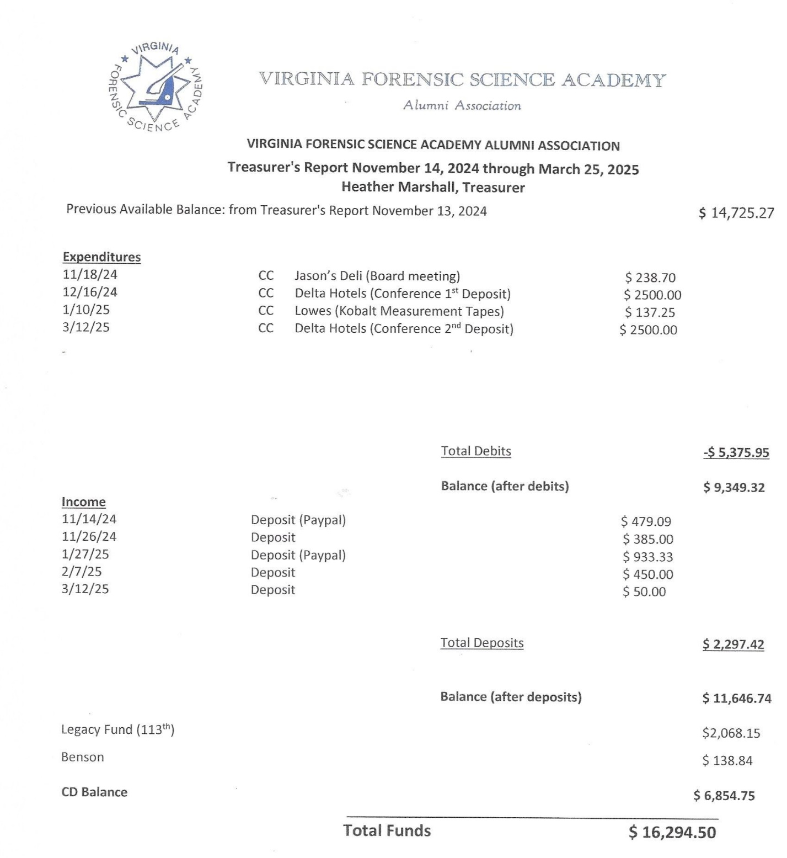

A Motion was made to approve the March 2025 Treasurer’s Report. A Second was made. The motion passed unanimously. There were no abstentions, objections, or dissenting votes.
Heather advised the Board that our CD’s rate is extremely low. It is a 9-month CD with a .01 % rate. She suggested opening a new CD with a higher rate. The new rates are approximately 4%. There will be a very small penalty for the transfer.
A motion was made to authorize Heather to transfer the CD funds to a new CD with a better rate. A Second was also made. The motion passed unanimously. There were no abstentions, objections, or dissenting votes.
Secretary’s Report:
The Meeting Minutes from November 2024 Board of Directors Meeting were presented to the Board by Mark Garman, Secretary. This was done via email prior to the meeting.
There were no questions or comments on any of the minutes presented to the membership.
A Motion was made to approve the November Board of Directors Meeting Minutes. A Second was also made. The motion passed unanimously. There were no abstentions, objections, or dissenting votes.

Old Business:
1ST Vice President Feldman reported that the Benson Fund is still not IRS compliant. She said she spoke with Brian O’Bier, Benson Committee Chairperson, and he indicated that the issue is because of the improper filing of paperwork with the IRS. There was a brief discussion by the Board on the matter. Secretary Garman said he would contact President Shumate to see if he could get further details for the June Board Meeting.
Andrea also advised the Board that the Delta contract was signed and returned.
There was no other Old Business.

New Business:
There was no New Business.

Committees:
Bylaws:

Mark Garman, Secretary, reported that our current Bylaws, approved by the membership at the 2024 Annual Meeting, are posted and available on our website, www.vfsaaa.org.

Currently there are no projected changes or updates to our Bylaws that need to be presented to the membership.

Membership Ethics:
Rick Conway, Legal Consultant and Committee Chairperson, reported that Sigmon’s appeal was denied. Rick said that he will send Sigmon a letter after his sentencing informing him of the Ethics Committee ongoing investigation. That matter is still being investigated by the Membership Ethics Committee.
Rick gave Secretary Garman State Corporation Commission paperwork and the IRS Form 990 receipt for filing.

Sales:
Greg Locke, 2nd Vice President and Committee Chairperson, reported the online sales through Shenandoah Awards is getting some activity and a check from Shenandoah to the Association should be in the mail.
Greg advised the Board that the VFSAAA Challenge Coins have not been ordered yet. He is holding off until Treasurer Marshall gives the approval. Secretary’s Note- Approval was given by the Board during the November 2024 Board Meeting for the purchase of the coins based on the financial status of the Association.

Memorial Table:
Mark Garman, Secretary, said that the committee will be ready for the Retraining Seminar.
Information on the Memorial Table Committee can be found on our website, www.vfsaaa.org.

Website:
Mark Garman, Secretary, reported that our website, www.vfsaaa.org, was currently up to date. Forms necessary for the 2025 Retraining Seminar will be posted on the website in mid-April.

PayPal:
Mark Garman, Secretary, reported that PayPal was up to date. He will continue to monitor and update PayPal, as necessary. Mark also said that he is working on having all his personal information removed from PayPal that is linked to the VFSAAA. This may result in issues associated with using PayPal as they required a SSN when the VFSAAA started using PayPal.

Retraining Committee:
Jeff Dwyer, DFS Consultant, confirmed that the cost of registration fees would be $150.00 per member to attend Retraining. He said that Mark Garman, Secretary/PayPal Administrator, would forward PayPal payment information to him weekly to link member registration and payments.
There was a period of discussion by the Board on linking online PayPal payments, member names, agency names, and registration.
Jeff said that the dates for the 2025 Retraining Seminar would be September 3rd through the 5th ,2025.

The Dr. Paul Ferrara Award:
Marilyn Durham, SGT-at-Arms and Committee Chairperson, was not present and there was no report.
Information on the Dr. Paul Ferrara Award and the individual nomination letters can be found on our website, www.vfsaaa.org on the Dr. Paul Ferrara Award page.

Social Committee:
Zack King, Northen Director and Committee Chairperson, reported that costs for the 2025 Social will be very close to last years. Eighty-five tickets will be the total number of tickets sold for the Social.

Benson Fund:
Brian O’Bier, Committee Chairperson, was not present and there was no report.

Raffle Committee:

Robby Richardson, Western Director and Committee Chairperson, said he is looking for items.

Mark Garman said he has a “crime scene” blanket and a book to donate. The book was written by Jeff Miller, Alumni member, on some of his crime scene investigations when he was with the Fairfax County Police Department.

Vendor:

Mike East, Central Director and Committee Chairperson, said he has started sending out information to possible attendees. He has had a few positive responses.

Dan Grinnan Fall Classic Golf Outing:

Karyn Buhrman, Eastern Director and Committee Chairperson, said the event is in planning.

Novelty T/shirt:

Karyn Buhrman, Eastern Director and Committee Chairperson, said she was thinking of recycling an old design.

Hospitality Night:

Karyn Buhrman, Eastern Director and Committee Chairperson, said the event is in planning.

1ST Vice President, Andrea Feldman, asked if there was a motion to adjourn the meeting. A Motion and Second were made to adjourn the meeting. The motion passed unanimously. There were no abstentions, objections, or dissenting votes.

The meeting adjourned at approximately 1:00 PM.

The next meeting of the VFSAAA will be a Board of Directors Meeting scheduled for June 27th, 2025, at approximately 11:30 AM after the graduation exercises of the 115th Session of the VFSA.

Mark Garman, Secretary

______________________________________________________________

These Minutes were approved by the Board of Directors at the June 27th, 2025, Board of Directors Meeting.

