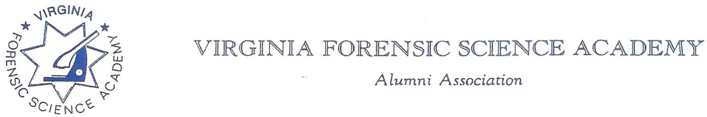

April 1st, 2025

Greetings Members:

In 2004, the Executive Board of the Virginia Forensic Science Academy Alumni Association (VFSAAA), created the “VFSAAA Crime Scene Officer of the Year” award. The Board of Directors changed the name of the award in 2006 to the “Dr. Paul Ferrara-VFSAAA Crime Scene Officer of the Year Award,” honoring Dr. Paul Ferrara. In 2021 the name was changed to the “Dr. Paul Ferrara Award”. The award is bestowed each year during the Annual Retraining Seminar in Virginia Beach and is presented during the opening programs of the seminar on Wednesday morning.

The award is intended for current Member(s) of the VFSAAA who, through their dedication and commitment, have performed outstanding work involving a particular (individual) case, or for a Member(s) who has continuously excelled in the field of Crime Scene Technology.

The Awardees will be selected by the VFSAAA Awards Committee, which is comprised of the current SGT-at-Arms and the four Regional Directors.

**We are requesting your input and nominations for the 2025 award. If you know of a member of the VFSAAA, who has either performed outstanding work over the past year or throughout their career, please contact one of the committee members listed below no later than August 1st, 2025. Please take the time to recognize and honor a member of our forensic community.**

**For current rules and conditions, please refer to our website at** [**www.vfsaaa.org**](http://www.vfsaaa.org)**.**

**Questions may be directed to:**

Marilyn Durham Committee Chairperson/SGT-at-Arms

Powhatan CO SO

804-598-5654 X1

[mndurham@powhatanva.gov](mailto:mndurham@powhatanva.gov)

Robby Richardson Western Director

Appomattox County SO

434-352-2666 x2071

[robby.richardson@appomattoxcountyva.gov](mailto:robby.richardson@appomattoxcountyva.gov)

Karyn Buhrman Eastern Director

Hampton Police Division

757-869-8286

[kmbuhrman@hampton.gov](mailto:klawrence@hampton.gov)

Mike East Central Director

Goochland CO SO

804- 556-5349

[meast@goochlandva.us](mailto:meast@goochlandva.us)

Zack King Northern Director

Front Royal Police Department

540-551-0332

zking@frontroyalva.com