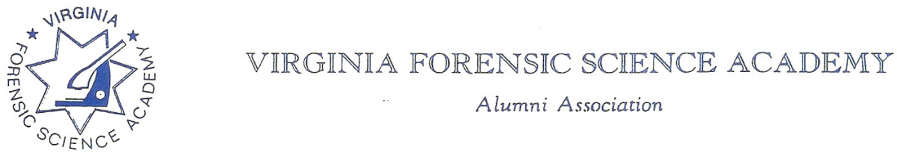

To: VFSAAA

Date: September 10th, 2026

From: Mark Garman, Secretary

Re: VFSAAA Board Meeting Minutes June 12th, 2026

Executive Board:
President Andrea Feldman
1st Vice President Robby Richardson ABSENT
2nd Vice President Greg Locke ABSENT
Treasurer Heather Marshall
Secretary Mark Garman
Sergeant-at-Arms Marilyn Durham ABSENT
Immediate Past President Sam Shumate
Legal Consultant Rick Conway
DFS Consultant Jeff Dwyer

Regional Directors:
Northern Director Zack King ABSENT
Eastern Director Karyn Buhrman
Western Director Justin Rothgeb ABSENT
Central Director Mike East

Committees:
Derek Richqards Benson Committee ABSENT
Eric Deel Audit Committee ABSENT
Alison Fox Nominating Committee ABSENT
Marilyn Durham Memorial Committee ABSENT

Others Present:
Jason Austin Member/DFS Instructor
Bryan McIntee Member/DFS Instructor
Tiffany Alston VFSA Admin

The meeting was called to order at approximately 12:00 PM by President Andrea Feldman.
It was determined that there were enough members present or on-line to establish the necessary quorum.

Treasurer’s Report:
Heather Marshall, Treasurer, presented the following Treasurer’s Report for June 2026. The report was emailed by Treasurer Heather Marshall to all Board members before the meeting.
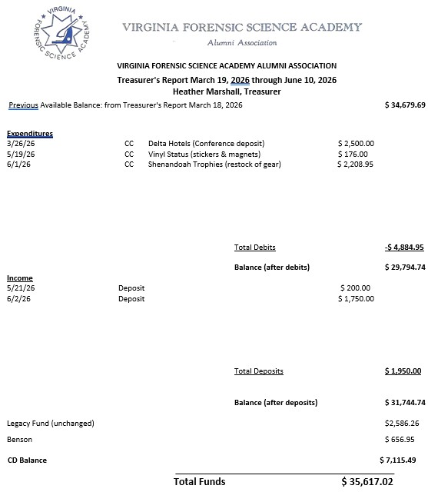

A Motion and a Second were made to approve the June 2026 Treasurer’s Report. The motion passed unanimously. There were no abstentions, objections, or dissenting votes.

Secretary’s Report:
The Meeting Minutes from the March 2026 Board Meeting were presented to the Board by Mark Garman, Secretary. This was done via email prior to the meeting.
A request was made by Rick Conway, Legal Consultant, to amend the March 2026 Meeting Minutes to indicate that the actual start time of the meeting was different from the start time that was assumed by several Board members due to miscommunication. Therefore, some of the Board members missed the meeting. After a period of discussion, the March 2026 Board Meeting Minutes were amended.
There were no other questions or comments on the March 2026 Minutes.
A Motion and a Second were made to approve the March 2026 Board Meeting Minutes. The motion passed unanimously. There were no abstentions, objections, or dissenting votes.

Old Business:

No old business was discussed.

New Business:
New business was discussed during Committee presentations.

Committees:
Bylaws:

Mark Garman, Secretary, reported that our current Bylaws, approved by the membership at the 2024 Annual Meeting, are posted and available on our website, www.vfsaaa.org. Mark said that the Bylaws need to be amended at the 2026 Annual Meeting to reflect the new address for the Association. The new address is 8850 Times Dispatch Blvd, Suite #100, Mechanicsville, VA, 23116. Mark said that the updates will be posted on our website, www.vfsaaa.org, for the membership to review before the Annual Meeting at the 2026 Retraining Seminar.

Membership Ethics:
Rick Conway, Legal Advisor and Committee Chairperson, spoke to the Board about the Justin Sigmon investigation. Rick said that he has emailed Sigmon several times covering the Membership/ Ethics Committee investigation and our Bylaws. Sigmon said that he will not contest his removal from the Membership and resigned from the Association.
The Memberships/Ethics Committees recommendation to the Board was to revoke Sigmon’s membership.
There were no other questions or comments on the revocation of Sigmon’s membership.
A Motion and a Second were made to approve the revocation of Simon’s membership. The motion passed unanimously. There were no abstentions, objections, or dissenting votes.

Sales:
Greg Locke, 2nd Vice President and Committee Chairperson, was not present and there was no official report.
President Feldman said that clothing shipments for the 2026 Retraining Seminar have already been received. Despite requesting that the order stick to blues and grays for clothing items, shirts in a maroon color were ordered and received. Also noted were the lack of small and medium sizes.
There was a period of discussion by the Board concerning the stickers/magnets that were received, what clothing sizes the Association should stock, the prices of some of the items, storage issues at the DFS, and obtaining coffee tumblers.
A Motion was made to authorize $2000.00 for the purchase of additional clothing items in blues/grays and in additional sizes. A Second was also made. The motion passed unanimously. There were no abstentions, objections, or dissenting votes.
President Feldman said she would contact Greg.
President Feldman suggested replacing the padfolio, that was previously given out to each new incoming student, with a clipboard that could be used on scene work. She said she would research the cost and advise the Board.
A reminder was made about the purchase of VFSAAA items on Shenandoah Awards website.
https://www.sanmar.com is Shenandoah Awards website.
https://stores.inksoft.com/virginia_forensic_science_acade/shop/home is the link to the VFSAAA Merchandise Page.
The password for our page must be obtained from Greg Locke, 2nd Vice President, Sales Committee Chairperson at Cfu2109@gmail.com or 540- 974-6880.

Memorial Table:
SGT-at-Arms Marilyn Durham, Committee Chairperson, was not present and there was no official report.
Information on the Memorial Table Committee can be found on our website, www.vfsaaa.org.

Website:
Mark Garman, Secretary, reported that our website, www.vfsaaa.org, was currently up to date. Tiffany Alston, VFSA Administration Assistant, now has administration access to our website.

PayPal:
Mark Garman, Secretary, reported that PayPal was up to date. Tiffany Alston, VFSA Administration Assistant, now has administration access to PayPal and she has a card reader at her office.

Retraining 2026:
Jeff Dwyer, DFS Consultant, said that plans for the 2026 Retraining Seminar were progressing.

Benson Fund:
Derek Richards, Committee Chairperson, was not present and there was no official report. It was noted that the Benson Fund is not IRS compliant for failure to file IRS Form 9090. The form has not been filed correctly since 2017 and as a result Benson’s tax status as a 501(c)3 has been revoked. To be reinstated Benson must refile with the IRS as if it is the first time they are seeking 501(C)3 status.
Mark Garman, Secretary, said he would contact Derek and check on any updates.

Social Committee:
Zack King, Northern Director and Committee Chairperson, reported the following.
The cost for the Association to host the Social will be about the same as last year, and he is looking at a “south of the border/Mexican” menu. There will be an open bar with beer and wine.
Coffee service will run about $600.00 for Wednesday and Thursday mornings.
A decision will be made by the Board on the number of tickets sold at the Summer online meeting.

Dan Grinnan Fall Classic Golf Outing:

Karyn Buhrman, Eastern Director and Committee Chairperson, submitted this information.

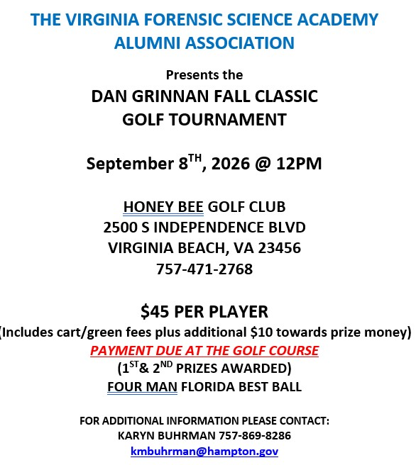

The Dr. Paul Ferrara Award:
Marilyn Durham, SGT-at-Arms and Committee Chairperson, was not present and there was no official report.
Information on the Dr. Paul Ferrara Award and the individual nomination letters can be found on our website, www.vfsaaa.org on the Dr. Paul Ferrara Award page.

Raffle Committee:

Justin Rotheb, Western Director and Committee Chairperson, was not present and there was no report.

Vendor:

Mike East, Central Director and Committee Chairperson, said that two vendors have signed up so far and that Mike Grimm from Grimm Forensics has committed to attend. Continuing Mike Eastsaid that Strohmann Enterprises has donated two Garmin watches and Southern Police Supply donated a shotgun, again, this year.

Novelty T/shirt:

Karyn Buhrman, Eastern Director and Committee Chairperson, said three designs were submitted. The Board voted and selected the shirt shown.

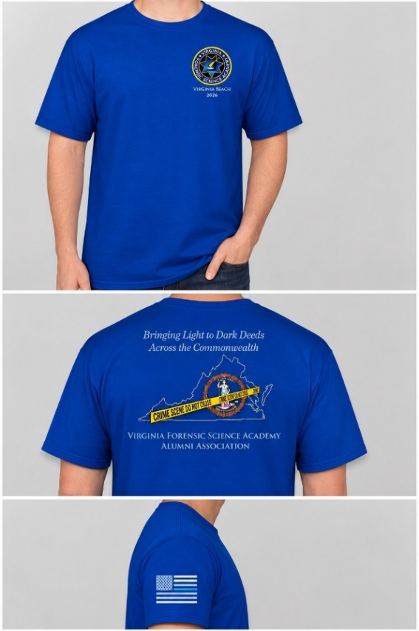

Hospitality Night:

Karyn Buhrman, Eastern Director and Committee Chairperson, said the event will be held at Shorebreak Taphouse just like the last several years.

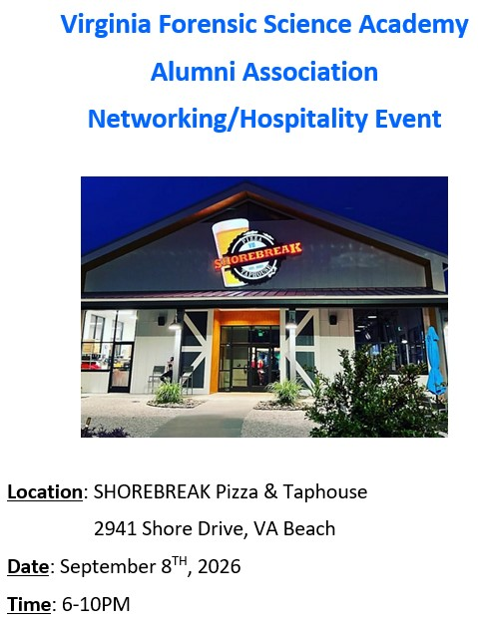
A Motion and a Second were made to approve a budget of $2500.00 for the Hospitality Night. A Second was also made. The motion passed unanimously. There were no abstentions, objections, or dissenting votes.

Nomination Committee/Honorary Membership.

Alison Fox, Committee Chairperson, was not present however she sent the below suggested slate to President Feldman. The slate will be posted on our website, www.vfsaaa.org, and will be presented during the Annual Meeting at the 2026 Retraining Seminar.

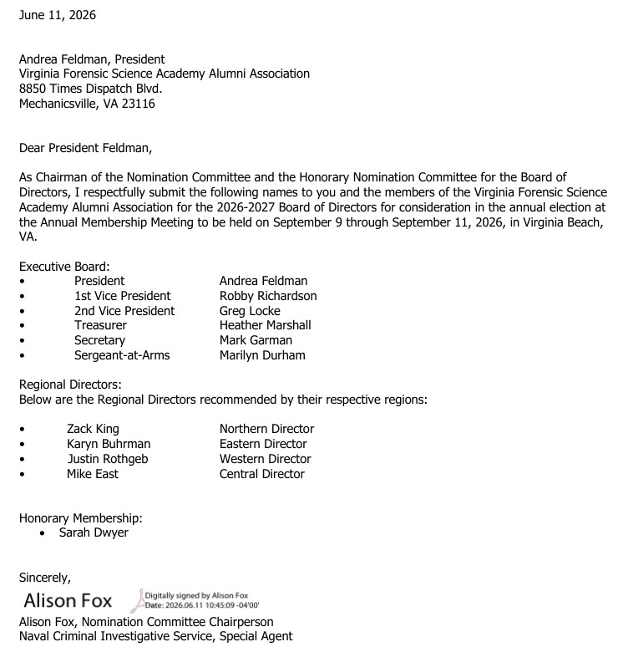

President Feldman also reported that the Board received one nomination for Honorary Membership.

A Motion and a Second were made to approve the Honorary Membership. The motion passed unanimously. There were no abstentions, objections, or dissenting votes.

The proposed Honorary Membership will need to be voted on for approval by the membership during the Annual Meeting at the 2026 Retraining Seminar.

The nomination letter is shown below,

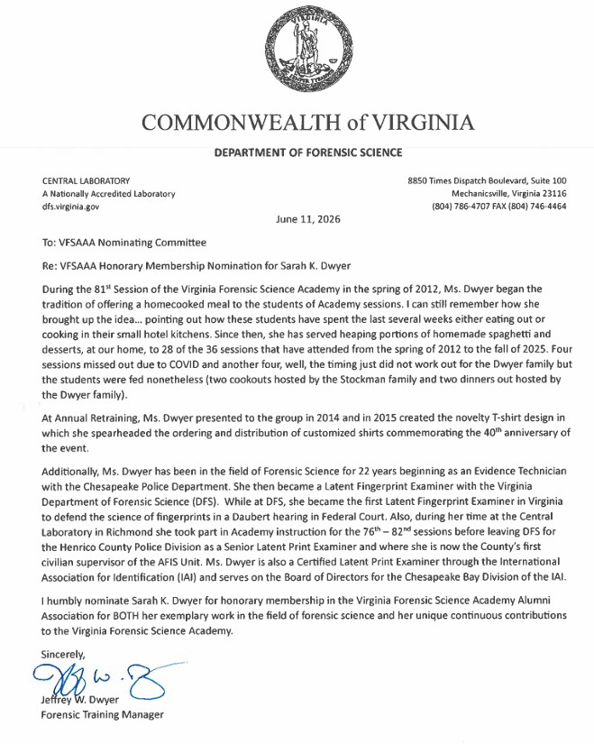

President Feldman asked if there was a motion to adjourn the meeting. A Motion and Second were made to adjourn the meeting. The motion passed unanimously. There were no abstentions, objections, or dissenting votes.

The meeting adjourned at approximately 1:15 PM.

The next official meeting of the Virginia Forensic Science Academy Alumni Association will be the Annual Membership Meeting scheduled for September 10th, 2026, at the Annual Retraining Seminar, Viginia Beach, VA.

Mark Garman, Secretary

______________________________________________________________

These Minutes were approved by the Membership at the Annual Membership Meeting September 10th, 2026.

