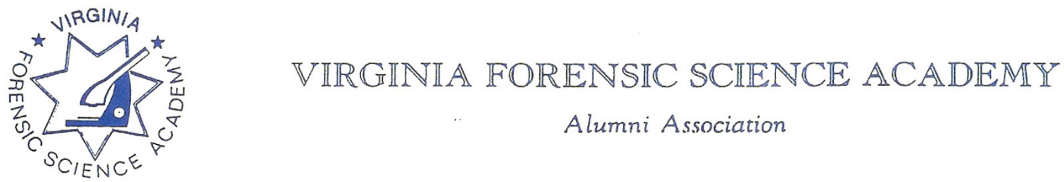

To: VFSAAA

Date: March 20th, 2026

From: Mark Garman, Secretary

Re: VFSAAA Board Meeting Minutes November 14th, 2025

Executive Board:
President Andrea Feldman
1st Vice President Robby Richardson ON-LINE
2nd Vice President Greg Locke ON-LINE
Treasurer Heather Marshall ABSENT
Secretary Mark Garman
Sergeant-at-Arms Marilyn Durham ABSENT
Immediate Past President Sam Shumate ABSENT
Legal Consultant Rick Conway ON-LINE
DFS Consultant Jeff Dwyer

Regional Directors:
Northern Director Zack King ABSENT
Eastern Director Karyn Buhrman
Western Director Justin Rothgeb
Central Director Mike East

Committees:
Derek Richqards Benson Committee ABSENT
Eric Deel Audit Committee ABSENT
Alison Fox Nominating Committee ON-LINE
Marilyn Durham Memorial Committee ABSENT

Others Present:
Jason Austin Member/DFS Instructor
Bryan McIntee Member/DFS Instructor
Tiffany Alston VFSA Admin

The meeting was called to order at approximately12:00 PM by President Andrea Feldman.
It was determined that there were enough members present, either in person or online, to establish the necessary quorum.

Treasurer’s Report:
Heather Marshall, Treasurer, was absent. Secretary Mark Garman presented the following Treasurer’s Report for November 2025. The report was emailed by Treasurer Heather Marshall to all Board members before the meeting.
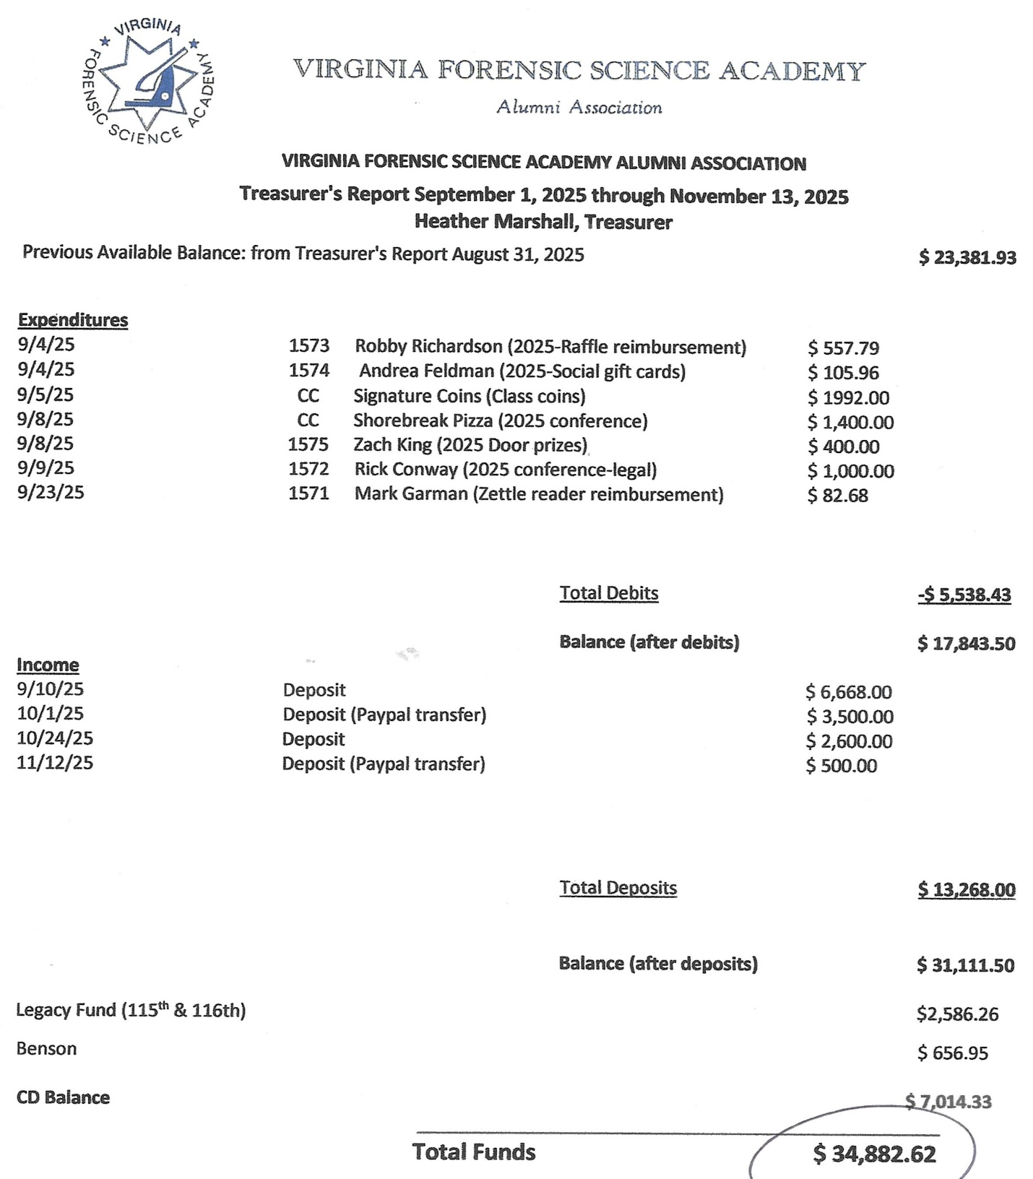

A Motion was made to approve the November 2025 Treasurer’s Report. A Second was also made. The motion passed unanimously. There were no abstentions, objections, or dissenting votes.

Secretary’s Report:
The Meeting Minutes from the September 2025 Annual Meeting were presented to the Board by Mark Garman, Secretary. This was done via email prior to the meeting.
There were no questions or comments on the minutes.
A Motion was made to approve the September 2025 Annual Meeting Minutes. A Second was also made. The motion passed unanimously. There were no abstentions, objections, or dissenting votes.

Old Business:
Secretary Mark Garman brought up the Membership/Ethics Committees investigation into former member Justin Sigmon. Mark advised the Board that Sigmon was sentenced and then released for time served in February of 2025. This information was based on an internet search. Mark suggested that it was time for the Committee to finish its investigation into the matter and present its findings to the Board. Rick Conway, Committee Chairperson, said he would investigate the matter and report to the Board at the next meeting.

There was no other Old Business.

New Business:
There was no new business to report.

Committees:
Bylaws:

Mark Garman, Secretary, reported that our current Bylaws, approved by the membership at the 2024 Annual Meeting, are posted and available on our website, www.vfsaaa.org. Currently there are no projected changes or updates to our Bylaws that need to be presented to the membership.

Membership Ethics:
Rick Conway, Legal Advisor and Committee Chairperson, advised that other than the Sigmon issue, there are no other Membership Ethics issues under investigation at this time.

Sales:
Greg Locke, 2nd Vice President and Committee Chairperson, gave the following updates/reports.
Challenge Coins were received by the Academy. Jeff Dwyer said the coins looked good. Mark Garman asked how we were going to get coins to the previous graduates who are owed coins. It was suggested that back-owed coins be sent to the members’ department or forwarded to them through their departments at Retraining. It was also suggested, and then decided by the Board, that in the future coins will be given to the graduates prior to graduation and not at Retraining.
Past President shirts were shipped, or will be shipped, to Larry Claytor and Sam Shumate. Mark Garman, Secretary, will hand deliver Jim Gogan’s shirt to him.
Greg asked how much money would be available to restock standard VFSAAA items. He said that normally $3,000.00 is allocated for sales. It was suggested that the decision could be made in the Spring of 2026 after consultation with Treasurer Heather Marshall. Greg said that he would reach out to Heather for her input.
There was a brief discussion on our web-based sales through Shenandoah Awards website and how we could improve its use by the members.
It was noted that each new class spends about $200 to $300 on sales items at the end of their session.
https://www.sanmar.com is Shenandoah Awards website.
https://stores.inksoft.com/virginia_forensic_science_acade/shop/home is the link to the VFSAAA Merchandise Page.
The password for our page must be obtained from GREG LOCKE/2ND VICE PRESIDENT/SALES COMMITTEE CHAIRPERSON at Cfu2109@gmail.com or 540- 974-6880.

Memorial Table:
SGT-at-Arms Marilyn Durham, Committee Chairperson, was not present and there was no official report.
Mark Garman, Secretary, brought up that there are photos of individual(s) on the Memorial Table Photo Frame that are not Active, Associate, Life, or Honorary members of the VFSAAA and requested clarification, by the Board, on whose images should be displayed. After discussion there was a consensus, by the Board, that only members of the VFSAAA should be shown as part of the Memorial Table display. President Feldman said that she would send an email to Marilyn about the decision.
Information on the Memorial Table Committee can be found on our website, www.vfsaaa.org.

Website:
Mark Garman, Secretary, reported that our website, www.vfsaaa.org, was currently up to date. He thanked Marilyn Durham, SGT-at-Arms, for going through the site and finding numerous errors. Those errors were corrected. Mark said that he will continue to monitor and keep the site current.

PayPal:
Mark Garman, Secretary, reported that PayPal was up to date. He said that PayPal has a two-factor log in procedure that has created some sign-on issues. As Tiffany Alston, VFASA Admin, has a PayPal reader at the VFSA he will supply her with log-on information. He will continue to monitor and update PayPal, as necessary.

Retraining Committee:
Jeff Dwyer, DFS Consultant, confirmed that the 2026 contract for the Delta has been signed.
Mark Garman, Secretary, suggested that the Board supply coffee service to the members during the first two days of Retraining. There was brief discussion about the topic and Jeff said he would investigate the costs.
Jeff Dwyer reported that as of 11/14/2025 the VSP had not yet paid the registration fees for VSP members who attended the 2025 Retraining Seminar. The total amount due is $2400.00.

Benson Fund:
Derek Richards, Committee Chairperson, was not present and there was no official report.

Social Committee:
Zack King, Northen Director and Committee Chairperson, was not present and there was no official report.

The Dr. Paul Ferrara Award:
Marilyn Durham, SGT-at-Arms and Committee Chairperson, was not present and there was no official report.
Information on the Dr. Paul Ferrara Award and the individual nomination letters can be found on our website, www.vfsaaa.org on the Dr. Paul Ferrara Award page.

Raffle Committee:

Justin Rotheb, Western Director and Committee Chairperson, asked for $500.00 for raffle prizes.
A Motion was made to authorize $500.00 for raffle prizes. A Second was also made. The motion passed unanimously. There were no abstentions, objections, or dissenting votes.

Vendor:

Mike East, Central Director and Committee Chairperson, said he has already started sending out emails. He has received some verbal commitments.

Dan Grinnan Fall Classic Golf Outing:

Karyn Buhrman, Eastern Director and Committee Chairperson, said the event went well. Most likely the event will be held at the same location as next year.

Novelty T/shirt:

Karyn Buhrman, Eastern Director and Committee Chairperson, said the 2025 Novelty T/shirts sales went well.

Hospitality Night:

Karyn Buhrman, Eastern Director and Committee Chairperson, said the event went well. She said that although $2,500.00 was authorized for the event the entire amount was covered by Capital One and Evident. She said she will be asking for $2,500.00 for the event in 2026.

A Motion was made to authorize $2,500.00 for the Hospitality Night. A Second was also made. The motion passed unanimously. There were no abstentions, objections, or dissenting votes.

President Feldman asked if there was a motion to adjourn the meeting. A Motion and Second were made to adjourn the meeting. The motion passed unanimously. There were no abstentions, objections, or dissenting votes.

The meeting adjourned at approximately 1:00 PM.

The next official Board Meeting of the VFSAAA will be a web-based meeting on March 20th, 2026, as there is no Spring 2026 Session of the VFSA.

Mark Garman, Secretary

______________________________________________________________

These Minutes were approved by the Board of Directors at the March 20th, 2026, Board Meeting.

