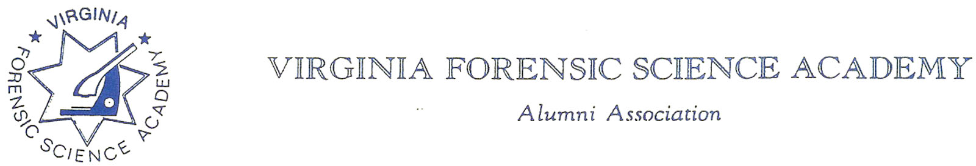

To: VFSAAA

Date: July 25th, 2024

From: Mark Garman, Secretary

Re: VFSAAA Board of Directors Meeting Minutes
June 28th, 2024

Executive Board:
President Sam Shumate
1st Vice President Andrea Feldman
2nd Vice President Greg Locke SIGNED IN ON-LINE
Treasurer Heather Marshall
Secretary Mark Garman
Sergeant-at-Arms Wendy Bailey ABSENT
Immediate Past President Marc Hackett SIGNED IN ON-LINE
Legal Consultant Rick Conway ABSENT
DFS Consultant Jeff Dwyer

Regional Directors:
Northern Director Zack King SIGNED IN ON-LINE
Eastern Director Karyn Buhrman
Western Director Robby Richardson
Central Director Charles “Trey” Lucy ABSENT

Committees:
R. Brian O’Bier Benson Committee ABSENT
Eric Deel Audit Committee ABSENT
Alison Fox Nominating Committee
Marilyn Durham Memorial Committee

Others Present:
Shantae Green DFS Admin Assistant
Jason Austin VFSA Instructor
Michael East Member

The meeting was called to order at approximately 11:47 AM by President Sam Shumate.
It was determined that there were enough Board members present, either in person or signed in on-line, to establish the necessary quorum.

Secretary’s Note: Because many of the Board members were signed in on-line some of their comments could not be heard for inclusion in the Minutes. Such occurrences are noted in the minutes.

Treasurer’s Report:
Heather Marshall, Treasurer, presented the following Treasurer’s Report for June 2024. The report was emailed to the Board prior to the meeting.

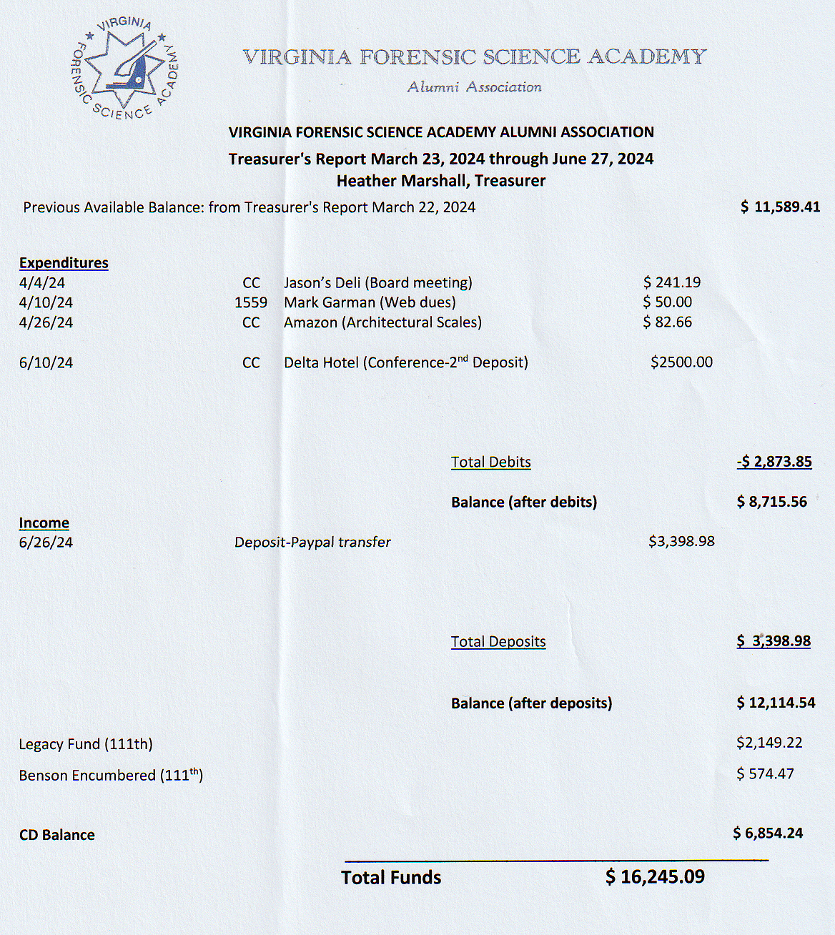

A Motion was made to approve the June 2024 Treasurer’s Report. A Second was also made. The motion passed by unanimous oral vote. There were no abstentions, objections, or dissenting votes.

Secretary’s Report:
The Meeting Minutes from the March 29th, 2024, Board Meeting were presented to the Board by Mark Garman, Secretary. This was done via email prior to the meeting.
A Motion was made to approve the March 29th, 2024, Board Meeting Minutes. A Second was also made. The motion passed by unanimous oral vote. There were no abstentions, objections, or dissenting votes.

Old Business:
President Shumate asked if there was any Old Business to be discussed.

Mark Garman, member of the Membership Ethics Committee, summarized the investigation concerning VFSA graduate Justin Sigmon.

MIAMI – On Nov. 17, a federal jury convicted the former Major of the Franklin County Sheriff’s Office in Virginia of abusive sexual contact with a minor under 12 years old. The conviction comes after a five-day jury trial before U.S. Senior District Judge Donald L. Graham in Miami. In May 2023, Justin Dale Sigmon, 47, while on a cruise that departed from the Port of Miami, repeatedly put his hands up the skirt of a nine-year-old, rubbing her inner thighs and private area, despite her repeatedly pushing his hands away on multiple occasions. Two good Samaritans, who were seated next to Sigmon in the cruise ship dining room, noticed his behavior, recorded it, and reported it to cruise ship security. The cruise ship’s surveillance cameras also captured Sigmon’s actions. When cruise security officials confronted him about his conduct, Sigmon identified himself as a law enforcement officer. Sentencing is set for Jan. 12, 2024, at 1:30 p.m. in Miami. Sigmon faces up to life in prison. U.S. Attorney Markenzy Lapointe for the Southern District of Florida and Special Agent in Charge Jeffrey B. Veltri of the FBI, Miami Filed Office, announced the guilty verdict. FBI Miami investigated the case with assistance from the U.S. Customs and Border Protection (CBP) and Carnival Cruise Line security. Assistant U.S. Attorneys Jessica Kahn Obenauf and Lacee Elizabeth Monk prosecuted it.

Mark said he felt that the Membership Ethics Committee would recommend to the Board that Sigmon’s membership in the VFSAAA be terminated but because Rick Conway, the Membership Ethics Committee Chairperson, was not in attendance he recommended that the matter be tabled until Rick could be at the July 2024 Board Meeting.

The matter was tabled by President Shumate until the July meeting.

Mark Garman, member of the Bylaws Committee, reviewed the current suggested updates and changes to our Bylaws. The changes are in Article II Section 13 Disciplinary Actions and how a member is contacted concerning an investigation. Adjustments need to be made concerning when, where, and how a member who is under investigation is contacted by the Board.

The following summarizes the changes.

The member whose conduct is in question shall be contacted by registered or certified mail to that member’s business and/or home address supplied by the member and on record with The Association.

These suggestions will be emailed to Board members. Again, Mark suggested that the matter be tabled until our next meeting as the committee chairperson, Rick Conway, was not in attendance. Mark said that if the matter is addressed by the Board and approved at the July Board meeting there will still be enough time to post the suggested changes on our website within the prescribed time as stated in our Bylaws.

The matter was tabled by President Shumate until the next Board meeting.

New Business:
No other New Business was presented.

Committees:

Membership Ethics:
Rick Conway, Legal Consultant and Committee Chairperson, was not in attendance. Mark Garman, Committee Member, said that there were no issues other than what was mentioned previously under Old Business.

Bylaws:

Rick Conway, Legal Consultant and Committee Chairperson, was not in attendance. Mark Garman, Committee Member, said that there were no issues other than what was mentioned previously under Old Business.

Sales:
Greg Locke, 2ND Vice President and Committee Chairperson, indicated that at this time no new items will be ordered for Retraining. He will continue to monitor the situation.
The Board discussed other ways to sell items including posting items for sale on our website or having manufacturers, i.e. Shenandoah Awards, sell directly to the members. He said he would contact Shenandoah Awards.

Memorial Table:
Marilyn Durham, Committee Chairperson, said that the committee is keeping up on the numerous passing of members and that the table would be ready for Retraining.
Information on the Memorial Table Committee can be found on our website, www.vfsaaa.org.

Website:
Mark Garman, Secretary, reported that our website, www.vfsaaa.org , is currently up to date. He said that all current information on the 2024 Retraining Seminar, to include Retraining Registration, Dues, Dr. Paul Ferrara Award, Benson Scholarship, and the Novelty T/Shirt is on the site. He will continue to monitor and update the site as necessary.

PayPal:
Mark Garman, Secretary, reported that PayPal is up to date. The new Dues form is on our website, www.vfsaaa.org, and has been tested.
He will continue to monitor and update PayPal as necessary.

Retraining 2024 Exploration Committee:
Jeff Dwyer, DFS Consultant, advised that the Delta hotel will be re-evaluated after the upcoming Retraining Conference. There was a period of general discussion by the Board on Retraining at the Delta hotel. The topics included the cost of having the conference there, most members like the hotel. Other possible locations, many do not meet our needs for holding the conference. The fact that we do not charge for the conference, and can’t because of VA government policy, and other conferences do (i.e. VHIA) was also discussed. Heather Marshal, Treasurer, mentioned the cost of having the conference at the Delta hotel and its effect on the continued decline of the amount of money in the treasury of the Association.
Jeff also explained some of the issues with the Delta hotel including fees charged for the conference rooms and the cost of food for the Social. He did say that some things remained the same such as parking and room rates.
The committee members are Jeff Dwyer, DFS Consultant, Trey Lucy, Central Director, Wendy Bailey, SGT-at-Arms, and Karyn Buhrman, Eastern Director.

Retraining 2023:
Jeff Dwyer, DFS Consultant, said Retraining is scheduled for September 3rd through the 6th and is on track.

Benson Fund:
Brian O’Bier, Committee Chairperson, was not present. The below report was submitted prior to the meeting.
President Shumate reported that there will be a Corn Hole Tournament held by the Benson Committee at the Shorebreak Pizza and Taphouse which is the same location as the Hospitality event.
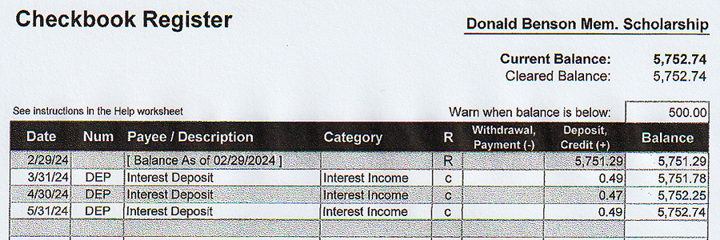

The Dr. Paul Ferrara Award:
Wendy Bailey, SGT-at-Arms and Committee Chairperson, was not present and there was no official report.
Mark Garman, Secretary, mentioned that there is already one nomination for the Dr. Paul Award with the committee and a decision had not been made on it yet. He said he also received a second nomination, but this one was for the Dan Grinnan Award. There was some discussion by the Board on the differences between the Dr. Paul and the Dan Grinnan awards. It was decided that there was an error on our website concerning who nominated members for the Dan Grinnan Award. Nominations for the Dan Grinnan Award are made by the Board and not members. Mark said the website will be corrected. Jeff Dwyer, DFS Consultant, said he would contact Wendy to see if she could reach out to the nominating member and explain the Board’s error.
The Board elected to hold off on any decisions until the summer Board Meeting.
Information on the Dr. Paul Ferrara Award and the Dan Grinnan Award can be found on our website, www.vfsaaa.org on the Dr. Paul Ferrara Award page.

Social:
Zack King, Northen Director and Committee Chairperson, made a presentation to the Board about the Social and its cost. Unfortunately, most of it was not picked up by the recorder. To summarize, the Social will be held on Thursday night at the Delta hotel and the menu is still being worked on. A more complete report will be made at the summer Board meeting.
There was a period of discussion by the Board on the various aspects of the Social.
A motion was made to increase the price of the Social to $30.00 per person. A Second was also made. The motion passed by unanimous oral vote. There were no abstentions, objections, or dissenting votes.
A motion was made to authorize the spending of up to $500.00 on door prizes for the Social. A Second was also made. The motion passed by unanimous oral vote. There were no abstentions, objections, or dissenting votes.

Raffle Committee:

Robby Richardson, Western Director and Committee Chairperson, said he is working on the raffle and will be ready for Retraining.

Vendor:

Trey Lucy, Central Director and Committee Chairperson, was not present. Mike East, Central member who is assisting, said Trey reported to him that there are currently 3 vendors signed up.

Information on the vendors who were at Retraining in 2023 is posted on our website, www.vfsaaa.org.Those vendors are, Evident Crime Scene Products, File On Q, Precision Survey Supply/Leica, and Spacesaver Storage Solutions.

Novelty T/shirt:

Karyn Buhrman, Eastern Director and Committee Chairperson, presented the design for the 2024 Novelty T/shirt.

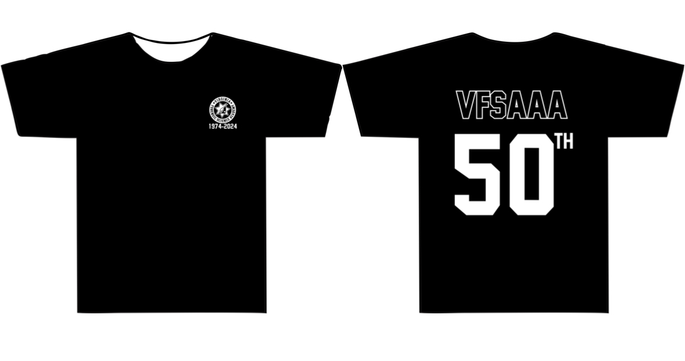

The cost will $20.00 per shirt. There will be no pre-orders. The shirt will be in black only.

Hospitality Night:
Karyn Burhman, Eastern Director and Committee Chairperson, said the event would run something like it did at the 2023 Retraining Seminar and again will be held at the Shorebreak Pizza and Taproom, 2941 Shore Dr, Virginia Beach, VA 23451
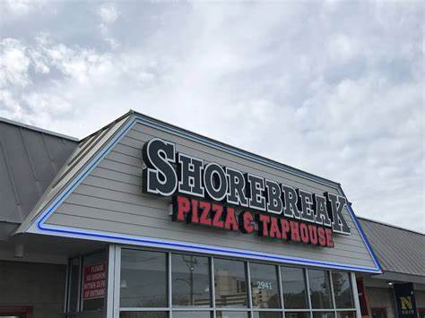
A motion was made to authorize the spending of up to $2000.00 for the Hospitality event. Second was also made. The motion passed by unanimous oral vote. There were no abstentions, objections, or dissenting votes.

Dan Grinnan Fall Classic Golf Outing:

Karyn Buhrman, Eastern Director and Committee Chairperson, said the event will be at the Honey Bee Golf Club. More information will be available at the summer Board meeting.



Nomination:
Alison Fox, NCIS, is now the new Chairperson for the Nominating Committee. A report will be presented at the July meeting.

President Shumate asked if there was a motion to adjourn the meeting. A Motion and Second were made to adjourn the meeting. As there were no objections, abstentions, or dissenting votes, the motion passed.

The meeting adjourned at approximately 1:10 PM.

The next meeting of the VFSAAA is a web-based Board Meeting scheduled for July 25th, 2024, at approximately 10:00 AM.

Mark Garman, Secretary

______________________________________________________________

Minutes Approved by the Board of Directors at the July 25th, 2024, Board Meeting.

