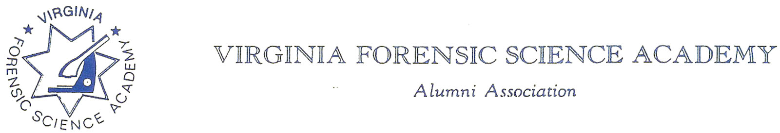
VFSAAA Board Meeting Minutes
Because of COVID-19 issues this Meeting was a virtual-web based meeting.

To: VFSAAA

Date: April 1st, 2022

From: Mark Garman, Secretary

Re: VFSAAA Board Meeting
November 12th, 2021

Executive Board:
President Marc Hackett
1st Vice President Chris McClure-ABSENT
2nd Vice President Greg Locke
Treasurer Heather Marshall
Secretary Mark Garman-LEFT MEETING EARLY
Sergeant-at-Arms Wendy Bailey
Immediate Past President Clay Overholt-ABSENT
Legal Consultant Rick Conway
DFS Consultant Jeff Dwyer

Regional Directors:
Northern Director Andrea Feldman
Eastern Director Karyn Burhman
Western Director Samuel Shumate
Central Director Charles “Trey” Lucy

Committees:
R. Brian O’Bier Benson Committee-ABSENT
Eric Deel Audit Committee-ABSENT
Jim Gogan Nominating Committee-ABSENT

Others:
Fhatima Shands Admin Assistant/Honorary Member
Steve Stockman Instructor

The meeting was called to order at approximately 10:00 AM by President Marc Hackett.
It was determined that there were enough Board members signed into the meeting to establish the necessary quorum.

Secretary’s Report:
The Meeting Minutes from the 2021 Annual Membership were presented to the Board by Mark Garman, Secretary, prior to the meeting via email.
There were no questions or comments on the minutes.
A Motion, along with a Second, was made to accept the 2021 Annual Membership Meeting Minutes. There were no objections. The motion passed by unanimous oral vote. There were no dissenting votes.

Website:
Mark Garman, Secretary, advised that our old website through WEB.Com is in the process of being shut down. It will take several days for the site to be completely removed. Further, our new website, www.vfsaaa.org through NetworkSolutions.Com is up and running. He indicated that the site is under construction and will be so for the next several months. He will continue to work on it and hopefully it will be completed before the Spring/Summer of 2022.

PayPal:
Mark Garman, Secretary, reported that PayPal has not been linked to the new website yet. It is one of the more important website projects that he will be working on in the future.

The Dr. Paul Ferrara VFSAAA Crime Scene Officer of the Year Award:
Mark Garman, Secretary, asked the Board to consider renaming The Dr. Paul Ferrara VFSAAA Crime Scene Officer of the Year Award. Mark advised that when the award program was started in 2002 it was known as the “member of the year” award. In 2006 it was changed to the “crime scene officer of the year award”. Researching the Board meeting minutes for that period Mark could find no cause, reason, or discussion on why the award was renamed. Further, Mark noted that there are many members of the VFSAAA who are not “officers” and who do not do “crime scene” work.
There was a period of general discussion by the Board on renaming of the award. It was suggested that the name be changed to the “Dr. Paul Ferrara Award”. The purpose of the award would still be to honor Dr. Paul Ferrara.
Mark Garman made a Motion that the name of our annual award be changed to the “Dr. Paul Ferrara Award”. Wendy Bailey, SGT-at-Arms, Seconded the motion. There were no objections. The motion passed by unanimous oral vote. There were no dissenting votes.

Secretary’s Note: Secretary Garman left the meeting at 10:30 AM, a quorum was still in effect. Meeting Minutes notes and documentation after “The Dr. Paul Ferrara VFSAAA Crime Scene Officer of the Year Award” section is from the recording of the meeting supplied by President Hackett.

Treasurer’s Report:
Heather Marshall, Treasurer, presented the following Treasurer’s Report for November 2021.
President Hackett asked for a motion to accept the November 2021 Treasurer’s Report. A Motion and Second was made to accept the report. As there were no objections or dissenting votes, the motion passed.
Earlier in the meeting Rick Conway, Legal Consultant, asked the Board if anyone had received any notifications from the State Corporation Commission concerning our yearly registration with the commission. No Board member had. Rick said he will contact the commission to check why.
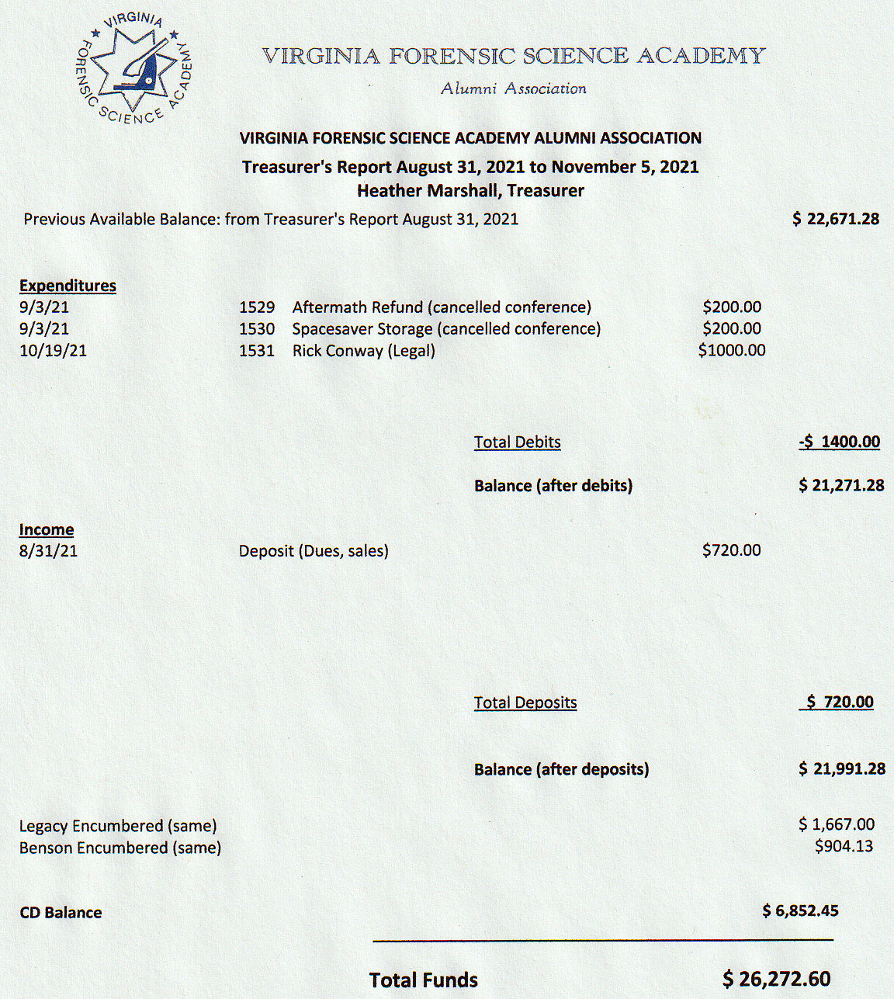

Audit Report:
President Hackett advised that the financial audit of the VFSAAA from August 2018 to November 2021 was completed by Eric Deel, Chairperson of the Audit Committee. All financial records were found to be in order and accurate.
A Motion and Second was made to accept the presented Audit Report. As there were no objections or dissenting votes, the motion passed.

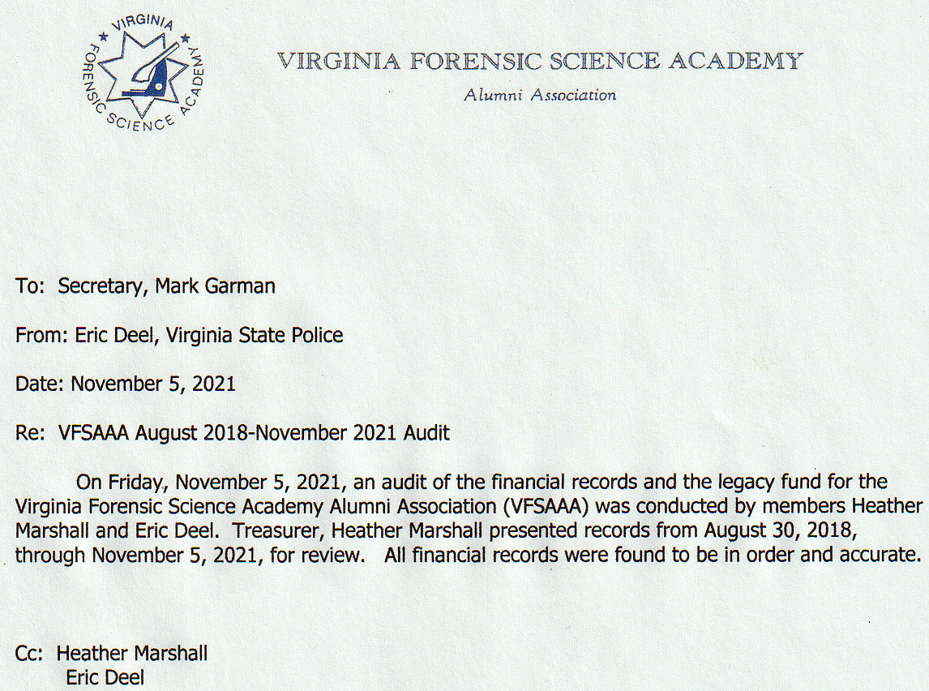

Old Business:

There was no old business.

New Business:

There was no new business.

Committees:

Membership and Ethics Committee:
Rick Conway, Committee Chairperson, brought up the member from Petersburg Bureau of Police who was under investigation by both the VSP and an internal investigation by the Petersburg Bureau of Police. There was a period of general discussion by the Board concerning the topic. Heather Marshall/VSP, Treasurer, said she was not aware of any ongoing investigation. Jeff Dwyer, DFS Consultant, said he thought the investigation was over. This was per member Angie Witt/VSP who investigated the issue. Trey Lucy, Central Director, said that the person in question has not been an active member for several years. This information was through Fhatima Shands, Admin Assistant/Honorary Member. Marc Hackett, President, asked if there was some way to mark the membership roster if the member tried to join the Alumni Association in the future. Fhatima said she would note that the member was not eligible for future membership.
Rick also advised that there are no other issues are under investigation.

Bylaws Committee:

Rick Conway, Committee Chairperson, advised that all motions were approved by the membership during the Annual Meeting, and he further believes that our Bylaws are up to date.
Secretary’s Note: Our new and current Bylaws as of 09/2021 are up to date and posted on our website, www.vfsaaa.org .

Sales:
Greg Locke, Committee Chairperson, deferred to Fhatima Shands who advised that sales were low. She also stated that as there was no Retraining, no new items were purchased.

Memorial Table:
Greg Locke, Committee Member, had no report.

Annual Retraining Relocation Exploration Committee:

Jeff Dwyer advised that he sent proposals to all Board members.

Wendy Bailey, SGT-at-Arms, reported that she contacted Founders Inn in Virginia Beach. Their initial proposal was for 200 students. When Wendy explained that the number of students could possibly be less, the projected costs went up substantially. Heather Marshall, Treasurer, had information that although the meeting rooms were nice the actual hotel rooms were mediocre at best. Wendy did not think the Founders Inn would be a viable choice.

Jeff Dwyer advised that the Committee met and discussed the possibility of having the VFSAAA hold the Annual Retraining Seminar without the involvement of the DFS. There would be several positive points and several negative. Additionally, there would need to be a Memo of Understanding between the DFS and the VFSAAA covering various topics such as preparation, supply, support, DFS employee involvement, etc.

Jeff continued with two proposals that he sent to the Board. The first was from the Delta Virginia Beach Bayfront Suites, www.deltavirginiabeachbayfront.com .The second was Holiday Inn Virginia Beach North Beach, www.vboceanfrontnorth.com . Jeff said that both locations were very nice, both had positive and negative points. There was a period of extended discussion by the Board covering various topics including who will sponsor Retraining, other possible locations, room costs, vendor costs, meeting room costs, the Social, the Hospitality Suite, and parking.

Jeff received no information on other possible locations from the membership.

A decision was made for the committee to seek answers to many of the questions raised and present the answers to the Board at a Special Board Meeting scheduled for 11-22-2021 at 10:00AM.

Benson Fund:
Brian O’Bier, of the Benson Fund Committee, was not present. There was no report.
Jeff Dwyer said a “private organization” would be donating to the fund. They would not say how much, he had no other details.

Social Committee Report:
Andrea Feldman, Northern Director, had no report.

Raffle Committee:
Sam Shumate, Western Director, had no report.

Vendor:

Trey Lucy, Central Director, had no report.

Novelty T/shirts:
Karyn Burhman, Eastern Director, had no report.

Hospitality Suite:
Karyn Burhman, Eastern Director, had no report.

Dan Grinnan Fall Classic Golf Outing:

Karyn Burhman, Eastern Director, had no report.

There will be a Special Board Meeting to discuss the location for the 2022 Annual Retraining Seminar. The meeting will be held on November 22nd, 2021, at 10:00 AM.

The next regular VFSAAA Board Meeting is scheduled for Friday April 1st, 2022. The time and manner are yet to be determined.

President Hackett asked if there was a motion to adjourn the meeting. A Motion and Second was made to adjourn the meeting. As there were no objections or dissenting votes, the motion passed.

The meeting adjourned at approximately 11:50 AM.

Mark Garman, Secretary

Approved by the Board of Directors

04/01/2022

____________________________________

