

To: VFSAAA

Date: March 29th, 2024

From: Mark Garman, Secretary

Re: VFSAAA Board of Directors Meeting Minutes
November 17th, 2023

Executive Board:
President Sam Shumate
1st Vice President Andrea Feldman
2nd Vice President Greg Locke SIGNED IN
Treasurer Heather Marshall
Secretary Mark Garman
Sergeant-at-Arms Wendy Bailey SIGNED IN
Immediate Past President Marc Hackett SIGNED IN
Legal Consultant Rick Conway SIGNED IN
DFS Consultant Jeff Dwyer ABSENT

Regional Directors:
Northern Director Zack King
Eastern Director Karyn Buhrman
Western Director Robby Richardson ABSENT
Central Director Charles “Trey” Lucy SIGNED IN

Committees:
R. Brian O’Bier Benson Committee ABSENT
Eric Deel Audit Committee ABSENT
Jim Gogan Nominating Committee ABSENT
Marilyn Durham Memorial Committee ABSENT

The meeting was called to order at approximately 11:47 AM by President Sam Shumate.
It was determined that there were enough Board members present, either in person or web-based, to establish the necessary quorum.

Secretary’s Note: Because many of the Board members were web-based some of the comments expressed by them could not be heard by the Secretary for inclusion in the Minutes.

Secretary’s Report:
The Meeting Minutes from the September 7th, 2023, Annual Membership Meeting were presented to the Board by Mark Garman, Secretary. This was done via email prior to the meeting.
There were no questions or comments on any of the minutes.
A Motion was made to approve the September 7th, 2023, Board Meeting Minutes. A Second was also made. The motion passed by unanimous oral vote. There were no abstentions, objections, or dissenting votes.

Treasurer’s Report:
Heather Marshall, Treasurer, presented the following Treasurer’s Report for November 2023.
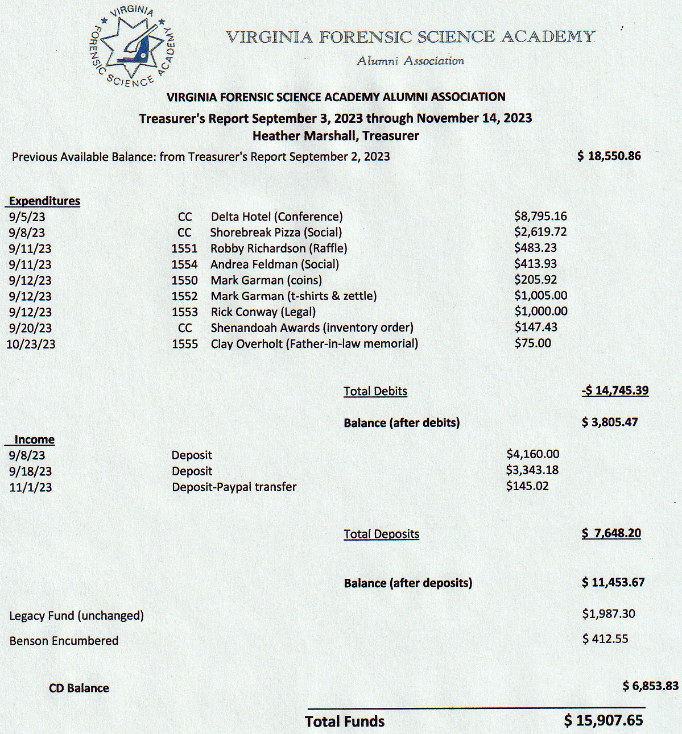
A Motion was made to approve the November 2023 Treasurer’s Report. A Second was also made. The motion passed by unanimous oral vote. There were no abstentions, objections, or dissenting votes.

Old Business:
President Shumate asked if there was any Old Business to be discussed. There was none.

New Business:
President Shumate asked if there was any New Business to be discussed.

Membership Cards and Dues:

Mark Garman,Secretary, advised the Board that membership cards have been sent to all members that he had a record of who requested one when paying their 2023-2024 dues. He said additional dues payments are still being received and he will send out cards when he receives additional requests. Mark said that he will send out an email to the membership, with Shantae Green’s assistance, in early December to all members reminding them to pay their dues.

Financial State of the VFSAAA:

Heather Marshall, Treasurer, brought to the Board’s attention the current financial state of the VFSAAA. She began by reminding the Board that we did not hold conferences in 2020 or 2021. The VFSAAA Retraining costs for the Delta were approximately $12,000.00 in 2022 and approximately $11,000.00 in 2023. Heather broke down the deposits and expenditures for the 2021-2022 and 2022-2023. For those two years the VFSAAA recorded a negative income of approximately $5,000.00 to $6,000.00 for each year. In her opinion she felt it was a combination of decreased Dues payments, decreased sales, and an increase of costs at the Delta.

There was an extended period of discussion by the Board centering around the costs for various projects to include using the Delta Hotel, the Social, and the Hospitality Suite. Money spent on the raffle and sales items were also discussed. Ideas to generate funds were discussed to include increasing vendor fees, making a profit on T/shirt sales, and increasing the member cost for the Social.

President Shumate gave some cost figures on staying at the Delta for 2024 that were supplied by Jeff Dwyer, DFS Consultant.

President Shumate formed a committee to research the topic. Committee members are, President Shumate, Heather Marshall, Treasurer, Mark Garman, Secretary, Andrea Feldman, 1ST Vice President, Marc Hackett, Immediate Past President, and Jeff Dwyer. The committee will investigate the matter and report back to the Board.

No other New Business was presented.

Committees:
Bylaws:

Rick Conway, Legal Consultant and Committee Chairperson, advised that there were no current Bylaws issues.

Membership Ethics:
Rick Conway, Legal Consultant and Committee Chairperson, advised the membership that there were no current investigations.

Sales:
Greg Locke, 2ND Vice President and Committee Chairperson, had no official report. Greg felt that the purchase of any future sales items should be put on hold until the financial concerns of the Association are resolved.
Shantae Green reported $483.00 in sales to the 110th Session graduating class.

Memorial Table:
Mark Garman, Committee Member, reported that all went well at Retraining and that the committee will continue to update information as necessary.
Information on the Memorial Table Committee can be found on our website, www.vfsaaa.org.

Website:
Mark Garman, Secretary, reported that our website, www.vfsaaa.org , is currently up to date with all new information since Retraining. He will continue to monitor and update the site as necessary.

PayPal:
Mark Garman, Secretary, reported that PayPal went well during Retraining. He also advised the Board that because of the new card system that PayPal uses, called Zettle, it is now more difficult to keep track of members by name who use the system to make payments. Once an “Activity Report” is requested from PayPal/Zettle the members name is deleted. He said he will check with PayPal to see if there is a way to work around this situation.

Retraining 2024 Exploration Committee:
Jeff Dwyer, DFS Consultant, was not present and there was no report.
President Shumate said that the committee would remain in effect pending the possible need to locate a new venue for Retraining in 2024.
The committee members are Jeff Dwyer, DFS Consultant, Trey Lucy, Central Director, Wendy Bailey, SGT-at-Arms, and Karyn Buhrman, Eastern Director.

Retraining 2023:
Jeff Dwyer, DFS Consultant, was not present and there was no report.

The Dr. Paul Ferrara Award:
Wendy Bailey, SGT-at-Arms and Committee Chairperson, had no report.
Information on the Dr. Paul Ferrara Award can be found on our website, www.vfsaaa.org on the Dr. Paul Ferrara Award page.

Nomination:
Mark Garman, Secretary, said he would check with Jim Gogan, Committee Chairperson, and see if he was still interested in running the committee.

Novelty T/shirt:

Karyn Buhrman, Eastern Director and Committee Chairperson, said that sales went well during Retraining and all shirts were sold.

Social:
Andrea Feldman, Northen Director and Committee Chairperson, had no report other then what was mentioned during the discussions on the financial state of the VFSAAA. For 2024 Retraining Andrea will be handing the Social Committee over to the new Northern Director, Zack King.

Benson Fund:
Brian O’Bier, Committee Chairperson, was not present and there was no report.
Secretary’s Note: The below report was forwarded to Secretary Garman after the meeting.
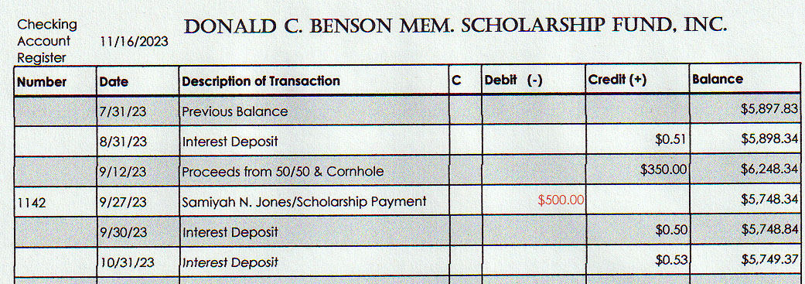

Vendor:

Trey Lucy, Central Director and Committee Chairperson, had no report other than what was mentioned during the discussions on the financial state of the VFSAAA.

Information on the vendors who were at Retraining in 2023 is posted on our website, www.vfsaaa.org .Those vendors are, Evident Crime Scene Products, File On Q, Precision Survey Supply/Leica, and Spacesaver Storage Solutions.

Hospitality Suite:
Karyn Burhman, Eastern Director and Committee Chairperson, had no official report.

Dan Grinnan Fall Classic Golf Outing:

Karyn Buhrman, Eastern Director and Committee Chairperson, had no official report.

President Shumate asked if there was a motion to adjourn the meeting. A Motion and Second were made to adjourn the meeting. As there were no objections, abstentions, or dissenting votes, the motion passed.

The meeting adjourned at approximately 12:45 AM.

The next meeting of the VFSAAA is a Board Meeting scheduled for Friday March 29th, 2024, after the graduation of the 111th Session of the VFSA.

Mark Garman, Secretary

______________________________________________________________

Minutes Approved on March 29th, 2024, by the Board of Directors at the March 29, 2024, Board Meeting.

