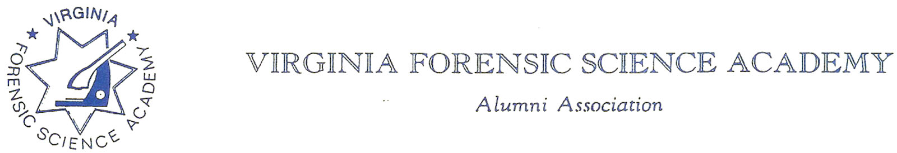

To: VFSAAA

Date: June 28th, 2024

From: Mark Garman, Secretary

Re: VFSAAA Board of Directors Meeting Minutes
March 29th, 2024

Executive Board:
President Sam Shumate SIGNED IN ON-LINE
1st Vice President Andrea Feldman SIGNED IN ON-LINE
2nd Vice President Greg Locke ABSENT
Treasurer Heather Marshall ABSENT
Secretary Mark Garman
Sergeant-at-Arms Wendy Bailey
Immediate Past President Marc Hackett SIGNED IN ON-LINE
Legal Consultant Rick Conway
DFS Consultant Jeff Dwyer

Regional Directors:
Northern Director Zack King
Eastern Director Karyn Buhrman
Western Director Robby Richardson SIGNED IN ON-LINE
Central Director Charles “Trey” Lucy

Committees:
R. Brian O’Bier Benson Committee ABSENT
Eric Deel Audit Committee ABSENT
Position open Nominating Committee
Marilyn Durham Memorial Committee ABSENT

Others Present:
Shantae Green DFS Admin Assistant
Jason Austin VFSA Instructor
Michael East Member

The meeting was called to order at approximately 11:56 AM by President Sam Shumate.
It was determined that there were enough Board members present, either in person or signed in on-line, to establish the necessary quorum.

Secretary’s Note: Because many of the Board members were signed in on-line some of their comments could not be heard for inclusion in the Minutes. Such occurrences are noted in the minutes.

Treasurer’s Report:
Heather Marshall, Treasurer, was not present. The following Treasurer’s Report for March 2024 was emailed to the Board prior to the meeting.

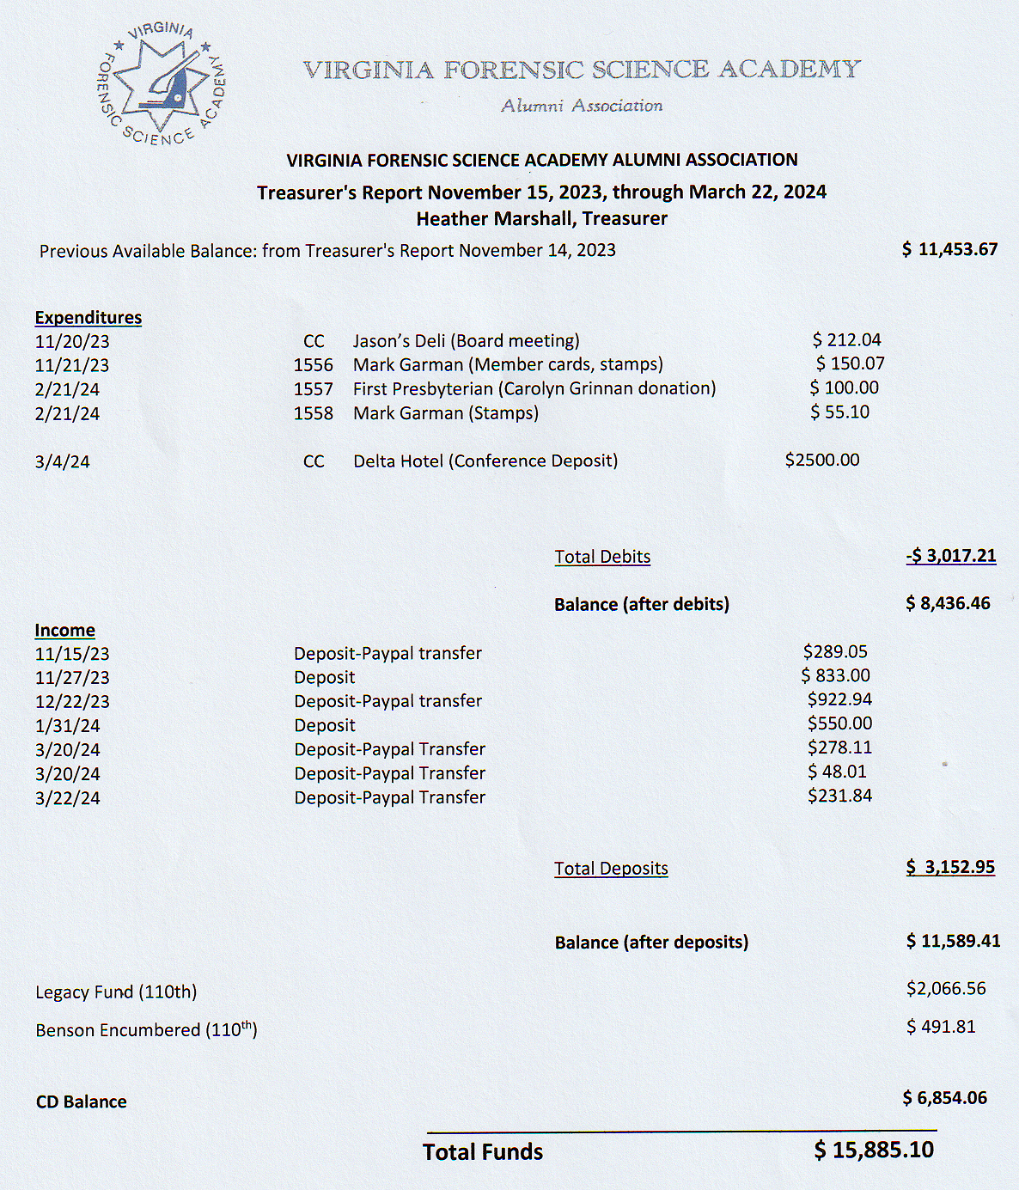

Mark Garman, Secretary, made note that the Total Funds for the March 2024 Treasurer’s Report was approximately $2,100.00 less than the March 2023 report.
A Motion was made to approve the March 2024 Treasurer’s Report. A Second was also made. The motion passed by unanimous oral vote. There were no abstentions, objections, or dissenting votes.

Secretary’s Report:
The Meeting Minutes from the November 17th, 2023, Board Meeting were presented to the Board by Mark Garman, Secretary. This was done via email prior to the meeting.
Secretary Garman noted one error that needed to be corrected. There were no other questions or comments on any of the minutes.
A Motion was made to approve the amended November 17th, 2023, Board Meeting Minutes. A Second was also made. The motion passed by unanimous oral vote. There were no abstentions, objections, or dissenting votes.

Old Business:
President Shumate asked if there was any Old Business to be discussed. There was none.

New Business:
President Shumate asked if there was any New Business to be discussed.

Rick Conway, Chairperson of the Membership Ethics Committee, brought up an issue concerning a member. The issue will be covered in the Membership Ethics section of the Minutes.

President Shumate commented on the vacancy of the Nominating Committee Chairperson. The Board briefly discussed filling the position and how the Nominating Committee was run. Karyn Buhrman, Eastern Director, suggested member Allison Fox of NCIS. During the meeting Karyn contacted Allison and she said she would fill the chair.
Wendy Bailey, SGT-at-Arms, advised the Board that she would not be continuing as the SGT-at-Arms for the 2024-2025 year. She suggested Marilyn Durham, current Memorial Committee chairperson, as a replacement. Marilyn was contacted via phone during the meeting, and she expressed interest in becoming the new SGT-at-Arms.
Trey Lucy, Central Director, advised the Board that he would not be continuing as Central Director for the 2024-2025 year. He introduced member Michael East, who was in attendance, as a possible replacement. Michael expressed interest in becoming the new Central Director.
No other New Business was presented.

Committees:

Membership Ethics:
Rick Conway, Legal Consultant and Committee Chairperson, advised the Board of the following.
Rick received information concerning Justin Dale Sigmon, a graduate of the VFSA from the 81st Session and a former Major with the Franklin County Sheriff’s Office, from Jeff Dwyer, DFS Consultant. Full information can be obtained at https://www.justice.gov/usao-sdfl/pr/former-major-franklin-county-sheriffs-office-convicted-abusive-sexual-contact-minor .
Some information from the listed site includes the following.
MIAMI – On Nov. 17, a federal jury convicted the former Major of the Franklin County Sheriff’s Office in Virginia of abusive sexual contact with a minor under 12 years old. The conviction comes after a five-day jury trial before U.S. Senior District Judge Donald L. Graham in Miami. In May 2023, Justin Dale Sigmon, 47, while on a cruise that departed from the Port of Miami, repeatedly put his hands up the skirt of a nine-year-old, rubbing her inner thighs and private area, despite her repeatedly pushing his hands away on multiple occasions. Two good Samaritans, who were seated next to Sigmon in the cruise ship dining room, noticed his behavior, recorded it, and reported it to cruise ship security. The cruise ship’s surveillance cameras also captured Sigmon’s actions. When cruise security officials confronted him about his conduct, Sigmon identified himself as a law enforcement officer. Sentencing is set for Jan. 12, 2024, at 1:30 p.m. in Miami. Sigmon faces up to life in prison. U.S. Attorney Markenzy Lapointe for the Southern District of Florida and Special Agent in Charge Jeffrey B. Veltri of the FBI, Miami Filed Office, announced the guilty verdict. FBI Miami investigated the case with assistance from the U.S. Customs and Border Protection (CBP) and Carnival Cruise Line security. Assistant U.S. Attorneys Jessica Kahn Obenauf and Lacee Elizabeth Monk prosecuted it.
It should be noted that as of March 13th, 2024, Sigmon has requested a new trial.
There was a period of discussion by the Board on the issue.
A Motion was made by Trey Lucy, Central Director, to proceed with the investigation concerning Sigmon and his actions. A Second was made by Karyn Buhrman, Eastern Director. The motion passed by unanimous oral vote. There were no abstentions, objections, or dissenting votes.
It was decided that this investigation will proceed under Article II Section 13 Disciplinary Action of our Bylaws. Bylaws can be found at www.vfsaaa.org .The Board will keep the membership apprised of the investigation by the Membership Ethics Committee and the actions of the Board of Directors.

Bylaws:

Rick Conway, Legal Consultant and Committee Chairperson, advised that there were no current Bylaws issues.

Mark Garman, Committee member, stated that the Bylaws may need to be updated based on the Membership Ethics item discussed previously in the meeting. Mark said that there were some discrepancies in Article II Section 13 Disciplinary Action on how a member is notified of a disciplinary investigation. Mark also said that he will present more information to the Board during the June Meeting.

Sales:
Greg Locke, 2ND Vice President and Committee Chairperson, was not present and there was no official report. Mark Garman, Secretary, said he would contact Greg to see if an inventory of popular sales items needed to be made before Retraining.
Shantae Green reported approximately $500.00 in sales to the 111th Session.

Memorial Table:
Mark Garman, Committee Member, reported that there are several members who have passed since Retraining and that the Committee will keep information up to date and will be ready for the 2024 Retraining Seminar.
Information on the Memorial Table Committee can be found on our website, www.vfsaaa.org.

Website:
Mark Garman, Secretary, reported that our website, www.vfsaaa.org , is currently up to date. He said that he has started to post information for the 2024 Retraining Seminar to include Dues, Dr. Paul Ferrara Award, Benson Scholarship, and the Novelty T/Shirt. He will continue to monitor and update the site as necessary.

PayPal:
Mark Garman, Secretary, reported that PayPal is up to date. The new Dues form is on our website, www.vfsaaa.org, and has been tested.
He will continue to monitor and update PayPal as necessary.

Retraining 2024 Exploration Committee:
Jeff Dwyer, DFS Consultant, advised that Holiday Inn North Beach contacted him after the contract was signed with Delta. Jeff said that there were issues with the Holiday Inn. The Founder’s Inn was checked, the comment from the committee members was that it was “outrageous”.
Jeff also explained some of the issues with the Delta to included fees charged for the conference rooms and the cost of food for the Social. He did say that some things remained the same such as parking and room rates.
The committee members are Jeff Dwyer, DFS Consultant, Trey Lucy, Central Director, Wendy Bailey, SGT-at-Arms, and Karyn Buhrman, Eastern Director.

Retraining 2023:
Jeff Dwyer, DFS Consultant, said Retaining is scheduled and the contract for the Delta has been signed. Retraining is scheduled for September 3rd through the 6th.

The Dr. Paul Ferrara Award:
Wendy Bailey, SGT-at-Arms and Committee Chairperson, said that we have only one submission so far. The Board elected to hold off on any decisions until the summer Board Meeting.
Information on the Dr. Paul Ferrara Award can be found on our website, www.vfsaaa.org on the Dr. Paul Ferrara Award page.

Nomination:
Allison Fox, NCIS, is now the new Chairperson for the Nominating Committee.

Social:
Zack King, Northen Director and Committee Chairperson, said that he is in the process of working with the Delta, is looking for suggestions, and will have a more complete report at the summer Board meeting.

Raffle Committee:

Robby Richardson, Western Director and Committee Chairperson, requested money for purchasing raffle prizes. Robby said that he normally receives $500.00 from the Board and makes about $200.00 profit from ticket sales.

A Motion was made to authorize $500.00 to the Raffle Committee. A Second was also made. The motion passed by unanimous oral vote. There were no abstentions, objections, or dissenting votes.

Benson Fund:
Brian O’Bier, Committee Chairperson, was not present. The below report was submitted prior to the meeting.
.
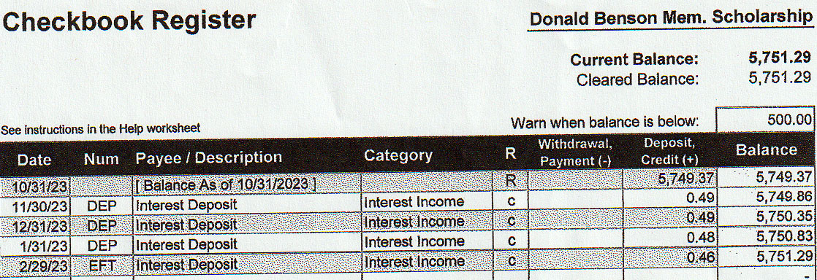

Dan Grinnan Fall Classic Golf Outing:

Karyn Buhrman, Eastern Director and Committee Chairperson, said she is working on having the outing at the Honey Bee Golf Club. More information will be available at the summer Board meeting.



Hospitality Night:
Karyn Burhman, Eastern Director and Committee Chairperson, said the event would run something like it did at the 2023 Retraining Seminar.

Novelty T/shirt:

Karyn Buhrman, Eastern Director and Committee Chairperson, reported that there was one submission. The design was sent to the Board by Mark Garman, Secretary. It was an update of an unselected design suggested by Lloyd Rigsby, former VFSA instructor, last year. Karyn suggested that a shirt celebrating the 50th Anniversary of the VFSA be developed. The topic will be revisited at the summer Board meeting.

Vendor:

Trey Lucy, Central Director and Committee Chairperson, said that initial contacts have been made to “normal” vendors that show up. Evident has already committed to helping at Retraining.

Information on the vendors who were at Retraining in 2023 is posted on our website, www.vfsaaa.org .Those vendors are, Evident Crime Scene Products, File On Q, Precision Survey Supply/Leica, and Spacesaver Storage Solutions.

President Shumate asked if there was a motion to adjourn the meeting. A Motion and Second were made to adjourn the meeting. As there were no objections, abstentions, or dissenting votes, the motion passed.

The meeting adjourned at approximately 1:12 PM.

The next meeting of the VFSAAA is a Board Meeting scheduled for Friday June, 28th, 2024, after the graduation of the 112th Session of the VFSA.

Mark Garman, Secretary

______________________________________________________________

Minutes Approved by the Board of Directors at the June 28th, 2024, Board Meeting.

