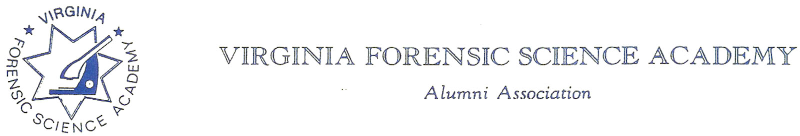
VFSAAA Board Meeting Minutes

To: VFSAAA

Date: June 24, 2022

From: Mark Garman, Secretary

Re: VFSAAA Board Meeting
April 1st, 2022

Executive Board:
President Marc Hackett
1st Vice President Sam Shumate
2nd Vice President Greg Locke Web-Based Attendance
Treasurer Heather Marshall
Secretary Mark Garman
Sergeant-at-Arms Wendy Bailey Web-Based Attendance
Immediate Past President Clay Overholt (double filling as Western Director)
Legal Consultant Rick Conway
DFS Consultant Jeff Dwyer

Regional Directors:
Northern Director Andrea Feldman Web-Based Attendance
Eastern Director Karyn Buhrman
Western Director Clay Overholt (double filling as Immediate Past President)
Central Director Charles “Trey” Lucy Absent

Committees:
R. Brian O’Bier Benson Committee Absent
Eric Deel Audit Committee Absent
Jim Gogan Nominating Committee Absent

Others:
Fhatima Shands Admin Assistant/Honorary Member
Steve Stockman Instructor

The meeting was called to order at approximately 11:55 AM by President Marc Hackett.
It was determined that there were enough Board members present or signed into the meeting to establish the necessary quorum.

Secretary’s Report:
The Meeting Minutes from the November 2021 Board Meeting and the November 2021 Special Board Meeting were presented to the Board by Mark Garman, Secretary, prior to the meeting via email.
There were no questions or comments on the minutes.
A Motion, along with a Second, was made to accept the meeting minutes. There were no objections. The motion passed by unanimous oral vote. There were no dissenting votes.

Treasurer’s Report:
Heather Marshall, Treasurer, presented the following Treasurer’s Report for April 2022.
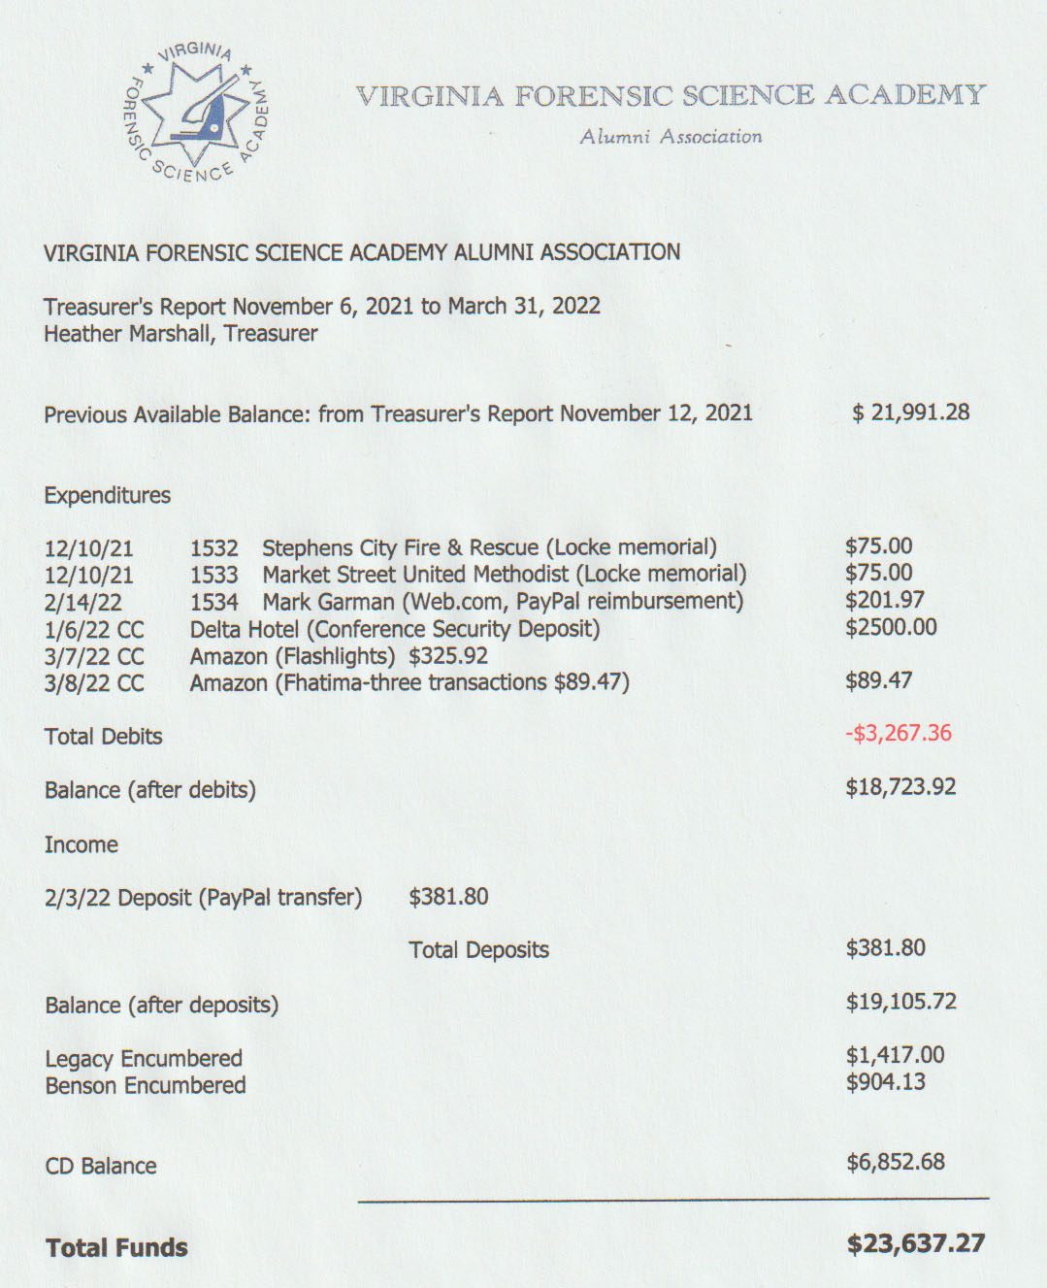
President Hackett asked for a motion to accept the April 2022 Treasurer’s Report. A Motion and Second was made to accept the report. As there were no objections or dissenting votes, the motion passed.

Old Business:
Letter to the Membership:
Marc Hackett, President, asked the Board for input concerning the letter he had previously sent to the Board. The letter addressed the selection process for picking the new Retraining location and dates. There were some minor adjustments to the original letter. Marc advised that the adjusted letter would be sent to the membership shortly after the meeting.

New Business:
State Corporation Commission:
Rick Conway, Legal Consultant, advised the Board that he was having some difficulty in filing our yearly paperwork with the Virginia State Corporation Commission. The mail with the proper paperwork apparently was not forwarded to Rick by his previous employer. Rick contacted the SCC who advised that our 501(C)10 status is currently listed as expired as of 12/2021. Rick said that he is working on the issue and the problem should be solved before the next Board meeting.

Committees:

Bylaws Committee:

Mark Garman, Secretary and Committee Member, advised that the current Bylaws are posted on our website, www.vfsaaa.org. There are no new changes or updates for the members to vote on at the 2022 Annual Meeting.

Membership and Ethics Committee:
Rick Conway, Committee Chairperson, advised that there were no issues under investigation.

Sales:
Greg Locke, Committee Chairperson, deferred to Fhatima Shands who advised that sales were low. There was a period of discussion on how to incorporate sales items into the new website. Mark Garman said he would work on the issue. Heather Marshall said that there was still a bill outstanding for the VFSA Padfolios. Fhatima said she would check with the manufacturer.

Memorial Table:
Mark Garman, Committee Member, said that there is a lot of information that needs to be updated, but the Table should be ready for Retaining.

Website:
Mark Garman, Secretary/Webmaster, advised that our new website, www.vfsaaa.org, is up and running. He advised that the site is easier to work with. It is an ongoing evolving project. He said that he is trying to add a new email address. All new information concerning Retraining 2022 will be posted on the site when available. Steve Stockman asked if a new Dues payment option could be put on the site for the Spring session members. The Spring session only pays $20.00 for their first dues payment not the full $40.00. Mark said that he would add the option.

PayPal:
Mark Garman, Secretary, reported that PayPal would be up and running for Retraining.

Annual Retraining Relocation Exploration Committee:

Marc Hackett advised that he would like the committee to stay active as we only have a one year contract with the Delta. He would like the Committee to monitor the members’ comments on the new location.

Annual Retraining 2022:
Jeff Dwyer said that as soon as President Hackett’s letter to the members (explaining the Board’s choice on the new Retraining location) is sent out, he would follow up with the official DFS announcement, hotel information, and other necessary topics.

Benson Fund:
Brian O’Bier, of the Benson Fund Committee, was not present. There was no report.

Social Committee Report:
Andrea Feldman, Northern Director, reported that she still has not received the Northern Director’s bag from the former Northern Director. Both Steve Stockman and Marc Hackett said they would try to locate the bag. It was also noted that the 1st Vice President’s bag has not been recovered from the former 1st Vice President. Heather Marshall said she would try to locate the bag.
Andrea said she needs the name of the person, and number, to contact at the Delta to start planning for the Social. She also asked how much money she was authorized to spend. She also asked if we were going with a Casino Night this year. Jeff Dwyer indicted that a Casio Night would not be a good idea this year because of the out-of-pocket expenses incurred by the VFSAAA with the new location. He also said that he would forward the necessary contact information to Andrea. Marc Hackett indicated that our target range is $30.00 per person. Kegs will not be available. Wendy Bailey asked if the Board has considered raising the price to $20.00 from $15.00. It was decided to make that decision at the Summer meeting.

Raffle Committee:
Clay Overholt, new Western Director, said he had no report as he is new to the position. Mark Garman indicated that the VFSAAA quilt would be available this year. He said he will post the information concerning the quilt on the website. He also suggested a separate raffle for it from the general raffle. Details will be finalized during the Summer meeting.

Vendor:

Trey Lucy, Central Director, did not attend the meeting and therefore there was no report. Fhatima said they are waiting on the updated vendor fees from the hotel so information could be sent to the vendors.

Novelty T/shirts:
Karyn Buhrman, Eastern Director, asked the Board if we were still going with the shirt from 2021. The Board indicated yes and suggested some type a light gray color. Mark Garman said that he would post the information on the website when it came available.

Hospitality Suite:
Karyn Buhrman, Eastern Director, reported that the committee discussed the possibility of moving the Hospitality Suite off site. The Hospitality Suite would be on just Tuesday night. Wednesday night would be left to the Benson Fund and the Corn Hole Tournament. Thursday night would be the Social. They also said the committee thought “drink tickets” supplied by the Board would be a good idea. Full details from the committee will be available at the Summer meeting.

Dan Grinnan Fall Classic Golf Outing:

Karyn Buhrman, Eastern Director, said the outing is in the planning stages.

The Dr. Paul Ferrara Award:
Wendy Bailey, SGT-at-Arms, said that the annual notice announcing the Dr. Paul Award needed to be sent out. The announcement needs to be corrected with the new dates and contact information. Mark Garman said he would make the corrections indicating the new Board members and post the announcement on our website.

Nomination Committee:
Marc Hackett inquired if Jim Gogan was still running the Nominating Committee. Mark Garman said he would contact Jim to see if he was still interested.
There was a period of discussion by the Board concerning the nomination and election of Regional Directors to the Board of Directors. The Regional Directors are elected at the meetings following their respective Spring Lab Update Classes. Jeff Dwyer advised the Board that there would no longer be “in person” classes where the Spring meetings could be held. There would be only one virtual meeting for all four regions. Mark Garman said he would review the Bylaws and see if changes needed to be made. He would have a report at the Summer board meeting.

The next regular VFSAAA Board Meeting is scheduled for Friday June 24th, 2022, after the graduation of the 106th Session of the VFSA.

President Hackett asked if there was a motion to adjourn the meeting. A Motion and Second was made to adjourn the meeting. As there were no objections or dissenting votes, the motion passed.

The meeting adjourned at approximately 12:50 AM.

Mark Garman, Secretary

Approved by the Board of Directors

06/24/2022

____________________________________

