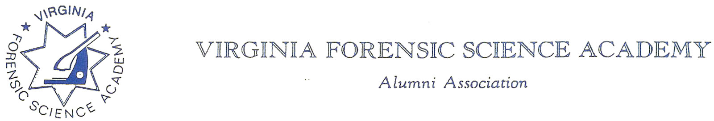
VFSAAA Board Meeting Minutes

To: VFSAAA

Date: June 23rd, 2023

From: Mark Garman, Secretary

Re: VFSAAA Board Meeting
March 31st, 2023

Executive Board:
President Marc Hackett
1st Vice President Sam Shumate
2nd Vice President Greg Locke Web-Based Attendance
Treasurer Heather Marshall Absent
Secretary Mark Garman
Sergeant-at-Arms Wendy Bailey Web-Based Attendance
Immediate Past President Clay Overholt
Legal Consultant Rick Conway
DFS Consultant Jeff Dwyer

Regional Directors:
Northern Director Andrea Feldman
Eastern Director Karyn Buhrman
Western Director Robby Richardson
Central Director Charles “Trey” Lucy

Committees:
Benson Committee R. Brian O’Bier Absent
Audit Committee Eric Deel Absent
Nominating Committee Jim Gogan Absent
Memorial Committee Marilyn Durham

Others:
Admin Assistant Shantae Green
Instructor Wayne Rigsby
Instructor Jason Austin

The meeting was called to order at approximately 12:04 PM by President Marc Hackett.
It was determined that there were enough Board members physically present or signed into the meeting via phone/internet to establish the necessary quorum.

Secretary’s Report:
The Meeting Minutes from the November 18th, 2022, Board Meeting were presented to the Board by Mark Garman, Secretary, prior to the meeting via email.
There were no questions or comments on the minutes.
A Motion was made by Clay Overholt, Immediate Past President, along with a Second by Karyn Buhrman, Eastern Director, to accept the Meeting Minutes. There were no objections. The motion passed by unanimous oral vote. There were no dissenting votes.

Treasurer’s Report:
Heather Marshall, Treasurer, was not present. The March 2023 Treasurer’s Report was presented to the Board via email prior to the meeting. The report was read by President Hackett.
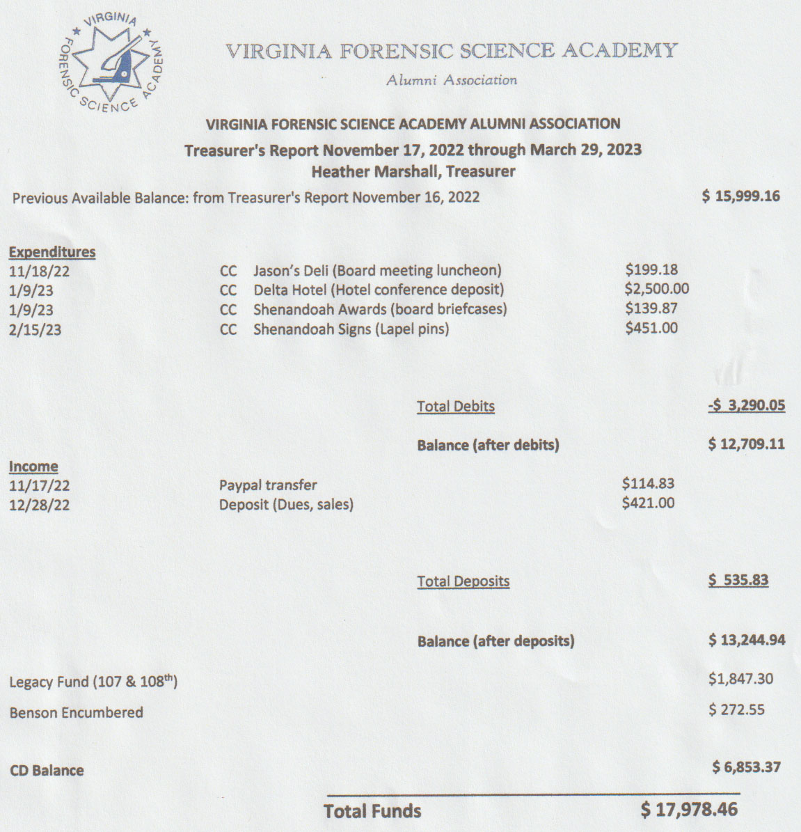
There were no questions or comments on the Treasurer’s Report.
A Motion was made by Sam Shumate, 1st Vice President, along with a Second by Andrea Feldman, Northern Director, to accept the Treasurer’s Report. There were no objections. The motion passed by unanimous oral vote. There were no dissenting votes.

Old Business:
Lifetime Achievement Award
There was a period of discussion by the Board concerning what the qualifications should be for the Award, who would be eligible, and how often the Award would be given. Jeff Dwyer, DFS Consultant, said he would write a proposal for the Board to review at our next Board Meeting (June 2023).
The matter was tabled by President Hackett until the June 2023 Board Meeting.

Ceramic Coffee Mugs
Mark Garman, Secretary, advised that because of manufacturing time constraints it was not possible to have the mugs made by the 2023 Retraining Seminar dates. He suggested that the matter be revisited in the Fall of 2023 in enough time to consider the project again for delivery during the 2024 Retraining Seminar.

Virginia State Corporation Commission
Rick Conway, Legal Consultant, reported that all paperwork with the Commonwealth of Virginia State Corporation Commission is now up to date. Rick turned over a Certificate of Good Standing from the Commission to Secretary Garman to be filed.

Standing Rules
Mark Garman, Secretary, went over the changes to the Standing Rules that were put into effect by motions at the November 2022 Board Meeting. He confirmed to the Board that the rules would show November 2022 as the enactment date.
Mark then suggested an addition to Rule #6, shown below in blue.
- Authorizes the spending of up to $75.00 for flowers in reference to the death or hospitalization of a member or an immediate family member of any member of the Board of Directors. Enacted April 2000.
- Rule amended June 2017 to authorize in lieu of flowers a donation of up the $75 to the charity of the family’s choice.
Mark suggested that section b. (shown below) should be added to the rule.
b. Rule amended March 2023 to indicate that it is the responsibility of the First Vice President to ensure that a donation is made, or flowers are sent.
A Motion was made by Sam Shumate, 1st Vice President, along with a Second by Clay Overholt, Immediate Past President, to enact the changes suggested to the VFSAAA Standing Rules #6, adding “b” as shown above. There were no objections. The motion passed by unanimous oral vote. There were no dissenting votes.

Board Member Briefcase Bags
President Hackett asked if the ordered Board Member Briefcase Bags were received. Mark Garman and Jeff Dwyer confirmed that they were received at the DFS/VFSA. Jeff said he would deliver the bags to the proper recipients.

New Business:
There was no new business.

Committees:

Bylaws Committee:

Rick Conway, Legal Consultant Committee Chairperson, advised that there were no new updates or changes pending.

Membership and Ethics Committee:
Rick Conway, Legal Consultant Committee Chairperson, advised that there were no issues under investigation and that he had nothing to report.

Sales:
Greg Locke, 2nd Vice President and Committee Chairperson, said there was nothing to report. He asked if the ordered lapel pins were received. Jeff Dwyer confirmed that they were received. Jeff also advised that approximately $655.00 in sales were made to the class that just graduated. Jeff reminded Greg that an inventory of sales items needed to be done. Greg acknowledged the need for an inventory. Mark Garman said he would assist if needed.

Memorial Table:
Marilyn, Committee Chairperson, reported that currently there was only one deceased member since Retraining 2022. She said the committee would continue to update the table for Retraining 2023. It was mentioned that new and updated photographs are needed for the members who have already passed. Mark Garman said requests are made at Retraining, he would do it again this year, and post a notice on the Memorial Page on our website.

Website:
Mark Garman, Secretary/Webmaster, advised that our website, www.vfsaaa.org, will be updated over the next month with the forms necessary for Retraining 2023 and the 2023-2024 year. By quizzing the various committee chairpersons, the necessary forms for the 2023 Retraining Seminar and the 2023-2024 were updated.
Mark said that he is still working on “password protecting” our website.

PayPal:
Mark Garman, Secretary, reported that PayPal has dropped their PayPal Pay Here method for payments. They have transitioned to a system called Zettle. It is very similar to PayPal Pay Here. As a result, a new card reader costing approximately $35.00 will be needed. President Hackett gave the authorization to purchase the reader. Mark said that he would take care of the purchase. Mark also advised that the new dues form should be posted on the PayPal page of our website within the next couple of weeks.

Annual Retraining Relocation Exploration Committee:
Jeff Dwyer, DFS Consultant, had no report as Retraining is already set for the Delta Hotel in 2023.

Annual Retraining 2022:
Jeff Dwyer, DFS Consultant, said that a contract has been signed with the Delta Hotel. He also said that the announcement for Retraining including the necessary information and forms would be sent out soon.

Benson Fund:
Brian O’Bier, of the Benson Fund Committee, was not present and there was no report.
Previously in the meeting Mark Garman asked if the exemption of Benson’s tax status because of the failure to file IRS Form 990-EZ has been resolved. President Hackett said he had no information but would contact Brian for a report. Rick Conway said he would assist the Benson Committee in resolving the matter if needed.

The Dr. Paul Ferrara Award:
Wendy Bailey, SGT-at-Arms, said she has received no nominations but that most come in the summer months anyway.

Social Committee Report:
Andrea Feldman, Northern Director and Committee Chairperson, said she would be reaching out to the Delta soon to get things moving for the Social.
A Motion was made by Mark Garman along with a Second by Jeff Dwyer to authorize the spending of up to $500.00 for door prizes for the Social. There were no objections. The motion passed by unanimous oral vote. There were no dissenting votes.

Raffle Committee:
Robby Richardson, Western Director and Committee Chairperson, had no report.
A Motion was made by Mark Garman along with a Second by Jeff Dwyer to authorize the spending of up to $500.00 for raffle prizes. There were no objections. The motion passed by unanimous oral vote. There were no dissenting votes.

Vendor:

Trey Lucy, Central Director and Committee Chairperson, reported that he has had 4, possible 5 commitments for attendance with one already paying. He also advised that a vendor, File On Q, expressed interest in helping with either the Hospitality event or the Social.

Hospitality Suite:
Karyn Buhrman, Eastern Director and Committee Chairperson, said that the Hospitality Suite, renamed the VFSAAA Networking Event, would be run at the same location, Shorebreak Pizza & Taphouse, and in the same manner. Efforts would be made to have the Benson Committee’s Cornhole Tournament at Shorebreak.

Novelty T/shirts:
Karyn Buhrman, Eastern Director and Committee Chairperson, said that she would work on the project with Mark Garman. A flyer would be going out soon.

Dan Grinnan Fall Classic Golf Outing:

Karyn Buhrman, Eastern Director and Committee Chairperson, said she is working on the project.

Nomination Committee:
Mark Garman, Secretary, said that he would check with Jim Gogan, previous Chairperson, and see if he is still interested in running the committee.
Mark took an initial tally of the interests of Board members for the 2023-2024 year. He said he would forward that information to Jim.

Miscellaneous:

There was an extended period of discussion by the Board on helping two Board members, Trey Lucy and Robby Richardson, who are running for Sheriff in their particular jurisdiction. There were concerns about the possible tax ramifications for the VFSAAA. Rick Conway said he would investigate the matter and report to the Board during the June 2023 Board Meeting.

The next regular VFSAAA Board Meeting is scheduled for Friday, June 23rd, 2023, after the graduation of the 109th session of the VFSA.

President Hackett asked if there was a motion to adjourn the meeting. A Motion, along with a Second, was made to adjourn the meeting. As there were no objections or dissenting votes, the motion passed.

The meeting adjourned at approximately 1:15 PM.

Mark Garman, Secretary

Approved by the Board of Directors

June 23rd, 2023

____________________________________

