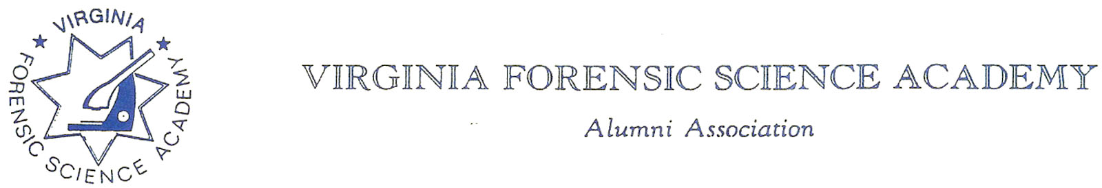
VFSAAA Board Meeting Minutes

To: VFSAAA

Date: September 8th, 2022

From: Mark Garman, Secretary

Re: VFSAAA Board Meeting
June 24th, 2022

Executive Board:
President Marc Hackett Web-Based Attendance
1st Vice President Sam Shumate
2nd Vice President Greg Locke Web-Based Attendance
Treasurer Heather Marshall Absent
Secretary Mark Garman
Sergeant-at-Arms Wendy Bailey Web-Based Attendance
Immediate Past President Clay Overholt Absent
Legal Consultant Rick Conway
DFS Consultant Jeff Dwyer

Regional Directors:
Northern Director Andrea Feldman Web-Based Attendance
Eastern Director Karyn Buhrman
Western Director Clay Overholt Absent-Position Vacant, Temporarily filled by the Immediate Past President
Central Director Charles “Trey” Lucy

Committees:
R. Brian O’Bier Benson Committee
Eric Deel Audit Committee Absent
Jim Gogan Nominating Committee Absent

Others:
Fhatima Shands AA/Honorary Member
Steve Stockman Instructor Absent

The meeting was called to order at approximately 12:10 AM by President Marc Hackett.
It was determined that there were enough Board members present or signed into the meeting to establish the necessary quorum.
Secretary’s Report:
The Meeting Minutes from the April 1st ,2022 Board Meeting were presented to the Board by Mark Garman, Secretary, prior to the meeting via email.
There were no questions or comments on the minutes.
A Motion, along with a Second, was made to accept the Meeting Minutes. There were no objections. The motion passed by unanimous oral vote. There were no dissenting votes.

Treasurer’s Report:
Heather Marshall, Treasurer, was not present. However, she submitted the following Treasurer’s Report for June 2022 via email to President Hackett.
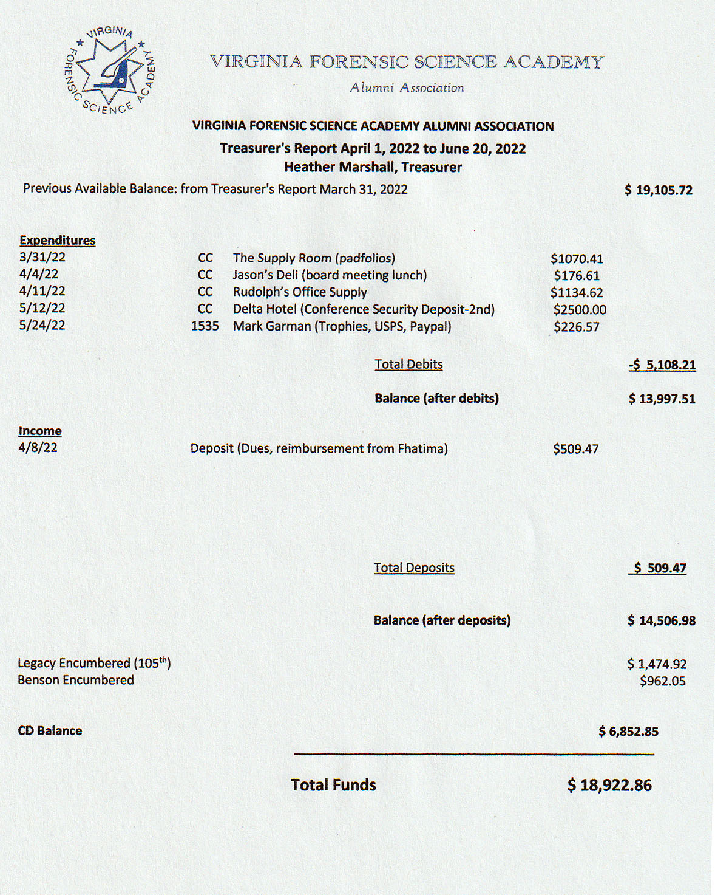
Fhatima Shands advised the Board that there should be a credit for the Supply Room charge listed on the Treasurer’s Report. The charge is listed as,
3/31/22 | CC | The Supply Room (padfolios) | $1070.41
Fhatima said there was an error in the order concerning taxes and a refund should have been issued. She is not sure if it was. Treasurer Heather Marshall was not available to comment. President Hackett said he would contact Heather to make sure the matter was handled. Mark Garman, Secretary, advised the Board that the Dues Payments submissions via PayPal for the 2022-2023 year were picking up.
President Hackett asked for a motion to accept the June 2022 Treasurer’s Report. A Motion, along with a Second, was made to accept the Treasurer’s Report. There were no objections. The motion passed by unanimous oral vote. There were no dissenting votes.

Old Business:
1ST Vice President Bag:
Marc Hackett, President, said he contacted Chris McClure, former 1ST Vice President, and Chris said he mailed the bag and contents to the DFS/VFSA in Richmond. Both Fhatima and Jeff said they never received the bag. A roll call of the Board was done, and it was determined that several members need bags. Mark Garman/Secretary said he would send out an email to the Board confirming who needs a bag. He said he would research the cost of the project. Mark also mentioned that approximately half of the VFSAAA response cards were with former 1ST Vice President McClure when he resigned from the Board. The other half of the cards were sent to the new 1st Vice President, Sam Shumate. Mark said that the Board would need to monitor the inventory of the cards for reordering.

State Corporation Commission:
Rick Conway advised that everything was brought up to date, late filing fees were paid, and we are again in good standing with the Virginia State Corporation Commission.

Raffle Quilt:
Mark Garman said the Quilt Flyer has been posted on the website including the ability to pay for tickets with PayPal.

Bylaws Changes:
There was extensive discussion by the Board concerning the Nomination and Election of Regional Directors. Our Bylaws are ambiguous on how and when Regional Directors are nominated, elected, and sworn into the Board of Directors. Previously the Regional Directors were nominated to the position and voted on at the Regional Retraining Seminars. They were then sworn in at Retraining along with the rest of the Board of Directors. As there will no longer be in-person Regional Retraining Seminars this procedure would not be possible. Additionally, it was noted that the Nominating Committee is only responsible for the slate of the Executive Board. It is not responsible for the Regional Directors.
President Hackett decided to table the matter until after Retraining. If there were issues in electing Regional Directors at Retraining the matter would be discussed again during the November 2022 Board meeting.

New Business:
Fhatima Shands:
Marc Hackett informed the Board that Fhatima was leaving the DFS for a bigger and better job and therefore many of the “tasks” that Fhatima completed for the VFSA would now be the Boards responsibility. Wendy Bailey, SGT-at-Arms, suggested that an Admin Assistant position be added to the Board. There was period of general discussion by the Board on the topic. Marc advised the Board that the entire Board would need to step up and cover some functions such as assisting with sales, administration, dues, etc., at Retraining. Mark Garman presented a card and gift to Fhatima from the Board of Directors and the entire VFSAAA membership.

Committees:
Benson Fund:
Brian O’Bier, of the Benson Fund Committee, presented the below report.
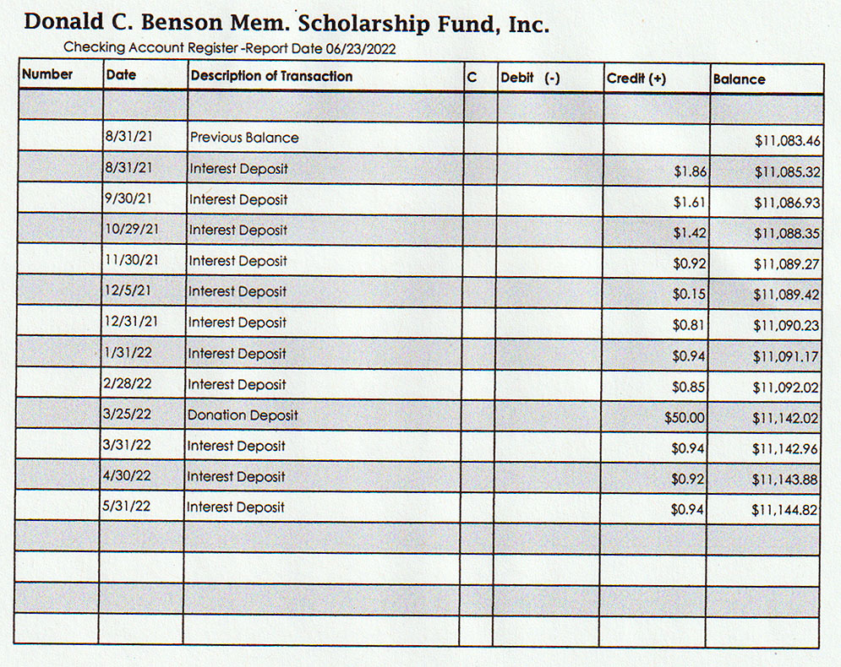
Brian advised that scholarships for this year have not been given out yet. He also said there will be a Cornhole Tournament at Retraining this year if there is space at the hotel.
Brian advised the Board he received a phone call from President Hackett concerning the status of the Benson Fund and the IRS. This came to light when Secretary Garman was doing the annual review of our, the VFSAAA and the Benson Fund, charitable organization status with the IRS. The Benson Fund was found to be non-compliant. Brian advised that he contacted the IRS and was informed that several years ago all IRS 990-N forms needed to be e-filed. Form 990-N is an Electronic Notice (e-Postcard) for Tax-Exempt Organizations used by small, tax-exempt organizations for annual reporting and can only be submitted electronically. Brian was not aware of this, and he was mailing them in. Brian said he is currently working with the IRS to either be reinstated or to go through the procedures to resubmit an application for charitable organization recognition.

Social Committee Report:
Andrea Feldman, Northern Director, reported that she still is in the planning stages. There is a new contact person that she is trying to reach out to. Andrea said she is hoping for a better price. The former contact person quoted a $38.00 per person price for the dinner.
There was a period of general discussion by the Board concerning various topics to include:
Will there be a DJ or just use the background music from the hotel? It was suggested that the Board invest in a Bluetooth speaker for music and announcements.
The hotel wanted to know how many people would be attending the Social. Jeff said the final number is usual due to the hotel approximately 5 days before the event.
There will be no kegs this year. This is a hotel policy. It will be a cash bar only. Andrea suggested at least one drink ticket per attendee. Drink prices at the hotel are $8.00 for beer/wine and $14.00 for cocktails. It was suggested that two bartenders be used.
Trey Lucy, Central Director, reported that Evident will be donating $1500.00, minus $200.00 for the Vendor Fee, toward the Social.
There was a Motion, along with a Second, to set the attendance fee for the Social at $20.00. There were no objections. The motion passed by unanimous oral vote. There were no dissenting votes.
President Hackett asked for a motion to authorize $500.00 for door prizes for the Social. A Motion along with a Second was made to authorize the money. There were no objections or dissenting votes, the motion passed.

Raffle Committee:
Clay Overholt, Interim Western Director, was not available and there was no official report.
There was a Motion, along with a Second, to authorize the spending of $500.00 for raffle prizes. There were no objections. The motion passed by unanimous oral vote. There were no dissenting votes.

It was reported that Clay may not be able to be at Retraining. If this is the case Sam Shumate, 1st Vice President, will fill in for him.

Vendor:

Trey Lucy, Central Director, reported that so far only Evident has confirmed that they will attend as a vendor. There are three other vendors that are very interested in attending however they have not committed. Trey said that he sent out 36 invitations, most companies declined because of the high costs of travel.

Fhatima Shands suggested that Mike Grimm, Jr. be nominated for Honorary Membership. Mark Garman reminded the Board that a Nomination form still needed to be filled out and submitted to the Nomination Committee. It was indicated by several Board members that the form would be submitted.

Novelty T/shirts:
Karyn Buhrman, Eastern Director, said that the design has been set and the printer selected. She said that an email to the membership would be sent out within the week. Mark Garman said that ordering information for the Novelty T/shirt would be posted on our website.

Hospitality Suite:
Wendy Bailey, SGT-at-Arms, reported that she has reached out to Hot Tuna, a nearby restaurant, as a possible location for the Hospitality Suite. Her concerns were limited space, menu choices, how members would be identified, and costs. Trey Lucy suggested that Wendy contact, Shore Break, another nearby restaurant that is “law enforcement” friendly.
Wendy said that in the past $2,500.00 budget was normally given to the Hospitality Suite. This amount was set per a motion by member Tom Butler at the 2015 Annual Meeting. This information was to be transferred into the Standing Rules of the VFSAAA. During the meeting Rick Conway, Legal Advisor and Mark Garman Secretary, researched our Standing Rules and found that this information was never included. Mark Garman said he would review the 2015 Annual Meeting Minutes for complete details.
Rick Conway made a motion that if the 2015 Annual Meeting Minutes did in fact say that $2500.00 was authorized to be the budget for the Hospitality Suite that the Standing Rules be changes to reflect that. A Second was made to Rick’s Motion. There were no objections. The motion passed by unanimous oral vote. There were no dissenting votes.

Dan Grinnan Fall Classic Golf Outing:

Karyn Buhrman, Eastern Director, said that a golf course has been selected. The announcement has been sent out and is posted on our website.

The Dr. Paul Ferrara Award:
Wendy Bailey, SGT-at-Arms, said she has not had any nominations thus far for the award this year.

Nomination Committee:
Marc Hackett said that Jim Gogan expressed an interest in continuing as the Chairperson of the Nominating Committee. Mark Garman said he would work with Jim and contact Board members via email to check on their interest in remaining on the Board.

Bylaws Committee:

Rick Conway, Committee Chairperson, said that there are no new changes or updates for members to vote on at the 2022 Annual Meeting.

Membership and Ethics Committee:
Rick Conway, Committee Chairperson, advised that there were no issues under investigation.

Sales:
Greg Locke, Committee Chairperson, said the Board needed to investigate the transportation of sales items to Retraining from Richmond. Steve Stockman will be leaving the DFS in July and would be unavailable to transport the items. Steve normally took care of this. Jeff Dwyer said he would do the best that he could but that the Board most likely would need to help. Jeff Dwyer asked if an inventory would need to be done before reordering items. He remined the Board to check with him before coming to the DFS to make sure someone was there.
There was a Motion, along with a Second, to authorize the spending of up to $3,500.00 for sales items. There were no objections. The motion passed by unanimous oral vote. There were no dissenting votes.

Annual Retraining 2022:
Jeff Dwyer had no new information for 2022 Retraining.

Memorial Table:
Mark Garman, Secretary and Committee Member, said that there is a lot of information that needs to be updated, but the Table should be ready for Retaining. He said he would forward the information along to Marilyn Durham, Committee Chairperson.

Website:
Mark Garman, Secretary/Webmaster, advised that our new website, www.vfsaaa.org, is up to date and running. Mark said he is in the process of setting up a secure email account for PayPal accounts. Mark summarized the website expenses for the Board. To save money, he suggested that the Board go to a 5-year payment plan for the website programs and services as opposed to the yearly plan that we are now on. The programs and services that we now have and need to have are, SiteLock, Essential WebHosting, Domain registration, Private Registration, and nsProtect. All the programs and services deal with web building, web security, and domain registration. The savings would be approximately $500 over a five-year period. President Hackett gave the authorization to investigate the matter further.

PayPal:
Mark Garman, Secretary, reported that PayPal would be up and running for Retraining.

Annual Retraining Relocation Exploration Committee:

Marc Hackett advised that he would like the committee to stay active as we only have a one year contract with the Delta Hotel. He would like the Committee to monitor the members’ comments on the new location.

The next regular VFSAAA Board Meeting, a virtual meeting, is scheduled for Friday July 22nd, 2022.

President Hackett asked if there was a motion to adjourn the meeting. A Motion along with a Second was made to adjourn the meeting. As there were no objections or dissenting votes, the motion passed.

The meeting adjourned at approximately 2:00 PM.

Mark Garman, Secretary

Approved by the Membership of the VFSAAA at the 2022 Annual Meeting.

09/8/2022

____________________________________

