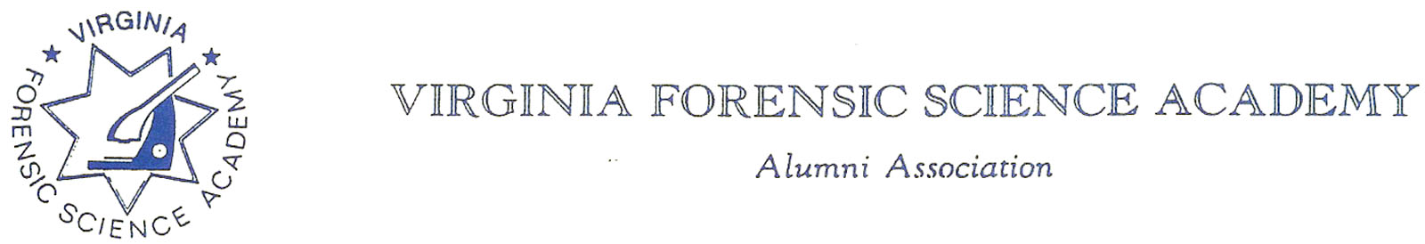
VFSAAA Board Meeting Minutes

To: VFSAAA

Date: July 27, 2023

From: Mark Garman, Secretary

Re: VFSAAA Board Meeting
June 23rd, 2023

Executive Board:
President Marc Hackett
1st Vice President Sam Shumate Web-Based/Signed Out Early
2nd Vice President Greg Locke Web-Based
Treasurer Heather Marshall Web-Based/Signed On Late
Secretary Mark Garman Absent
Sergeant-at-Arms Wendy Bailey Web-Based/Signed On Late
Immediate Past President Clay Overholt Web-Based
Legal Consultant Rick Conway
DFS Consultant Jeff Dwyer

Regional Directors:
Northern Director Andrea Feldman
Eastern Director Karyn Buhrman Web-Based
Western Director Robby Richardson
Central Director Charles “Trey” Lucy

Committees:
Benson Committee R. Brian O’Bier Absent
Audit Committee Eric Deel Absent
Nominating Committee Jim Gogan Absent
Memorial Committee Marilyn Durham Absent

Others:
Admin Assistant Shantae Green Absent
Instructor Wayne Rigsby
Instructor Jason Austin

Secretary’s note: The Secretary was absent from the meeting. These Minutes are transcribed from the notes of Jeff Dwyer, DFS Consultant, and the recordings of Marc Hackett, President.
The meeting was called to order at approximately 11:54 AM by President Marc Hackett.
It was determined that there were enough Board members physically present or signed into the meeting via phone/internet to establish the necessary quorum.

Secretary’s Report:
The Meeting Minutes from the March 2023 Board Meeting were presented to the Board by Mark Garman, Secretary, prior to the meeting via email.
There were no questions or comments on the minutes.
A Motion was made by Robby Richardson, Western Director, along with a Second by Andrea Feldman, Northern Director, to accept the Meeting Minutes. There were no objections. The motion passed by unanimous oral vote. There were no dissenting votes.

Treasurer’s Report:
Heather Marshall, Treasurer, presented the March 2023 Treasurer’s Report to the Board via email. The report was read to the Board by President Marc Hackett as Heather was slightly late signing into the meeting.
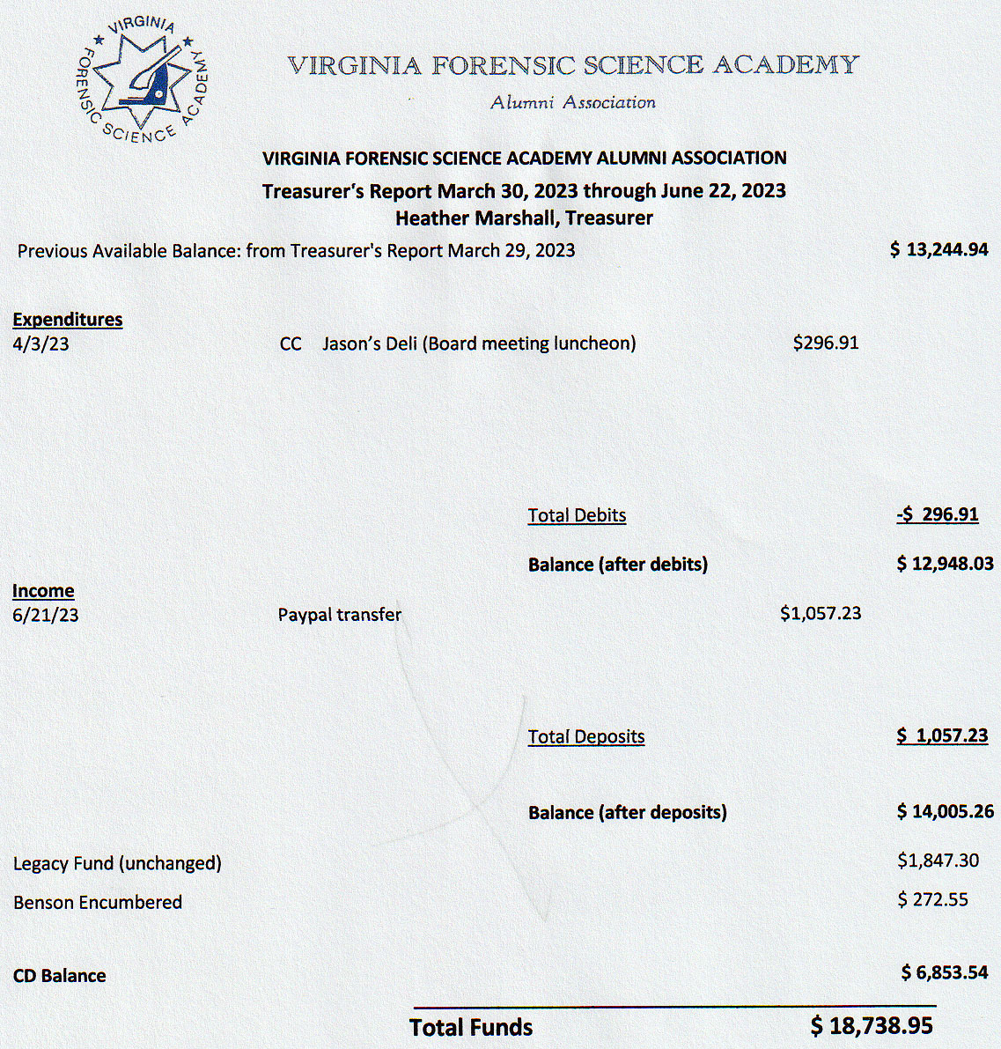
There were no questions or comments on the Treasurer’s Report.
A Motion was made by Rick Conway, Legal Consultant, along with a Second by Karyn Buhrman, Eastern Director, to accept the Treasurer’s Report. There were no objections. The motion passed by unanimous oral vote. There were no dissenting votes.
Jeff Dwyer, DFS Consultant, reported $800.00 in sales to the graduating class. He said he would transfer that money, along with several Dues payments received at the DFS, to Heather for deposit.

Old Business:
Lifetime Achievement Award
Jeff Dwyer, DFS Consultant, presented the following wording for the Dan Grinnan Lifetime Achievement Award,
Dan Grinnan Lifetime Achievement Award
This award is to recognize a member whose work over the course of a career of 10 years or more, unless such career is interrupted by circumstances beyond the control of the member, made a marked impact in the Forensic Science and or Crime Scene Investigation communities.
Any member in good standing may nominate any other member in good standing by letter to any Board Member. If the Board Member receiving the letter is not the SGT-at-Arms, that member will forward the letter to the SGT-at-Arms for presentation to the Board.
The Board will hold a vote to deny or confirm the nomination.
There was a period of discussion by the Board concerning the award.
A Motion was made by Trey Lucy, Central Director, along with a Second by Robby Richardson, Western Director, to accept the wording for the award. There were no objections. The motion passed by unanimous oral vote. There were no dissenting votes.
Administering the award will be added to the responsibilities of the SGT-at-Arms.
Information on the Dan Grinnan Lifetime Achievement Award will be added to our website, www.vfsaaa.org.
There was a period of additional discussion by the Board to add the responsibility of awarding Honorary Memberships to the Nominating Committee by stating these responsibilities in the Standing Rules.
The matter was tabled by President Hackett for additional research until the July 2023 meeting.
Secretary’s Note: In our Bylaws under Article II Section 5 and Section 7 and Article VII Section 3 the responsibilities of awarding Honorary Memberships are assigned to the Nominating Committee.

VFSAAA Support/Endorsement of Members Running for Political Office:
Rick Conway, Legal Consultant, reported on the VFSAAA supporting/endorsing members running for public office. Rick said after researching the Articles of Incorporation he believes that we can. There was an extended period of discussion by the Board on whether the Board could speak for the entire membership. Rick advised that the Bylaws would need to be amended and the changes presented to the membership for approval at Retraining 2023. Rick said that he would work on the wording for the Bylaw changes and present it to the Board at the July 2023 Board meeting.
President Hackett tabled the matter until the next meeting.
Secretary’s Note: Per our Bylaws, Amendment(s) to these Bylaws shall be enacted at the Annual Meeting by a two-thirds (2/3) vote of the electorate, provided that the proposed amendment(s) approved by the Board has been made available in writing to the Membership no later than thirty (30) days prior to the Annual Meeting. Voting by proxy shall not be permitted.
New Business:
There was no new business.

Committees:

Bylaws Committee:

Rick Conway, Legal Consultant and Committee Chairperson, advised that other than the changes needed for the VFSAAA supporting or endorsing members running for public office there were no new updates or changes pending.

Membership and Ethics Committee:
Rick Conway, Legal Consultant and Committee Chairperson, advised that there were no issues under investigation and that he had nothing to report.

Sales:
Greg Locke, 2nd Vice President and Committee Chairperson, said he had requests for smaller sizes and “zip-up” jackets. Greg asked for permission to buy a “PVC pipe system” for hanging sales items at Retraining. Andrea Feldman, Northern Director, said Prince William County has one that the association can use.
Greg asked for $3,000.00 to purchase new sales items.
A Motion was made by Trey Lucy, Central Director, along with a Second by Andrea Feldman, Northern Director, to authorize the spending of up to $3,000.00. There were no objections. The motion passed by unanimous oral vote. There were no dissenting votes.

Memorial Table:
Greg Locke, 2nd Vice President and Committee Member, reported that the committee is still looking for information on deceased members.

Website:
Mark Garman, Secretary/Webmaster, reported through President Hackett that our website, www.vfsaaa.org, is currently up to date with Retraining 2023 information.

PayPal:
Mark Garman, Secretary, reported through President Hackett that PayPal is up and working. So far in 2023, $1,057.23 in dues and other sales have been paid for through by PayPal via our website. Mark transferred the money to the association’s checking account.

Annual Retraining Relocation Exploration Committee:
Jeff Dwyer, DFS Consultant, had nothing to report.

Annual Retraining 2023:
Jeff Dwyer, DFS Consultant, said that everything was coming together. The Annual Meeting will be held Thursday morning September 7th, 2023.
Wendy Bailey, SGT-at-ARMS, and Karyn Buhrman, Eastern Director, both reported that they had not received any of the announcements for Retraining 2023. Jeff said he would investigate the matter.

The Dr. Paul Ferrara Award:
Wendy Bailey, SGT-at-Arms, said she has received no nominations for the award but that in the past most have come in the summer months.

Benson Fund:
Brian O’Bier, of the Benson Fund Committee, was not present and there was no official report. A report showing scholarships and financial status, shown below, was sent to President Hackett. Marc reported thru Brian that the Benson Fund’s tax issues have been taken care of.

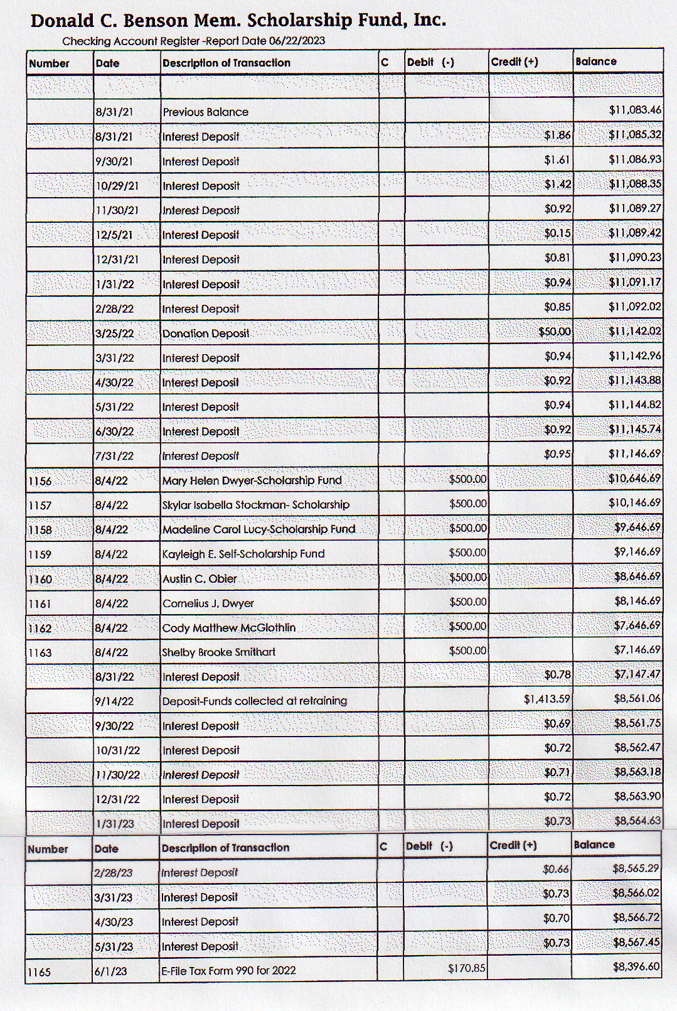

There will be a Benson Cornhole Tournament at the Shorebreak Pizza and Taphouse on Wednesday night of Retraining. A flyer will be sent out to the members concerning the event.

Raffle Committee:
Robby Richardson, Western Director and Committee Chairperson, reported that he has about half of the door prizes. Robby said that he needs our tax ID number. President Hackett said that he would make sure he got the number.

Social Committee Report:
Andrea Feldman, Northern Director and Committee Chairperson, reported that the buffet offered last year at $38.00 a person is now $57.00 a person. Catering does have more options and she was looking into a Taco/Margarita Bar at $38.00 a person. The charge for members would be $20.00 per person. There would be a cash bar at the Social, no credit cards.

Vendor:

Trey Lucy, Central Director and Committee Chairperson, reported that he has five commitments for attendance with three already paying. He has other possibilities that have not made a firm commitment yet. He also advised that Evident will be contributing $1,500.00 for use at Retraining and a second vendor, Leica, would like to sponsor some aspect of Retraining as well.

Hospitality Suite:
Karyn Buhrman, Eastern Director and Committee Chairperson, said that the Hospitality Suite, renamed the VFSAAA Networking Event in 2022, would be run at the same location, Shorebreak Pizza & Taphouse, and in the same manner as it was run in 2022. There may be an increase in price charged by the restaurant associated with the event.
A Motion was made by Trey Lucy, Central Director, along with a Second by Robby Richardson, Western Director, to authorize the spending of up to $2,500.00 for the event. There were no objections. The motion passed by unanimous oral vote. There were no dissenting votes.

Novelty T/shirts:
Karyn Buhrman, Eastern Director and Committee Chairperson, said that she would work on the project with Mark Garman. So far there have been no submissions. There was a period of discussion on recycling an old design if there are no new entries of merit.

Dan Grinnan Fall Classic Golf Outing:

Karyn Buhrman, Eastern Director and Committee Chairperson, said the outing is all set up at Honeybee Golf Course.

Nomination Committee:
President Hackett read out the proposed 2023-2024 slate that was sent to him by Jim Gogan, Committee Chairperson, and Mark Garman, Secretary. The slate was as follows.
Current slate Proposed 2023-2024 slate.

Executive Board:
President Marc Hackett Samuel Shumate
1st Vice President Samuel Shumate Andrea Feldman
2nd Vice President Greg Locke Greg Locke
Treasurer Heather Marshall Heather Marshall
Secretary Mark Garman Mark Garman
Sergeant-at-Arms Wendy Bailey Wendy Bailey

Regional Directors:
Northern Director Andrea Feldman OPEN
Eastern Director Karyn Buhrman Karyn Buhrman
Western Director Robbie Richardson Robbie Richardson
Central Director Charles “Trey” Lucy Charles “Trey” Lucy

Other Board Members:
Immediate Past President Clay Overholt Marc Hackett
DFS Consultant Jeff Dwyer Jeff Dwyer
Legal Advisor Rick Conway Rick Conway

The next regular VFSAAA Board Meeting is scheduled for Thursday July 27th, 2023, at 1:00 PM. The meeting will be a virtual meeting.

President Hackett asked if there was a motion to adjourn the meeting.
A Motion was made by Greg Locke, 2nd Vice President, along with a Second by Karyn Buhrman, Eastern Director, to adjourn the meeting. There were no objections. The motion passed by unanimous oral vote. There were no dissenting votes.

The meeting adjourned at approximately 1:31 PM.

Mark Garman, Secretary

Approved by the Board of Directors

June 23rd, 2023

____________________________________

