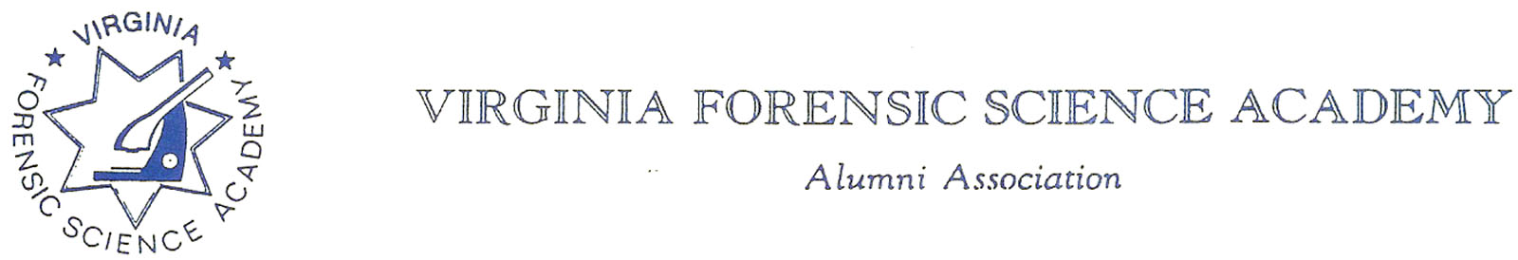

To: Secretary, Mark Garman

From: Eric Deel, Virginia State Police

Date: November 5, 2021

Re: VFSAAA August 2018-November 2021 Audit

On Friday, November 5, 2021, an audit of the financial records and the legacy fund for the Virginia Forensic Science Academy Alumni Association (VFSAAA) was conducted by members Heather Marshall and Eric Deel. Treasurer, Heather Marshall presented records from August 30, 2018, through November 5, 2021, for review. All financial records were found to be in order and accurate.

Cc: Heather Marshall
Eric Deel

