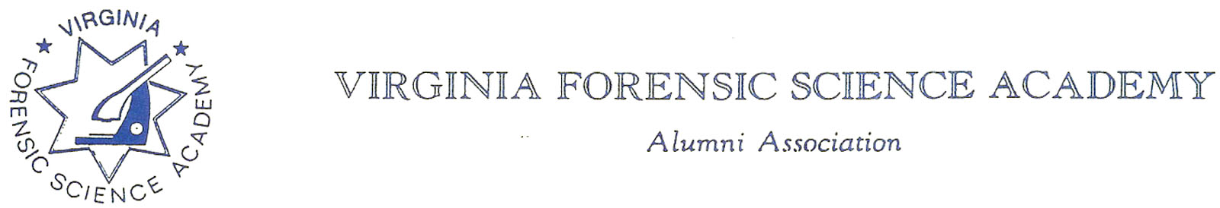

To: VFSAAA

Date: September 5th, 2024

From: Mark Garman, Secretary

Re: VFSAAA Board of Directors Meeting Minutes
July 25th, 2024

Secretary’s Note: Because this was a web-based meeting some of the comments by Board members could not be heard on the recorder for inclusion in the Minutes. Such occurrences are noted in the minutes.

Executive Board:
President Sam Shumate
1st Vice President Andrea Feldman
2nd Vice President Greg Locke
Treasurer Heather Marshall
Secretary Mark Garman
Sergeant-at-Arms Wendy Bailey
Immediate Past President Marc Hackett
Legal Consultant Rick Conway
DFS Consultant Jeff Dwyer

Regional Directors:
Northern Director Zack King ABSENT
Eastern Director Karyn Buhrman
Western Director Robby Richardson
Central Director Charles “Trey” Lucy

Committees:
R. Brian O’Bier Benson Committee ABSENT
Eric Deel Audit Committee ABSENT
Alison Fox Nominating Committee
Marilyn Durham Memorial Committee

Others Present:
Shantae Green DFS Admin Assistant
Jason Austin VFSA Instructor
Bryan McIntee VFSA Instructor
Michael East Member

The meeting was called to order at approximately 10:00 AM by President Sam Shumate.
It was determined that there were enough Board members signed in on-line to establish the necessary quorum.

Treasurer’s Report:
Heather Marshall, Treasurer, presented the following Treasurer’s Report for July 2024. The report was emailed to the Board prior to the meeting.
Heather indicated that the Legacy Fund figures do not reflect the donations made by the last class, the 112th Session. Donations were made via PayPal. Mark Garman, Secretary, said he would obtain the amount from PayPal and forward that information to Heather.

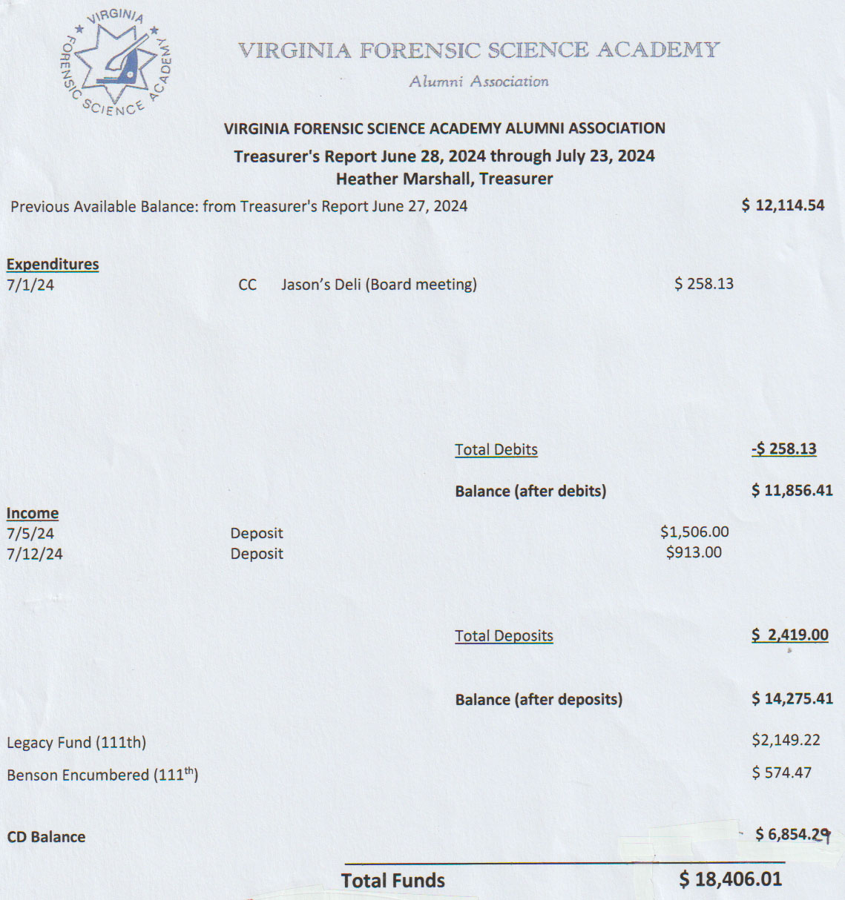
A Motion was made to approve the July 2024 Treasurer’s Report. A Second was also made. The motion passed by unanimous oral vote. There were no abstentions, objections, or dissenting votes.

Secretary’s Report:
The Meeting Minutes from the June 28th ,2024, Board Meeting were presented to the Board by Mark Garman, Secretary. This was done via email prior to the meeting.
A Motion was made to approve the June 28th ,2024, Board Meeting Minutes. A Second was also made. The motion passed by unanimous oral vote. There were no abstentions, objections, or dissenting votes.

Old Business:
President Shumate asked if there was any Old Business to be discussed.

Rick Conway, Chairperson of the Membership Ethics Committee and Bylaws Committee, reported to the Board on both Membership Ethics and Bylaws issues.

There was an extensive discussion by Rick and the Board on adjusting our Bylaws and proposing these changes to the Membership for approval at the 2024 Annual Meeting.

The proposed changes are in Article II Section 1. Membership and Dues of our Bylaws. The changes further define the members’ responsibility to keep their contact information up to date with the Association. Additional changes are in Article II Section 13. Disciplinary Action of our Bylaws. These changes define how a member is contacted by the Board and the member’s responsibilities in responding back to the Board during a Disciplinary Action investigation.

A Motion was made to present the suggested changes to the Membership at the Annual Meeting scheduled for September 5th, 2024. A Second was also made. The motion passed by unanimous oral vote. There were no abstentions, objections, or dissenting votes.

Mark Garman, Secretary, said the proposed changes would be posted on our website, www.vfsaaa.org , within the necessary time limits prescribed by our Bylaws.

To comply with the suggested changes to our Bylaws, Rick stated that the Alumni Association needs to maintain up to date contact information for the membership.

Rick also indicated that he needed a check to cover the cost of the yearly filing to the State Corporation Commission, which is $25.00. Heather Marshall, Treasurer, said she would send him a check.

Rick also requested new and current information on all Board Members. Mark Garman, Secretary, said he would send the information to him after the meeting.

The Membership Ethics Committee investigation concerning Justin Sigmon, described below, was tabled until the 2024 Annual Membership Meeting.

MIAMI – On Nov. 17, a federal jury convicted the former Major of the Franklin County Sheriff’s Office in Virginia of abusive sexual contact with a minor under 12 years old. The conviction comes after a five-day jury trial before U.S. Senior District Judge Donald L. Graham in Miami. In May 2023, Justin Dale Sigmon, 47, while on a cruise that departed from the Port of Miami, repeatedly put his hands up the skirt of a nine-year-old, rubbing her inner thighs and private area, despite her repeatedly pushing his hands away on multiple occasions. Two good Samaritans, who were seated next to Sigmon in the cruise ship dining room, noticed his behavior, recorded it, and reported it to cruise ship security. The cruise ship’s surveillance cameras also captured Sigmon’s actions. When cruise security officials confronted him about his conduct, Sigmon identified himself as a law enforcement officer. Sentencing is set for Jan. 12, 2024, at 1:30 p.m. in Miami. Sigmon faces up to life in prison. U.S. Attorney Markenzy Lapointe for the Southern District of Florida and Special Agent in Charge Jeffrey B. Veltri of the FBI, Miami Filed Office, announced the guilty verdict. FBI Miami investigated the case with assistance from the U.S. Customs and Border Protection (CBP) and Carnival Cruise Line security. Assistant U.S. Attorneys Jessica Kahn Obenauf and Lacee Elizabeth Monk prosecuted it.

New Business:
No New Business was presented.

Committees:

Membership Ethics:
Rick Conway, Legal Consultant and Committee Chairperson, had no report other than what was previously discussed.

Bylaws:

Rick Conway, Legal Consultant and Committee Chairperson, had no report other than what was previously discussed.

Sales:
Greg Locke, 2nd Vice President and Committee Chairperson, said that he has contacted Shenandoah Awards and is currently working on setting up an on-line sales site.

Memorial Table:
Marilyn Durham, Committee Chairperson, said that the committee is keeping up on the numerous passings of members and that the table would be ready for Retraining.
Information on the Memorial Table Committee can be found on our website, www.vfsaaa.org.

Website:
Mark Garman, Secretary, reported that our website, www.vfsaaa.org, is out of service because of a Security Certificate issue caused by Networks Solutions, our domain provider. Mark said that he was working on the issue and hoped to have it resolved within a week to 10 days. Otherwise, he said our site is up to date with all current information on the 2024 Retraining Seminar, to include Retraining Registration, Dues, Dr. Paul Ferrara Award, Benson Scholarship, and the Novelty T/Shirt. He will continue to monitor and update the site as necessary.

PayPal:
Mark Garman, Secretary, reported that PayPal is up to date. The new Dues form is on our website, www.vfsaaa.org, and has been tested.
He will continue to monitor and update PayPal as necessary.

Retraining 2024 Exploration Committee:
Jeff Dwyer, DFS Consultant, said that the committee was at a standstill until after Retraining and then the Delta hotel would be reevaluated.

Retraining 2023:
Jeff Dwyer, DFS Consultant, said Retraining is scheduled for September 3rd through the 6th,2024, and is on track. He did indicate that there is still some open time on Friday morning.
Benson Fund:
Brian O’Bier, Committee Chairperson, was not present. There was no official report.

The Dr. Paul Ferrara Award:
Wendy Bailey, SGT-at-Arms and Committee Chairperson, advised that she had two nominations. She was going to wait until August 1st, 2024, the cutoff date, before reaching out to the Board with all the nominations.
Information on the Dr. Paul Ferrara Award and the Dan Grinnan Award can be found on our website, www.vfsaaa.org on the Dr. Paul Ferrara Award page.

Social:
Zack King, Northen Director and Committee Chairperson, was not present. Andrea Feldman, 1st Vice President, reported that Zack is waiting to hear back from the Delta to finalize the event.

Raffle Committee:

Robby Richardson, Western Director and Committee Chairperson, was not available because of technical issues. Andrea Feldman, 1st Vice President, reported that Robby told her that he is working on the raffle, and all will be ready for Retraining.

Vendor:

Trey Lucy, Central Director and Committee Chairperson, reported that he only has two vendors signed up. He is still working on more.

Information on the vendors who were at Retraining in 2023 is posted on our website, www.vfsaaa.org.Those vendors are, Evident Crime Scene Products, File On Q, Precision Survey Supply/Leica, and Spacesaver Storage Solutions.

Novelty T/shirt:

Karyn Buhrman, Eastern Director and Committee Chairperson, said that the 2024 Novelty T/shirts have been ordered.

The cost will be $20.00 per shirt. There will be no pre-orders. The shirt will be in black only.

Hospitality Night:
Karyn Burhman, Eastern Director and Committee Chairperson, said the event would run something like it was at the 2023 Retraining Seminar and will be held at the Shorebreak Pizza and Taproom, 2941 Shore Dr, Virginia Beach, VA, 23451.
Wendy Bailey, SGT-at-Arms, reported that Capital One will be donating $2500.00 toward the cost of the Hospitality Night.

Dan Grinnan Fall Classic Golf Outing:

Karyn Buhrman, Eastern Director and Committee Chairperson, said the event will be at the Honey Bee Golf Club. She said that there are currently only 4 teams signed up.

Nomination:
Alison Fox, NCIS, Chairperson for the Nominating Committee, sent the proposed slate to President Shumate. Mark Garman, Secretary, said that he would post the information on our website.
President Shumate asked if there was a motion to adjourn the meeting. A Motion and Second were made to adjourn the meeting. As there were no objections, abstentions, or dissenting votes, the motion passed.

The meeting adjourned at approximately 11:15 AM.

The next meeting of the VFSAAA will be the Annual Membership Meeting scheduled for September 5th, 2024, at approximately 10:00 AM.

Mark Garman, Secretary

______________________________________________________________

Minutes Approved by the General Membership at the Annual Membership Meeting September 5th, 2024.

