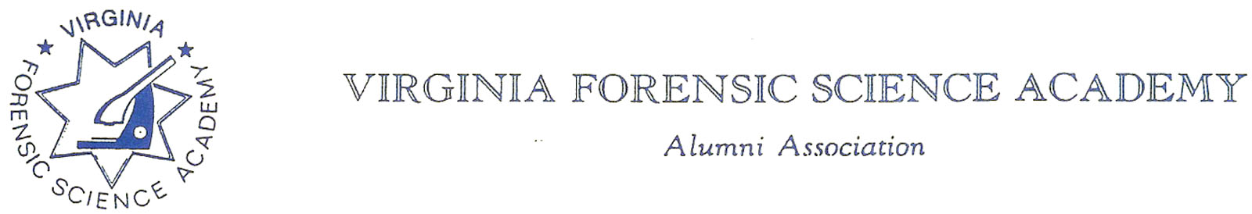
VFSAAA Special Board Meeting
July 30th, 2021

Date: September 2nd, 2021

NOTE: This meeting was a special unscheduled meeting called by President Marc Hackett to discuss the 2021 Retraining Seminar.

Executive Board:
President Marc Hackett
1st Vice President Chris McClure
2nd Vice President Greg Locke
Treasurer Heather Marshall
Secretary Mark Garman
Sergeant-at-Arms Wendy Bailey
Immediate Past President Clay Overholt
Legal Consultant Rick Conway
DFS Consultant Jeff Dwyer

Regional Directors:
Northern Director Andrea Feldman
Eastern Director Karyn Lawrence
Western Director Samuel Shumate
Central Director Charles “Trey” Lucy

Committees:
R. Brian O’Bier Benson Committee Absent
Elizabeth “Beth” Dunton Audit Committee Absent
Jim Gogan Nominating Committee Absent

Others Present:
Fhatima Shands Honorary Member/Admin Assistant
Steve Stockman Member/Forensic Trainer

The meeting was called to order at approximately 10:00 AM by President Marc Hackett.
A quorum was established with 13 voting Board Members.
Secretary’s Note; Because of the COVID-19 crisis the July 2021 Special Board Meeting was a virtual meeting held via phone/internet connection.

New Business:

President Marc Hackett advised the Board that he called for this special meeting to discuss the Annual Retraining Seminar because of issues discussed during the June 25th, 2021, Board meeting. He felt that the entire Board needed to be aware of the issues and for the entire Board to decide on how to proceed.

Retraining:

Jeff Dwyer, DFS Consultant, brought the entire Board up to date on the issues with the Wyndham. They include:
- Being short staffed which would result in a decline in overall cleanliness of the hotel and of the rooms.
- The unresponsiveness of the hotel and the staff either by emails or by phone.
- Issues with trying to make reservations and getting the correct rate for the different nights.
- Online customer evaluations on how bad the hotel is.
- The general condition of the hotel and its disrepair.
- The hotel is due to be torn down in 3 to 4 years.

Trey Lucy, Central Director, reported that Trip Advisor reviews of the hotel were extremely poor with most commenting on how dirty the hotel is and on pest infestation. Trey said hotel staff members told him that Virginia Beach PD is running about two domestic calls a day at the hotel. On a side note, Trey also reported that there are only 4 vendors signed up as many did not plan on conferences this year because of COVID.

Mark Garman reported that it took several weeks for him to make his reservations after repeated call backs. He repeated Trey’s observations about on-line reviews, adding that the only positive points stated on the reviews were the hotel’s location and the quietness of the beach. He reminded the Board that a survey was done of the membership several years ago and although the membership was unhappy with the hotel, its condition, and services by the staff, most were willing to overlook this for the sake of the hotel’s location.

Fhatima Shands, Admin Assistant, said she had several phone calls from various members complaining about the unresponsiveness of the hotel staff and how long it took to eventually get reservations. She said members were told that there were no rooms or limited rooms available, and some were told that there was no conference scheduled at the hotel for that time.

Several other Board members also spoke up and echoed the points already voiced adding in COVID issues of mask usage, social distancing, and the number of people allowed in the conference rooms.

Marc Hackett asked Jeff Dwyer if there was anything binding in the contract to compel the DFS/VFSAAA to use the hotel. Jeff advised that there is nothing in the signed contract to force us to use the hotel. Further stating that the State will not sign a contract that has any type of cancellation/attrition clause. The current contract only says that the hotel must be advised in writing if there is going to be a cancellation.

Jeff said that if the Annual Retraining Seminar is cancelled there would be a two-and-a-half-day web-based Annual Retraining Seminar. It would take some planning, but after the success with the recent multiday Homicide Scene Seminar held by DFS, he said it could be done.

Jeff then reported on his contact with the Delta Hotel. The Delta is along the Chesapeake Bay north of Virginia Beach. Jeff said there are pros and cons to the hotel. More detailed information will be available during the selection process for a new Retraining site.

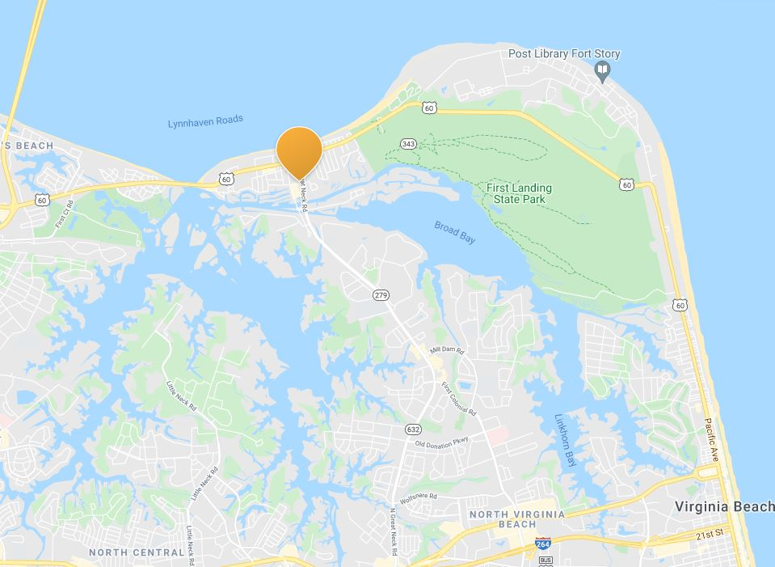

Delta Hotel location

Jeff also reported that he had a contact with the Holiday Inn North Beach. Again, Jeff said that there are pros and cons, and more detailed information would be available during the selection process for the new Retraining site.

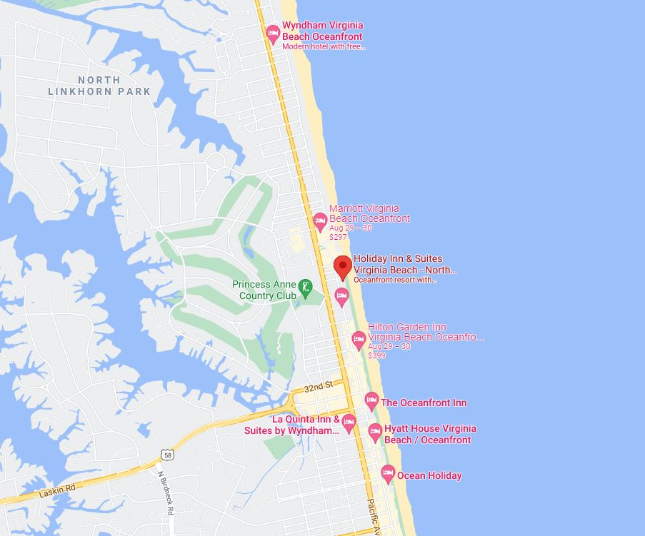

Holiday Inn North Beach location

Jeff said that the decision on where to move needs to be made soon as he needs to sell DFS on the new location, possible additional costs, and to make sure we can get the needed dates.

Mark Garman, Secretary, made a motion to the cancel the 2021 Annual Retraining Seminar. There was a second by Greg Locke, 2nd Vice President. There were no objections. The motion passed by unanimous oral vote. There were no dissenting votes.

Marc Hackett said he would send a letter to the members explaining the Board’s decision and the course of action.

Marc Hackett set up a new committee, the Retraining Exploration Committee, that would investigate a new Retraining Seminar location. Committee members are Jeff Dwyer, Trey Lucy, Wendy Bailey, and Karyn Lawrence.

The Board discussed having our 2021 Annual VFSAAA Membership Meeting during the virtual 2021 Annual Retraining Seminar. It was confirmed that there will be a membership meeting to include the election of officers, the approval of the Meeting Minutes, Treasurer’s Report, and new updated Bylaws. The Board also discussed the logistics of having members attend the virtual 2021 Annual Membership Meeting who are not attending the virtual 2021 Annual Retraining Seminar. Additional issues discussed were how to track the number of members who are attending just the seminar, or both the seminar and meeting, or just the membership meeting. And how we are going to tally member votes on important issues.

Bylaws Committee:

Rick Conway, Committee Chairperson, and Mark Garman, Secretary, advised that the suggested changes to our Bylaws are posted on our website. These suggested changes were to be voted on at the 2020 Annual Membership Meeting. As there was no 2020 Annual Membership Meeting and therefore no vote, the changes need to be voted on during the virtual 2021 Annual Membership Meeting.

Rick said he will fully review the proposed changes and check for any other potential changes and or updates. Mark said any new changes or updates will be posted on our website in the necessary amount of time as specified in our Bylaws.

Membership Ethics Committee:

Trey Lucy briefly advised the Board that a former member was released from his department because issues in their Property Room where he was assigned. Trey has a copy of the court filings in reference to this. This former member has not been fired and is currently not a member of the VFSAAA. He has not paid his dues for at least 2 years. Rick Conway, Chairperson, asked Trey to forward all information to him for further investigation.

Website:
Mark Garman, Secretary and Webmaster, advised that our current website is no longer fully functioning and needs to be replaced. In detail, Mark said the software used to maintain the website is over 25 years old. Our website is over 10 years old. The hosting company, WEB.Com, is no longer offering technical support for the site and WEB.Com does not have the ability to fix the problem. He found this out after learning that members could not access certain pages and after consultation with WEB.com. Mark said he has already contacted Network Solutions and will work with them to build our new website. Building the site will take several weeks. The new site will cost more per year to maintain due to more Federal restrictions and security requirements on websites.
Mark did find a way to “back-door” WEB.Com’s software and until our new site is up our current site can be fully accessed through this link, http://1697946.sites.myregisteredsite.com/virginiaforensicscienceacademyalumniassociation .

Novelty T/shirts:
Karyn Lawrence, Committee Chairperson and Mark Garman, asked the Board about the status of the 2021 Novelty T/shirt. It was decided to cancel the T/shirt and use the same design next year. For the 2022 shirt both 2020 and 2021 would be scratched out and 2022 written in.

A motion, along with a second, was made to adjourn the meeting. The motion passed by a unanimous oral vote. There were no dissenting votes.

The meeting adjourned at approximately 11:30 AM.

The next VFSAAA Meeting will be our Annual Meeting September 2nd, 2021, held during the 2021 Retraining Conference. This will be a virtual meeting

There will be a Board Meeting held on September 10th, 2021, at 1000 hours to discuss the 2021 Annual Retraining Seminar and to plan the 2022 Annual Retraining Seminar. The type of meeting has not been determined.

Secretary’s Note:

Because of COVID restrictions.
- The 2020 Annual Meeting was cancelled and therefore no Minutes.
- The November 13th, 2020, Board Meeting was a virtual meeting.
- The April 2nd, 2021, Board Meeting was a virtual meeting.
- The June 25th, 2021, Board Meeting was a virtual meeting.
- The July 30th, 2021, Special Board Meeting was a virtual meeting.

Approved by the Membership

September 2nd, 2021

Mark Garman/Secretary

