

March 20th, 2024
Members,
Please read the following:
- Open our Website, www.vfsaaa.org
- Navigate to the Dues Page and scroll down to the Dues Forms.
- From here you can access Dues Forms for the past several years including the form for the 2024-2025 year. Right click and open the form to complete and print out. EACH MEMBER FOR EACH YEAR MUST FILL OUT A NEW DUES FORM.
- Click on the …”Dues Payment Page” and it will take you to that page.

- From this page you can pay your dues for the selected year.
- Click on the “Buy Now” for that year and it will add to your shopping cart located in the upper right-hand corner of the page.
- Open your shopping cart to get to the PayPal site.
- If you have a PayPal account, you can log in or pay by credit card.
- On the PayPal site you can choose the number of dues that you are going to pay for. For jurisdictions that pay dues for multiple members, this enables them to make just one payment entry. For jurisdictions paying for more than one member at a time, it is EXTREMELY important for each member to complete a Dues Form and send to the VFSAAA. Please include the PayPal Order Number on the Dues Form.
- Complete PayPal and make your payment.
- You will get several receipts.
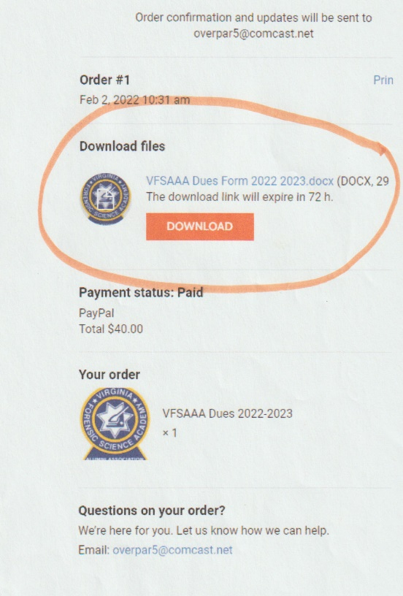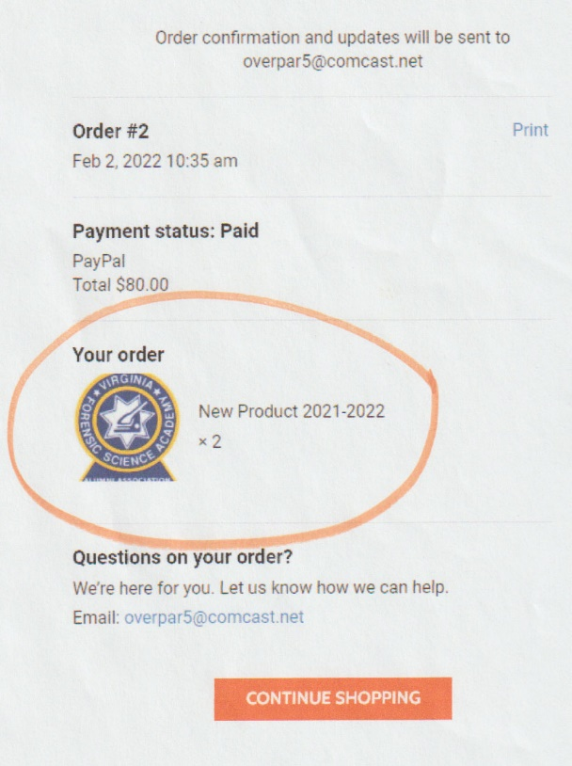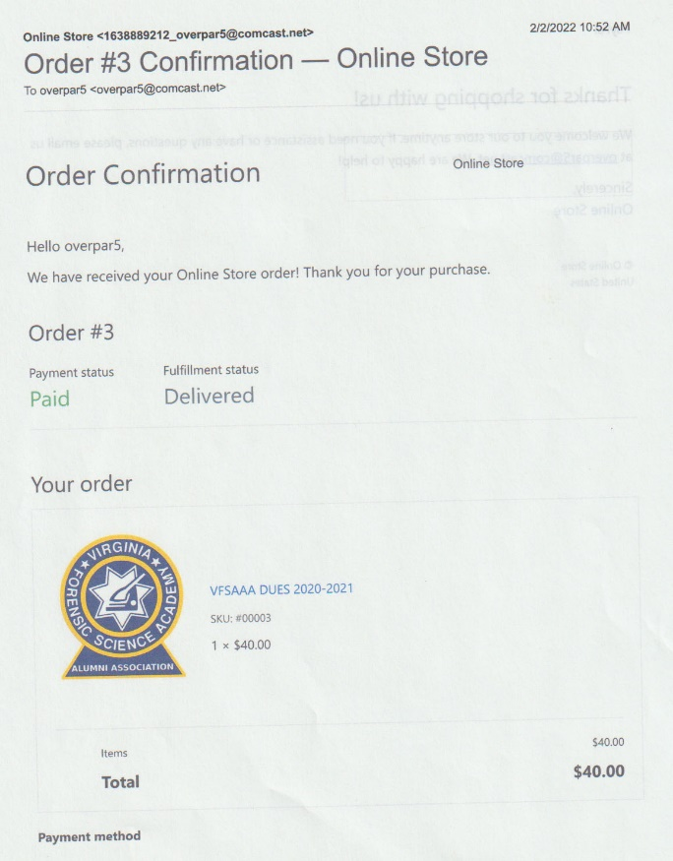
- Note, if you choose to you can also download the Dues Form from your order confirmation receipt.
- Also, the receipt will indicate the number of Dues paid for.
- Again, please remember EACH MEMBER FOR EACH YEAR MUST FILL OUT A NEW DUES FORM.
- Once you have your PayPal receipt, submit that with a copy of your dues form.
- INCLUDE THE PAYPAL RECEIPT TO YOUR DUES FORM.

If you have any questions or difficulties, please contact me at:
Overpar5@comcast.net , Or vfsaaa@gmail.com
Stay Safe,
Mark Garman/Secretary VFSAAA

