

To: VFSAAA

Date: November 18th, 2022

From: Mark Garman, Secretary

Re: VFSAAA Annual Meeting
September 8th, 2022

VFSAAA Annual Meeting Minutes

Executive Board:
President Marc Hackett
1st Vice President Sam Shumate
2nd Vice President Greg Locke
Treasurer Heather Marshall
Secretary Mark Garman
Sergeant-at-Arms Wendy Bailey
Immediate Past President Clay Overholt (double filling as Western Director)
Legal Consultant Rick Conway
DFS Consultant Jeff Dwyer

Regional Directors:
Northern Director Andrea Feldman
Eastern Director Karyn Buhrman
Western Director Clay Overholt (double filling as Immediate Past President)
Central Director Charles “Trey” Lucy

Committees:
R. Brian O’Bier Benson Committee
Eric Deel Audit Committee ABSENT
Jim Gogan Nominating Committee
Marilyn Durham Memorial Committee

The meeting was called to order at approximately 10:55 AM by President Marc Hackett.
It was determined that there were enough members present to establish the necessary quorum.

Jeff Dwyer, DFS Consultant, read out the names of the graduates of the VFSA from the 99th through 106th Sessions. The 2022 Annual Meeting was our first in-person meeting since 2019. Each graduate will receive a VFSA challenge coin. Those present were given their coin. Below is the list of graduates.
99th SESSION
Brandeberry Adam Colonial Heights Police Department
Brooks Sidney Newport News Police Department
Degear Brian Loudoun County Sheriff's Office
Garner Timothy Clarksville Police Department
Johnson William Virginia State Police - Div. I
Kiser Lester Virginia State Police - Div. IV
Lancaster John Goochland County Sheriff's Office
Maddox Jon Bedford County Sheriff's Office
Mahoney James Petersburg Bureau of Police
Moody Jane Chesterfield County Police Department
Patterson Travis Rockbridge County Sheriff's Office
Sexton Brian Marion Police Department
100TH SESSION
Burgess David Arlington County Police Department
Durbin Stephanie Suffolk Police Department
Hubert Douglas Virginia State Police - Div. VI
Izmirligil Edip Roanoke County PD
Johnson Brandon Virginia State Police - Div. VII
McWaters William Stafford County Sheriff's Office
Miller Jacob Salem Police Department
Myers David Culpeper County Sheriff's Office
O'Brien Sherry Fairfax County Police Department
Powell Travis Hanover County Sheriff's Office
Stanley Drew Herndon Police Dept
Stone Perry Henry County Sheriff's Office
101ST SESSION
Beard Wanda Virginia State Police - Div. II
Burrows Stephen Harrisonburg Police Department
Crabtree Joseph Virginia State Police - Div. III
English William Danville Police Department
Kilby Jason Madison County Sheriff's Office
Marsh Joshua Accomack County Sheriff’s Office
Pence Travis Woodstock Police Department
Shull Richard Alleghany County Sheriff's Office
Stein Nathan Charlottesville Police Department
Tax Alexander Metro Transit Police Department
Watts Talisha Richmond Police Department
White Nicholas Culpeper Police Department
102ND SESSION
Balek David Virginia State Police - Div. V
Barden Emma Powhatan County Sheriff's Office
Beatley William Goochland County Sheriff's Office
Contessa Jason Roanoke City Police Department
Cox Austin Radford City Police Department
Dranko Alisa Manassas City Police Department
Edwards Donald Isle of Wight County Sheriff's Office
Garthaffner Aaron Caroline County Sheriff's Office
Graham James Virginia State Police - Div. IV
King James Smyth County Sheriff's Office
Semple Heather Blacksburg Police Department
Wade Jacob Campbell County Sheriff's Office
103RD SESSION
Adamson Travis Frederick County Sheriff's Office
Brown Jamie Pulaski Police Department
Clawson Brett Department of Wildlife Resources
Crane Courtney Henrico County Police Department
Davis Mico Grayson County Sheriff's Office
Duong Phillip York-Poquoson Sheriff's Office
Green Matthew Fairfax City Police Department
Johnson Jonathan Virginia State Police - Div. I
Kugler Nicholas Accomack County Sheriff's Office
Sanchez Alyssa Gloucester County Sheriff’s Office
Wade Matthew Virginia State Police - Div. VI
Ware Matthew Leesburg Police Department
104TH SESSION
Alvarez Campos Marielsi Alexandria Police Department
Bourne Jessica Richmond Police Department
Dudding Devin Botetourt County Sheriff's Office
Harvey Renee Chesterfield County Police Dept.
Kushner Rebekah Prince William County Police Department
Moorman Morgan Franklin County Sheriff Office
Palmer Justin Virginia State Police - Div. VII
Roeseler Steven Arlington County Police Department
Springer Aaron Shenandoah County Sheriff's Office
Sutherland Seth Virginia State Police - Div. IV
Thurman Jesse Winchester Police Department
Watts Christopher Amherst Police Department
105TH SESSION
Abbasi M. Ismail Virginia State Police - Div. VII
Alger Christina Albemarle County Police Department
Durham Harley Martinsville Police Department
Furgurson Mark Henrico County Division of Fire
Greene Carl V irginia State Police - Div. V
Hull Richard Radford University Police
Isdanavage Ian Franklin Police Department
Jones Steven Mecklenburg County Sheriff's Office
Tuck Jared Charlotte County Sheriff's Office
Wistrom Donald Dinwiddie County Sheriff's Office
Wooley William Smithfield Police Department
Ziegler Heather Williamsburg Police Department
106TH SESSION
Aleshire Darrell Colonial Heights Police Department
Cusick Phillip Westmoreland County Sheriff's Office
Harris Nathan Roanoke County Police Department
Hill Brandon Virginia State Police - Div. I
Jacques Renee Spotsylvania Sheriff's Office
List Cameron Hopewell Police Department
Reavis John Galax Police Department
Roberts Michael Fairfax County Police Department
Rolle Jasnique Virginia State Police - Div. V
Schmitt Kaitlyn G reene County Sheriff's Office
Swain Stephen Bedford Police Department
Young Christopher Rockbridge County Sheriff's Office
President Hackett asked for a moment of silence for members who passed away during the previous year.
Secretary’s Report:
The Meeting Minutes from the November 2021, April 2022, June 2022 Board Meetings, and the July 2022 Special Board Meeting were presented to the membership by Mark Garman, Secretary. This was done by posting them on our website, www.vfsaaa.org. The November 2021 and April 2022 meetings were previously approved by the Board of Directors at Board Meetings. The June 2021 Board Meeting and the July 2021 Special Board Meeting required approval. The July Meeting was a special meeting call by President Hackett to plan for the new Retraining location.
There were no questions or comments on any of the minutes presented to the membership.
A Motion was made to approve the June 2022 Board Meeting Minutes and July 2022 Special Board Meeting Minutes. A Second was also made. The motion passed by unanimous oral vote. There were no objections or dissenting votes.

Treasurer’s Report:
Heather Marshall, Treasurer, presented the following Treasurer’s Report for September 2022.
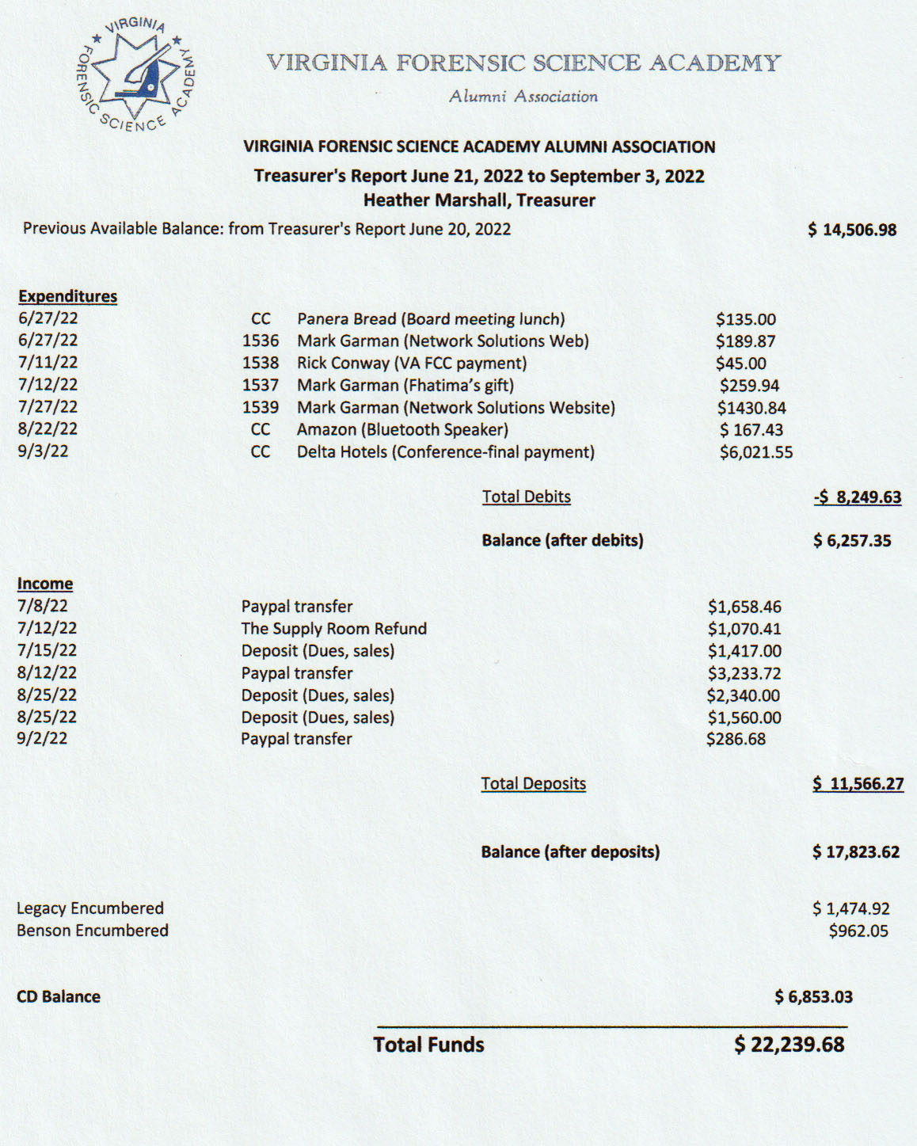

Treasurer Marshall advised the members that none of these figures included expenditures or income occurring during Retraining.
A Motion was made to approve the September 2022 Treasurers Report. A Second was also made. The motion passed by unanimous oral vote. There were no objections or dissenting votes.

Audit Committee:
President Hackett advised the membership that the 2022 Audit would be done by Eric Deel, Committee Chairperson, and Heather Marshall. When the audit is completed, an official report will be submitted to the Board. The Audit Report will then be posted on our website, www.vfsaaa.org for review by the members.

Old Business:
President Hackett asked if there was any Old Business to be discussed. There was none.

New Business:
President Hackett asked if there was any New Business to be discussed.
A member thanked the Board of Directors for moving the site of the Retraining Seminar from the Wyndham Hotel to the current location, the Delta Hotel/Virginia Beach Bayfront Suites. The member stated that although the Delta was more expensive it was a better facility and location. Further, he mentioned that the price of everything was going up for Retraining particularly for the Hospitality Suite and the Social. The member then made a motion to raise the dues for the Association from $40.00 to $60.00 per year. There was a second from the floor. There was then a period of discussion on the matter. Mark Garman, Secretary, stated that an increase to $60.00 was a big jump and suggested that an increase $50.00 might be a better choice. He said that dues could be increased in the future to $60.00 if the $50.00 was not sufficient. After some discussion the member amended his motion to make the dues for the VFSAAA $50.00 per year. There was a Second made from the floor to accept the amendment. There was no further discussion on increasing the dues. The motion passed by unanimous oral vote. There were no objections or dissenting votes.
The dues increase to $50.00 will go into effect for the 2023-2024 year.
No other New Business presented.

Committees:

Bylaws:
Rick Conway, Committee Chairperson, advised the membership that there were no new or pending changes to our Bylaws. He advised the membership that the current Bylaws are on our website, www.vfsaaa.org. Questions on our Bylaws can be directed to any Board member.

Membership Ethics:
Rick Conway, Committee Chairperson, advised the membership that there were no current investigations. He reviewed some the aspects of our Bylaws concerning member investigations and how they are handled. He stressed that if a member knows of a protentional membership ethics problem to contact any member of the Board.

Sales:
Greg Locke, Committee Chairperson, reported that sales were doing well however he had no figures. He did say that several items arrived late for Retraining and asked members to go by the sales tables again. He also advised members that if they had any ideas for sales items to contact the Board.

Memorial Table:
Mark Garman, Secretary/Committee Member, introduced Marilyn Durham as the Committee Chairperson. He thanked her for setting up the display table of members who have passed away. Mark also advised the members that the Memorial Committee is continually looking for new or updated information on members who have passed away. Any information can be forwarded to any Board member.
Information on the Memorial Table Committee can be found on our website, www.vfsaaa.org.
Memorial Table 2022 Retraining
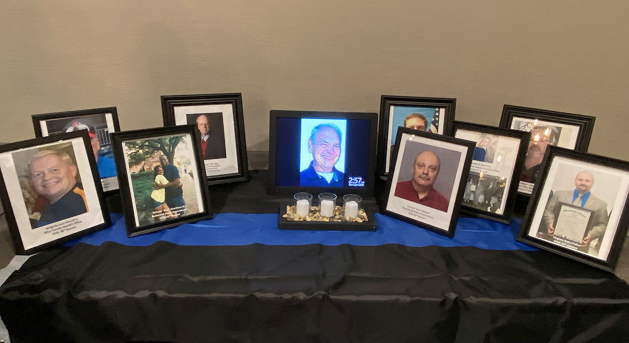

Website:
Mark Garman, Secretary and Webmaster, reported that the new website is up and running. He said that changes are coming to make the site more secure including having only two email accounts, one for general transactions and one for financial transactions. It will possibly be password protected in the future.

PayPal:
Mark Garman, Secretary, reported that PayPal continues to do well for the association with over $3500.00 in dues and sales transactions at Retraining.

Retraining Exploration:
Marc Hackett reported that the committee members are Jeff Dwyer, Trey Lucy, Wendy Bailey, and Karyn Buhrman. The committee will stay in effect and continue to look at possible different locations. He asked the membership in attendance to indicate there likes and dislikes concerning the Delta in the course evaluation.

Annual Retraining 2022:
Jeff Dwyer had no new information other than what was mentioned in the Exploration Committee report.

Social:
Andrea Feldman, Committee Chairperson and Northern Director, said the Social was set and ready to go. At the check-in each member would receive two drink tickets and the Social tickets would be collected to be used as tickets for the Social Raffle.

Benson Fund:
Brian O’Bier, Committee Chairperson, did not have an official report. He said one would be sent to the Board soon. He did indicate that $4000.00 in scholarships were given out in 2022 and the Benson Fund has about $7000.00 left in their accounts. He said that raffle sales were at about $300.00 so far at Retraining.
The below report was sent after Retraining.
Benson Report 09 2022
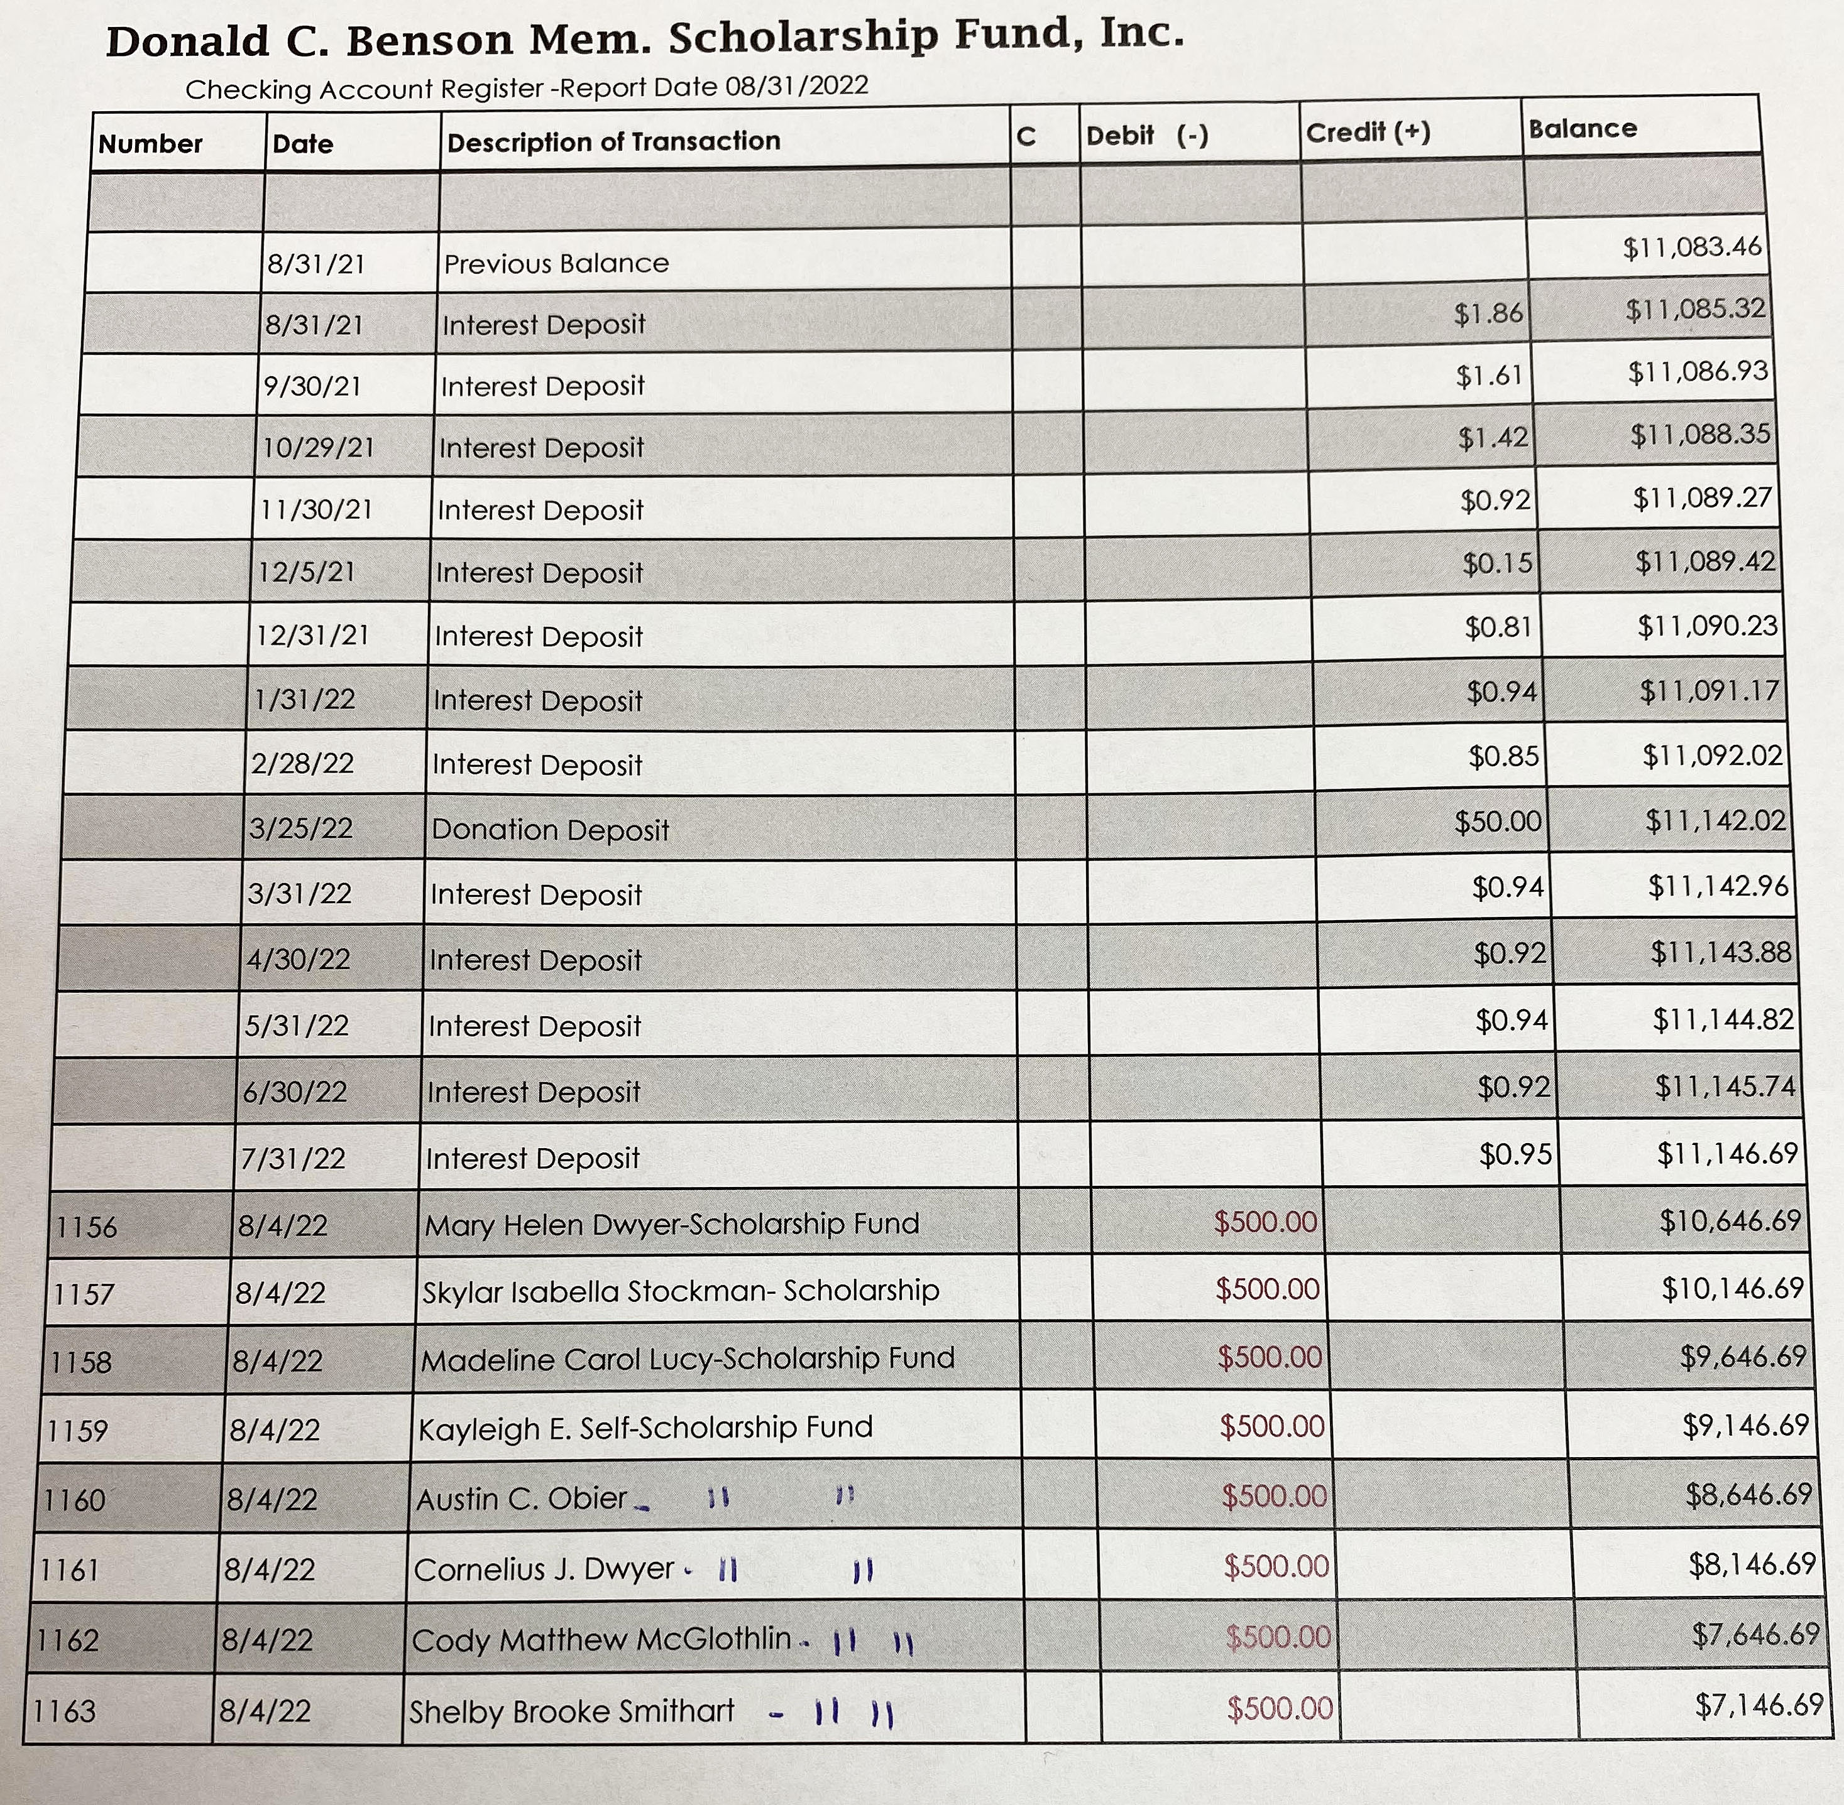

Raffle:
Clay Overholt, Committee Chairperson and Immediate Past President, said that the Raffle was doing well with approximately $600.00 in sales. Sales would continue up to the time of the drawing at the Social.

Novelty T/shirt Quilt Raffle:

Mark Garman, Committee Chairperson and Secretary, said that sales were going well and would continue up to the drawing at the Social. Total profits for the quilt were currently approximately $600.00

Vendor:

Trey Lucy, Committee Chairperson and Central Director, said that there were only four (4) vendors this year, two other vendors backed out at the last minute. He said that he did receive several suggestions for possible vendors for the 2023 Retraining Seminar.

Information on this year’s vendors, Evident Crime Scene Products, Arrowhead Forensics, Trancite Logic Systems, and Spacesaver Storage Solutions are posted on our website.

Dan Grinnan Fall Classic Golf Outing:

Karyn Buhrman, Committee Chairperson and Eastern Director, said that the golf outing, although small, went well.

The Dr. Paul Ferrara Award:
Two Dr. Paul Ferrara Awards were given out during the opening ceremonies of Retraining by Wendy Bailey, SGT-at-Arms and Committee Chairperson to Mr. Stephen K. Stockman (Steve) former instructor for the VFSA and to SGT Brian Kosko of the Roanoke City Police Department. Their nomination letters can be found on our website, www.vfsaaa.org.
Wendy Bailey and SGT Brian Kosko Mr. Steve Stockman and Wendy Bailey
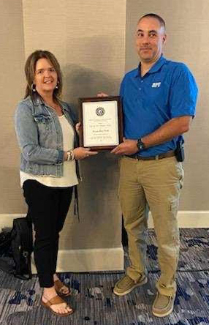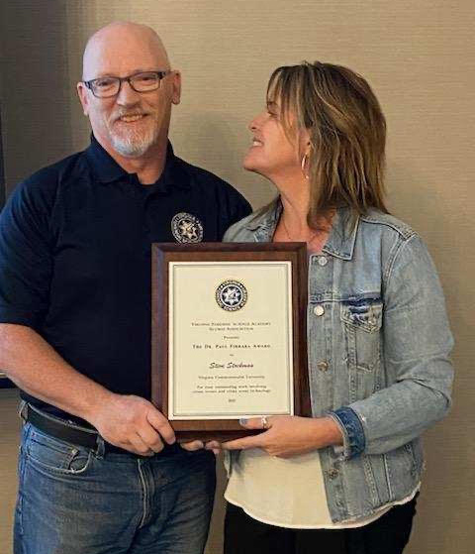

Hospitality Suite:
Karyn Burhman, Committee Chairperson and Eastern Director, said that the Hospitality Suite, renamed the VFSAAA Networking Event, held at the ShoreBreak Pizza and Taphouse went very well. ShoreBreak was within easy walking distance from the Delta Hotel. She thanked Wendy Bailey for all her help. Wendy asked for members to supply feedback on the Retraining evaluations concerning the event. Trey Lucy said that some vendors were interested in helping with the event in the future.

Novelty T/shirts:
Karyn Buhrman, Committee Chairperson and Eastern Director, said that sales for the 2022 Novelty T/shirt went extremely well and that very few shirts were left in stock. The images, designed by Steve Stockman, were originally conceived in 2020 but because of the cancelation of Retraining for both 2020 and 2021 they were not used. With slight adjustments the images were used for this year.

Left Front Back

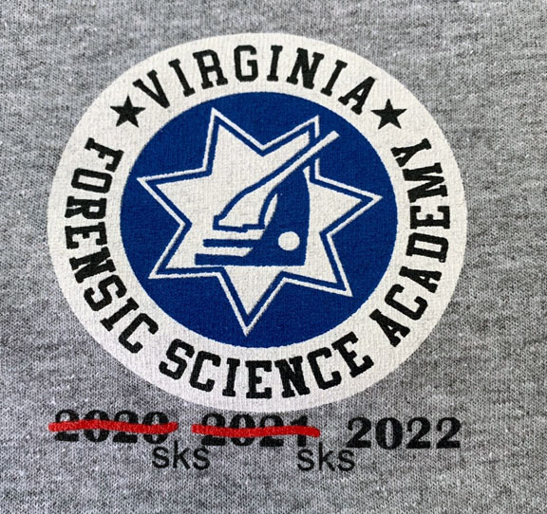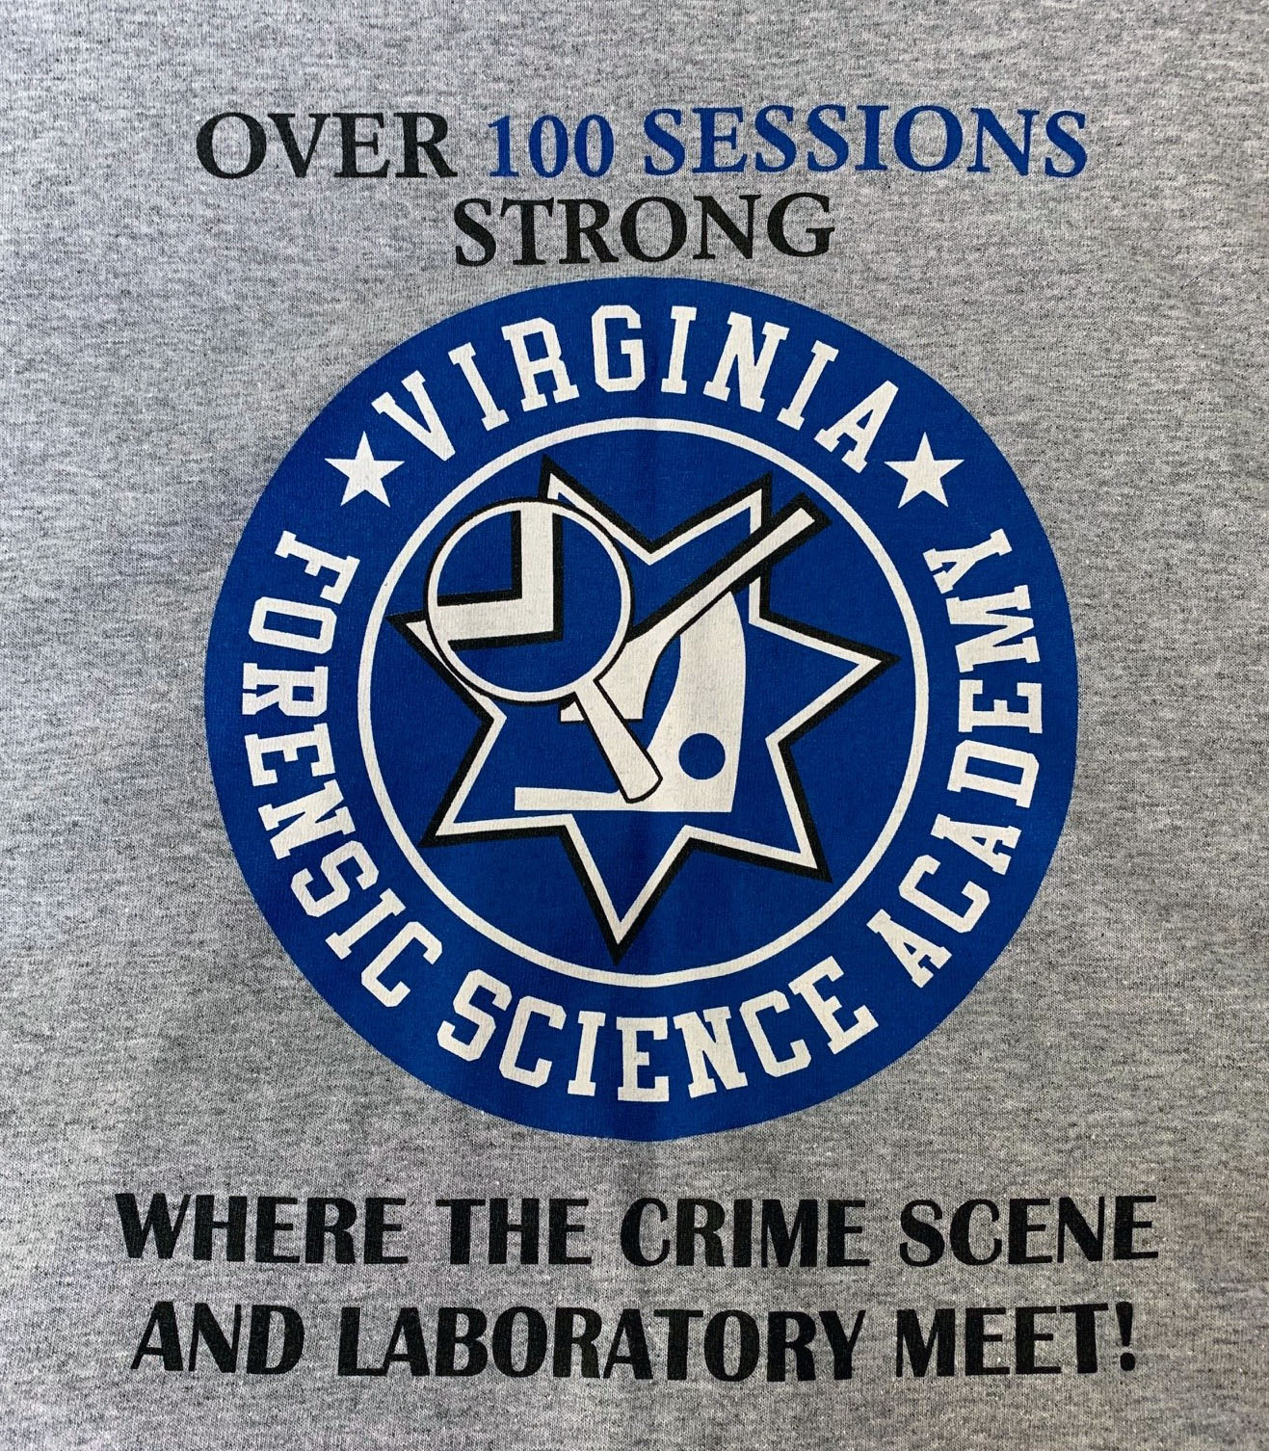

Nomination:
Jim Gogan, Committee Chairperson, presented the slate for the 2022-2023 Board of Directors to the membership. There were no other nominations. There was a motion and a second to accept slate. The motion passed unanimously. There were no dissenting votes or objections.
Jim then presented the slate for the Regional Directors. He presented each region separately. He asked for additional nominations for each region. After there were none, he accepted a Motion with a Second for each region. The motions passed unanimously for each region. There were no dissenting votes or objections.
Below is the nomination letter posted on our website. The letter was posted more than 30 days prior to the Annual Meeting as prescribed in our Bylaws.

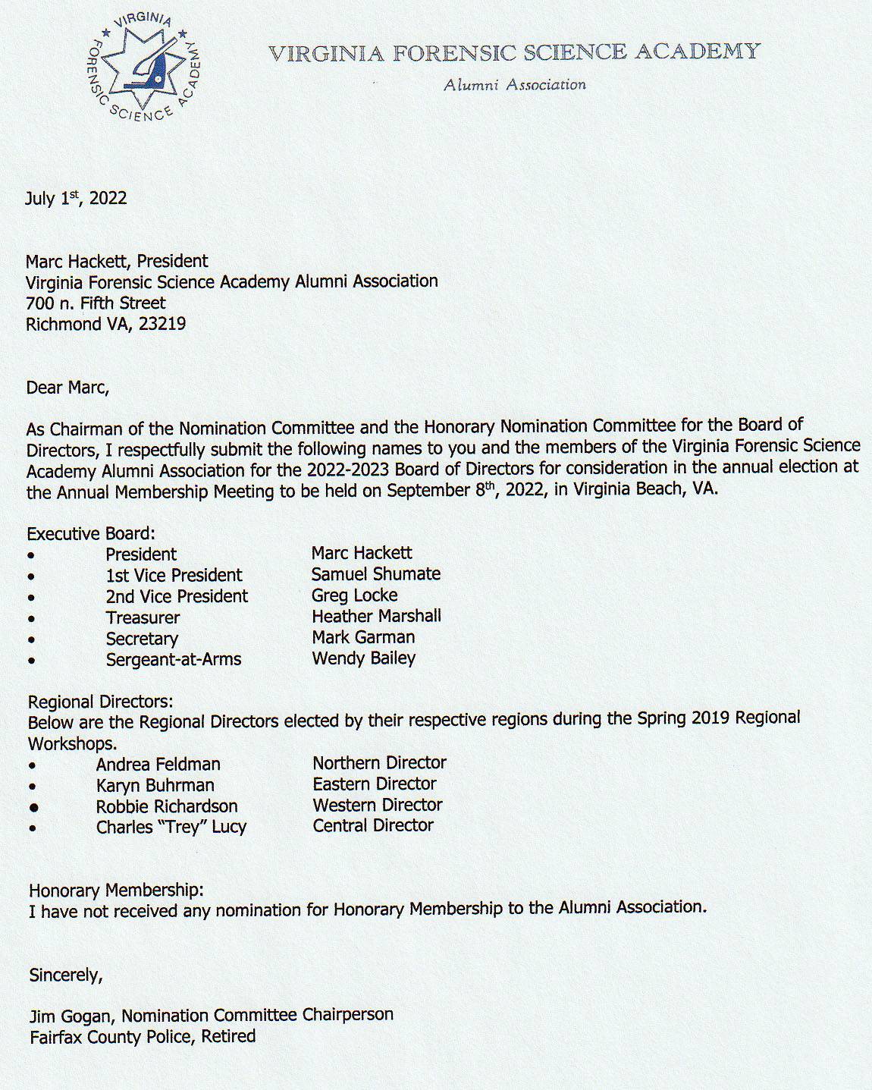

Honorary Membership:

Greg Locke, 2nd Vice President, advised the membership that there were two nominations for Honorary Membership in to the VFSAAA. The nominations were for Judy Grimm and Mike Grimm, Jr., of Evident Crime Scene Products. They are mother and son and are major supporters of the VFSA and the VFSAAA. Greg read the nomination letter for Judy and Mike. The nomination letter can be viewed on our website, www.vfsaaa.org. Of interest, Mike Grimm Sr. (husband/dad), is already an Honorary Member. A Motion and a Second were made to accept both as Honorary Members. The motion passed by unanimous oral vote. There were no objections or dissenting votes.

The announcements and presentations would be made to the Grimms at the Social. Below are images of the Grimm family.

Judy and Mike Jr. Judy and Mike Sr.
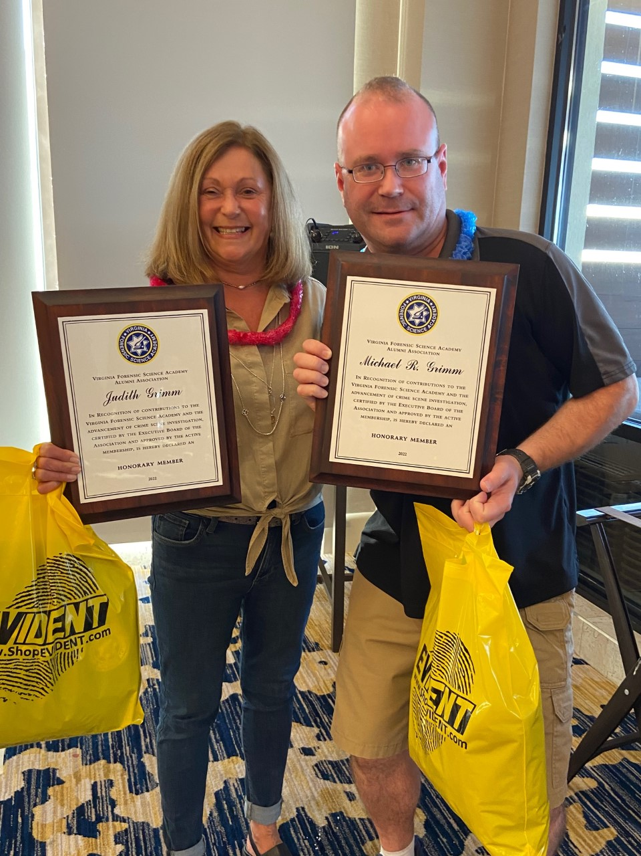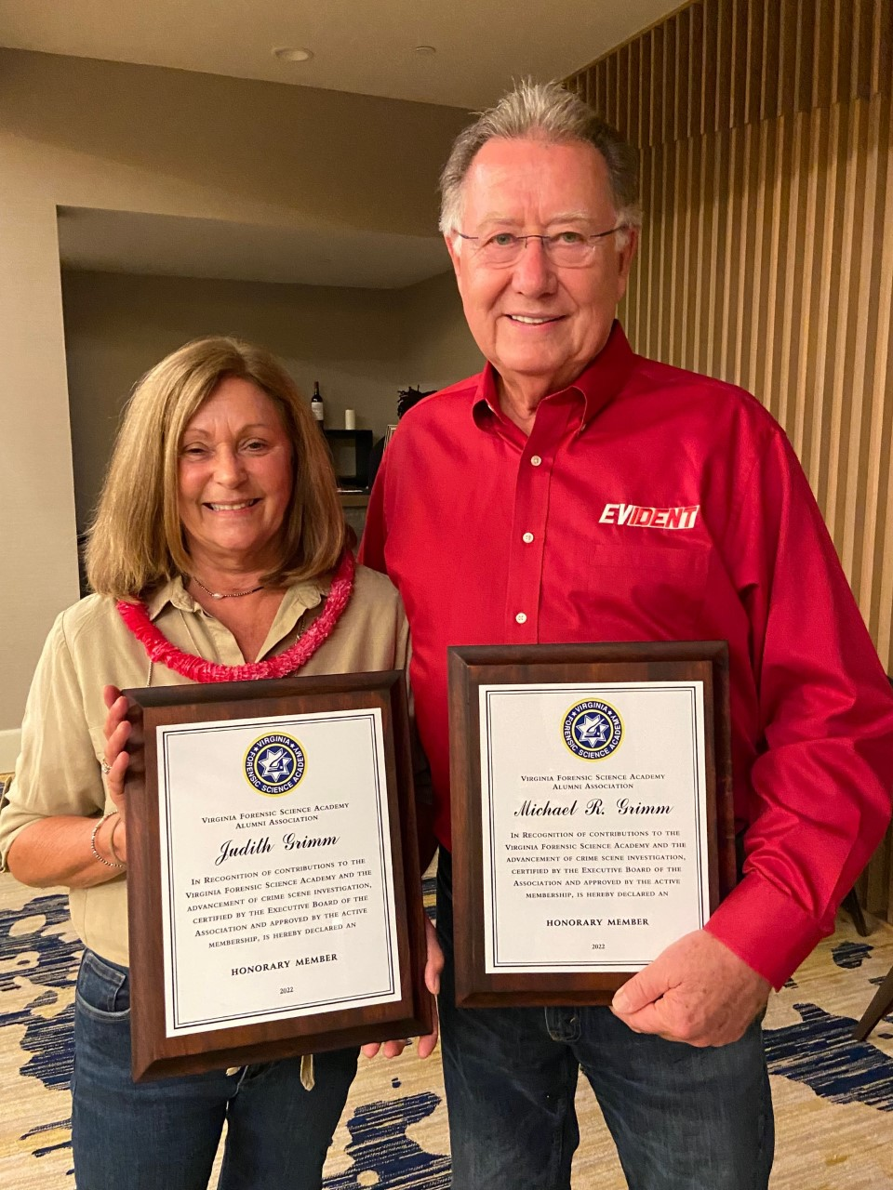

The Board of Directors, including Regional Directors, were then sworn in by Jeff Dwyer.

Secretary’s Note:

Although it was not presented during the Annual Meeting but rather during the Social, the Board felt it was important to mention that the Board of Directors presented the VFSA Lifetime Achievement Award to Rick Conway, our Legal Consultant, for his constant support of the VFSA and the VFSAAA. Rick has been on the Board of Directors for over 25 years. Rick retired from the PWC CWA Office in 2020 and was a graduate of the 4th Session in 1976 when he was with Falls Church City Police Department.

Bob Zinn Rick Conway Jeff Dwyer 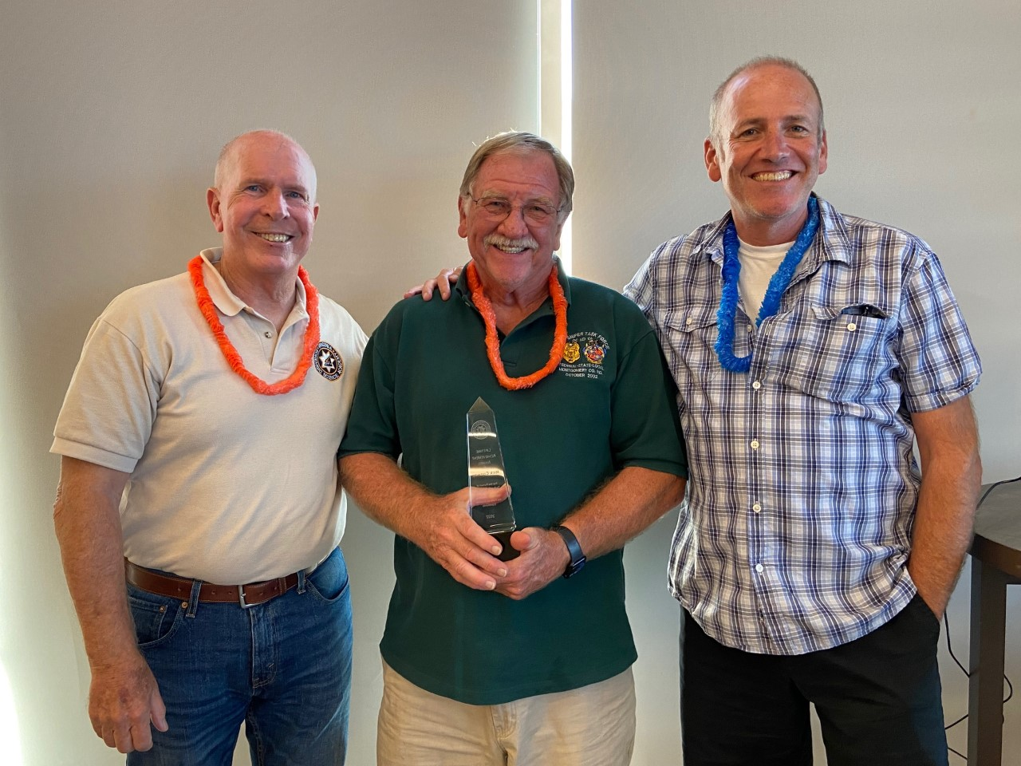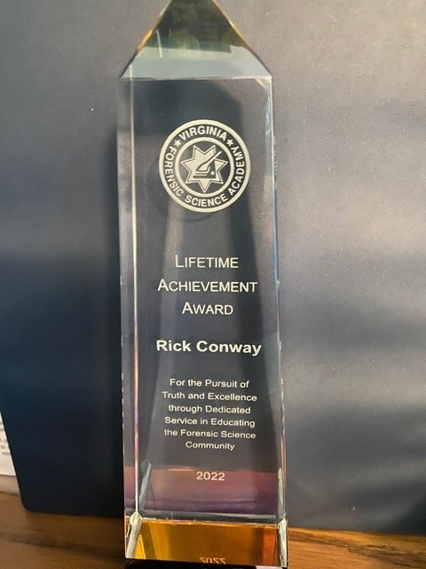

President Hackett asked if there was a motion to adjourn the meeting. A Motion and Second was made to adjourn the meeting. As there were no objections or dissenting votes, the motion passed.

The meeting adjourned at approximately 11:45 AM.

The next meeting of the VFSAAA is a Board Meeting scheduled for Friday November 18th, 2022, after the graduation of the 107th Session of the VFSA.

Mark Garman, Secretary

Approved by the Board of Directors of the VFSAAA at the November 2022 Board Meeting

11/18/2022

