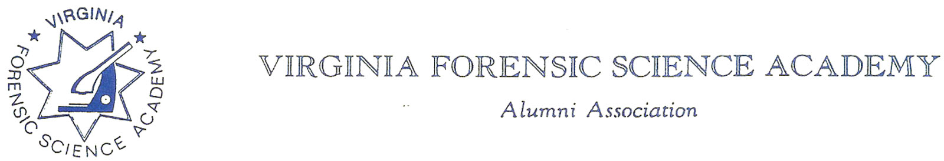
VFSAAA Board Meeting Minutes

To: VFSAAA

Date: March 31st, 2023

From: Mark Garman, Secretary

Re: VFSAAA Board Meeting
November 18th, 2022

Executive Board:
President Marc Hackett
1st Vice President Sam Shumate Absent
2nd Vice President Greg Locke Web-Based Attendance-Late
Treasurer Heather Marshall
Secretary Mark Garman
Sergeant-at-Arms Wendy Bailey Absent
Immediate Past President Clay Overholt
Legal Consultant Rick Conway
DFS Consultant Jeff Dwyer

Regional Directors:
Northern Director Andrea Feldman Absent
Eastern Director Karyn Buhrman
Western Director Robbie Richardson Absent
Central Director Charles “Trey” Lucy

Committees:
R. Brian O’Bier Benson Committee Absent
Eric Deel Audit Committee Absent
Jim Gogan Nominating Committee Absent

Others:
Shantae Green Admin Assistant

The meeting was called to order at approximately 12:30 PM by President Marc Hackett.
It was determined that there were enough Board members physically present or signed into the meeting via phone/internet to establish the necessary quorum.

Secretary’s Report:
The Annual Meeting Minutes from the September 8th, 2022, Annual Meeting were presented to the Board by Mark Garman, Secretary, prior to the meeting via email.
It was noted that the indicated date of the meeting needed to be corrected.
There were no other questions or comments on the minutes.
A Motion, along with a Second, was made to accept the Meeting Minutes. There were no objections. The motion passed by unanimous oral vote. There were no dissenting votes.

Treasurer’s Report:
Heather Marshall, Treasurer, presented the November 2022 Treasurer’s Report to the Board.

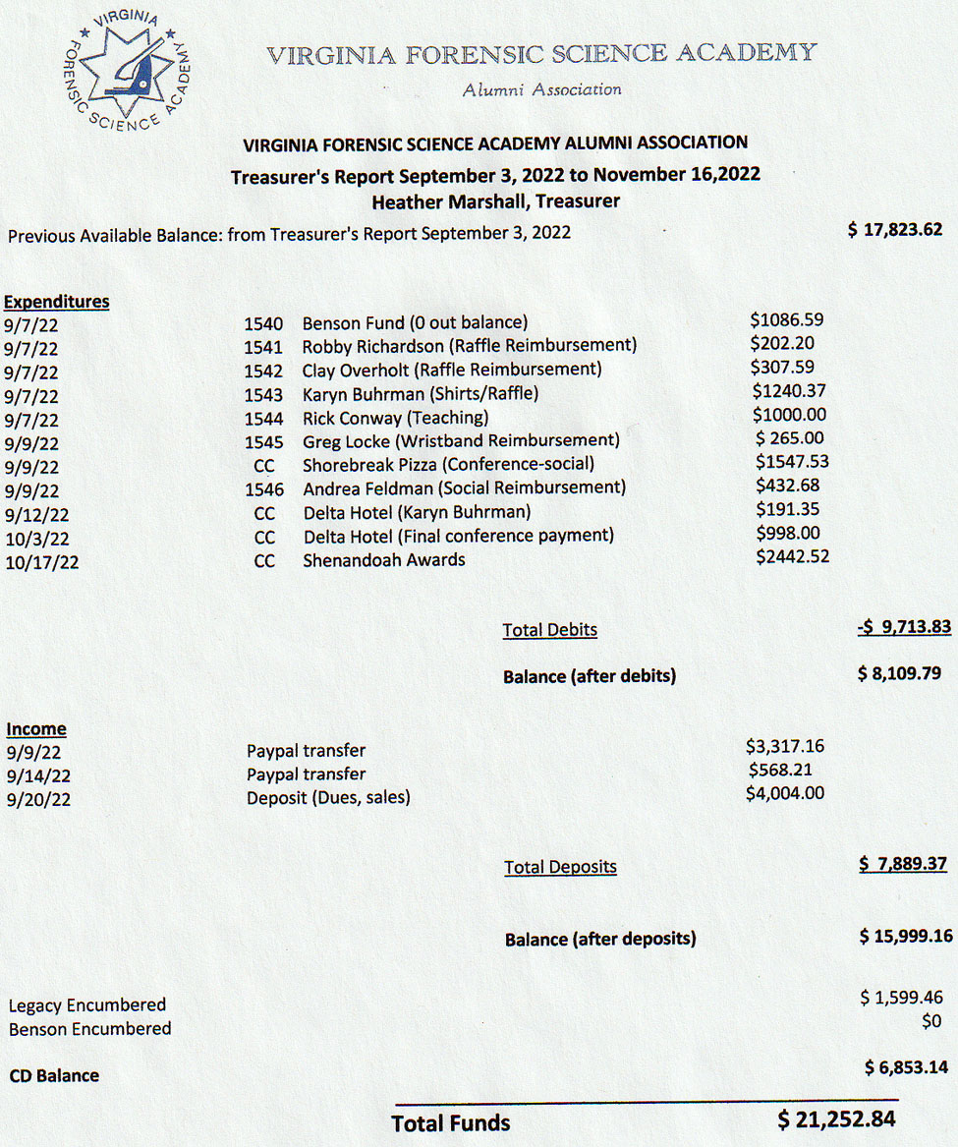

President Hackett asked for a motion to accept the November 2022 Treasurer’s Report. A Motion, along with a Second, was made to accept the Treasurer’s Report. There were no objections. The motion passed by unanimous oral vote. There were no dissenting votes.
The VFSAAA 2022 Annual Audit was presented to the Board by Chairperson Eric Deel thru President Hackett via email.
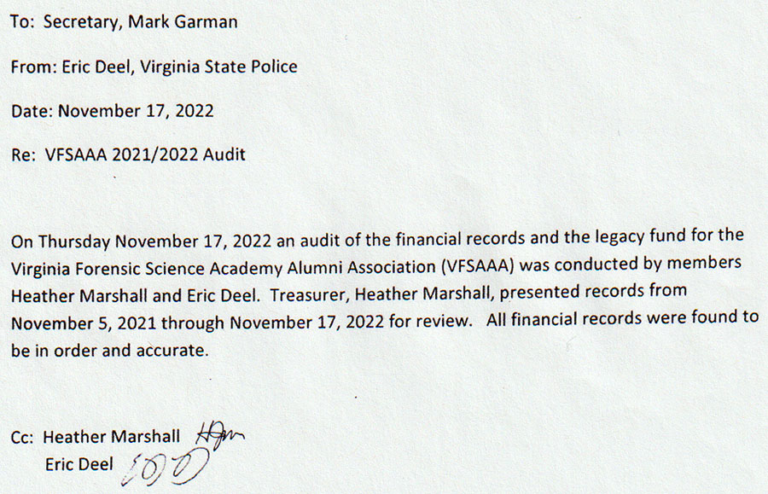
President Hackett asked for a motion to accept the 2022 Audit Report. A Motion, along with a Second, was made to accept the Audit Report. There were no objections. The motion passed by unanimous oral vote. There were no dissenting votes.

Old Business:

Officer Bags:
Mark Garman advised that the needed Board member briefcases/bags were ordered thru Shenandoah Awards. They will be shipped to Jeff Dwyer at the VFSA. The bags will be given out at the March 2023 meeting.

Association Credit Card:
Heather Marshall, Treasurer, said she has the Association’s credit card that was assigned to Fhatima Shands. It will be destroyed. It was decided to have a new Association credit card issued to Jeff Dwyer.

New Business:

New Admin Assistant for the DFS/VFSA:
Marc Hackett, President, and Jeff Dwyer, DFS Consultant, introduced Shantae Green as the new Admin Assistant to the Board. Shantae replaced Fhatima Shands who left the DFS for greener pastures.

Standing Rules:

There was a long discussion on our current Standing Rules. Mark Garman and Marc Hackett brought up that there are numerous issues with the Rules that need to be changed to bring them up to date. Of particular concern was rule #13 which states,
“13. A Board member whose employer does not pay for their lodging costs associated with the Annual Retraining Conference may request that the Board reimburse them for their lodging. Approval by the Board for reimbursement will be granted on a case-by-case basis. Authorized by the Board at the April 2013 Board Meeting.”
Mark noted that there are 5 or 6 current Board Members that can now ask for reimbursement and if all asked at the same time it would not be economically feasible for the Board to honor all the requests.
Mark Garman made a motion to limit the total amount expended by the Board in reference to Standing Rule #13 to a maximum total of $2,000.00 per Retraining Seminar to be divided equally among the total number of requests. The motion was seconded by Clay Overholt. There were no objections. The motion passed by unanimous oral vote. There were no dissenting votes.
Rule #13 would now read as follows;
“13. Any Board member whose employer does not pay for their lodging costs associated with the Annual Retraining Seminar may request that the Board reimburse them for their lodging. Approval by the Board for reimbursement will be granted on a case-by-case basis, up to a maximum total expense of $2,000.00 divided among all requests per Seminar.”

Marc Hackett made a motion to add Rule #14. The rule would read as follows.

“14. The current 1ST Vice President will be responsible for sending out cards of condolences on behalf of the Board of Directors. Cards shall be supplied by the Board.”

The motion was seconded by Mark Garman. There were no objections. The motion passed by unanimous oral vote. There were no dissenting votes.

Lifetime Achievement Award:

There was a discussion on the Lifetime Achievement Award presented by the Association. The matter was tabled until the March 2023 meeting.

VFSAAA Ceramic Coffee Mugs:

Mark Garman brought up the VFSAAA ceramic coffee mugs that were offered in 2015. He said he had several requests for the mugs. He said he would investigate the matter and advise the Board in March of 2023.

Virginia State Corporation Commission:

Rick Conway said that he is still working with the Virginia State Corporation Commission to bring all our information up to date.

Committees:

Bylaws Committee:

Rick Conway, Committee Chairperson, had nothing to report.

Membership and Ethics Committee:
Rick Conway, Committee Chairperson, advised that there were no issues under investigation and that he had nothing to report.

Sales:
Greg Locke, Committee Chairperson, gave a brief report, unfortunately some of it was garbled because of the phone connection and recording. Most, if not all, of the authorized $3500.00 was spent. Greg said he has ordered lapel pins. They will be shipped to the VFSA. Jeff Dwyer reported over $200.00 in sales to the recent graduating class.

Memorial Table:
Mark Garman, Secretary and Committee Member, said that he thought the Memorial table at Retraining went well. He thanked Marilyn Durham, Greg Locke, and Mark Stanton for their work. He said the committee would continue to update the table for Retraining 2023.

Website:
Mark Garman, Secretary/Webmaster, advised that our website, www.vfsaaa.org, is up to date. He said that he will be working on “password protecting” the site over the next year.

PayPal:
Mark Garman, Secretary, reported that PayPal went well at Retraining.

Annual Retraining Relocation Exploration Committee:

Jeff Dwyer said he is waiting on a proposal from the Delta. Jeff and Trey reported that member responses concerning the Delta were all positive. There was a period of general discussion by the Board on the different aspects of Retraining 2022. Most were positive. The only concern was the slow response from the Delta when information was needed by the VFSAAA and possible space issues if the number of vendors increase.

Annual Retraining 2022:
Jeff Dwyer said there were no real issues other than low attendance during some classes.

Benson Fund:
Brian O’Bier, of the Benson Fund Committee, was not present and there was no report.

The Dr. Paul Ferrara Award:
Wendy Bailey, SGT-at-Arms, was not present and there was no report.

Social Committee Report:
Andrea Feldman, Northern Director, was not present and there was no report.

Raffle Committee:
Clay Overholt, Immediate Past President, reported that the raffle went well and that the VFSAAA did make a profit.

Vendor:

Trey Lucy, Central Director, had nothing to report. He did say that things went well for Retraining 2022.

Novelty T/shirts:
Karyn Buhrman, Eastern Director, said that sales went well and that almost all of the T/shirts were sold.

Hospitality Suite:
Karyn Buhrman, Eastern Director, reported that the Hospitality Suite went well for 2022 and there were no complaints. She had information for the Suite in 2023.

Dan Grinnan Fall Classic Golf Outing:

Karyn Buhrman, Eastern Director, had no report.

Nomination Committee:
Mark Garman said that he would check with Jim Gogan, Chairperson, and see if he is still interested in running the committee.

The next regular VFSAAA Board Meeting, is scheduled for Friday, March 31st, 2023.

President Hackett asked if there was a motion to adjourn the meeting. A Motion, along with a Second, was made to adjourn the meeting. As there were no objections or dissenting votes, the motion passed.

The meeting adjourned at approximately 1:45 PM.

Mark Garman, Secretary

Approved by the Board of Directors

March 31st, 2023

____________________________________

