
VFSAAA Special Board Meeting Minutes
Because of COVID-19 issues this Meeting was a virtual-web based meeting.

To: VFSAAA
Date: April 1st, 2022

From: Mark Garman, Secretary
Re: VFSAAA Special Board Meeting
November 22nd, 2021

Executive Board:
President Marc Hackett
1st Vice President Chris McClure-ABSENT
2nd Vice President Greg Locke-ABSENT
Treasurer Heather Marshall
Secretary Mark Garman-ABSENT
Sergeant-at-Arms Wendy Bailey
Immediate Past President Clay Overholt-ABSENT
Legal Consultant Rick Conway
DFS Consultant Jeff Dwyer

Regional Directors:
Northern Director Andrea Feldman
Eastern Director Karyn Burhman
Western Director Samuel Shumate
Central Director Charles “Trey” Lucy

Committees:
R. Brian O’Bier Benson Committee-ABSENT
Eric Deel Audit Committee-ABSENT
Jim Gogan Nominating Committee-ABSENT

Others:
Fhatima Shands Admin Assistant/Honorary Member
Steve Stockman Instructor

The meeting was called to order at approximately 10:00 AM by President Marc Hackett.
It was determined that there were enough Board members signed into the meeting to establish the necessary quorum.

This special meeting was called for by President Hackett during the regular Board Meeting which was held on November 12th, 2021. The purpose of this meeting is to determine a location for the 2022 Annual Retraining Seminar.

Annual Retraining Relocation Exploration Committee:
The included spreadsheet comparing the two hotels was supplied by President Hackett prior to the meeting.
Marc went over the spreadsheet pointing out the differences between the two hotels.
Wendy Bailey, SGT-at-Arms, brought up the $5,000.00 limit to be spent on food required by both hotels. She pointed out that the food costs not only include food for the Social but also other items such as coffee in the morning.
Jeff Dwyer, DFS Consultant, mentioned the cost of the hotel rooms. The costs are $149.00 per night for the Delta Hotel and $106.00 a night for the Holiday Inn (these figures do not include taxes and other fees). He was wondering if this would affect the number of members attending.
Karyn Burhman, Eastern Director, indicated that the costs at the Holiday Inn were better than the Delta Hotel but the location of the Delta Hotel was far better. The concern is that the Holiday Inn is very “public” as it is in the north beach business area. Additionally, parking is across the street in a parking garage offering little security for marked police vehicles. The Delta Hotel is much more private and has onsite parking. She also mentioned that the seminar’s dates, after Labor Day, may affect the number of members who attend. Families with students would find it difficult to be there because of these dates. Trey Lucy, Central Director, stated that many school systems are starting back in mid to late August. Jeff Dwyer said that he has noticed a drop off in members with families.
Wendy Bailey said the VFSAAA sponsored Hospitality Suite at the Holiday Inn could possibly create some issues with members and the public consumption of alcohol. The hospitality suite location at the Holiday Inn fronts to the boardwalk. She suggested that maybe the Board set up a “meet up” location at a nearby establishment eliminating many of the costs associated with the suite. Karyn Lawrence who is the Hospitality Suite Committee Chairperson concurred. Steve Stockman, Instructor, advised that Mike Grimm, of Evident Crime Scene Products, has stated in the past that Evident would help with an off-site hospitality suite. Fhatima Shands, Admin Assistant/Honorary Member, questioned where and when members would pay their dues if the Tuesday night Hospitality Suite was held off site. It was a general opinion that the members would be responsible for paying their dues either before or during Retraining.
Heather Marshall, Treasurer, indicated that the state per diem rate is $186.00 in August and $106.00 in September. This may be an issue with some agencies. There was an extended period of discussion by the Board on the topic. Rick Conway, Legal Consultant, suggest that a letter of explanation be included in the Retraining announcement package explaining the changes and additional costs.
There was a period of Board discussion of the possibility of having both in-person and on-line capabilities for Retraining. Jeff, Steve, and Fhatima all said there would be issues in doing this and did not think it would either be viable or a good idea.

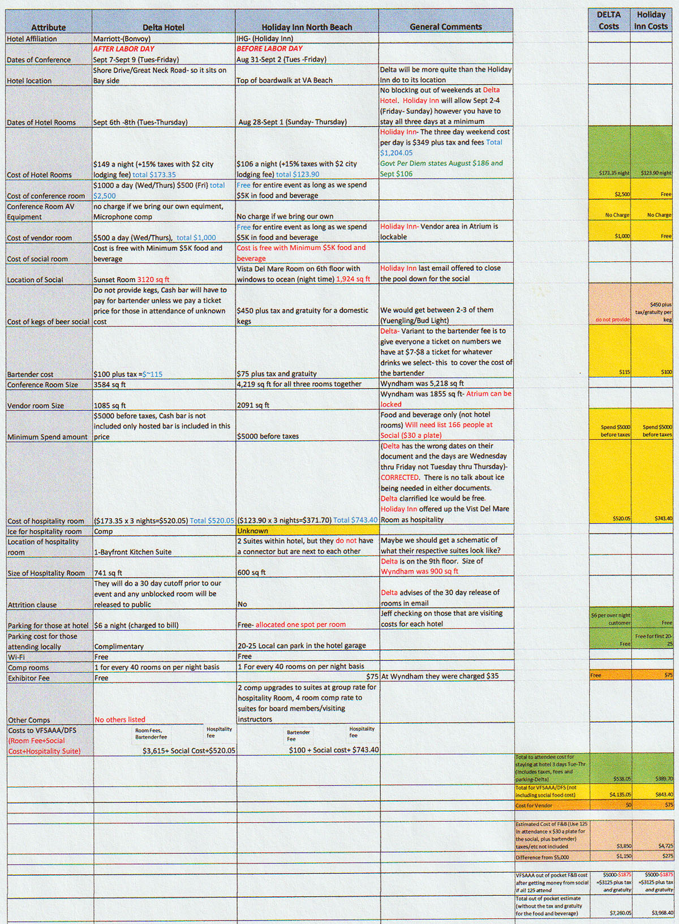
Sam Shumate, Western Director, made a Motion to use the Delta Virginia Beach Bayfront Suites, www.deltavirginiabeachbayfront.com as the site for the 2022 Retraining Seminar. There was a Second by Wendy Bailey. There was no further discussion. There were no objections. The motion carried.

New Business:

Marc Hackett received this information from Chris McClure, 1St Vice President,

All,
I wanted to let you know that I will be leaving VSP after 33 years and I have accepted a position with the Montana DOJ effective Dec 6. I will be resigning from the VFSAAA board effective immediately.
I am sad to be leaving, but excited to be moving on and the new opportunities.
I have enjoyed working with all of you. You are the best at what you do. Good luck with all your endeavors.
Best regards,

It was suggested that Sam Shumate, the current Western Director, move to the 1ST Vice President position and Clay Overholt, the current Immediate Past President, move to the Western Director position. Clay is from the Western Region and would hold the position until a full vote can be done by members of the Western Region to elect a new representative. Marc will reach out to the entire Board via email for their response and voting to confirm this change.

The next regular VFSAAA Board Meeting is scheduled for Friday April 1st, 2022. The time and manner are yet to be determined.

President Hackett asked if there was a motion to adjourn the meeting. A Motion and Second was made to adjourn the meeting. As there were no objections or dissenting votes, the motion passed.

The meeting adjourned at approximately 11:05 AM.

Mark Garman, Secretary

Approved by the Board of Directors

04/01/2022

____________________________________

